Biodiversity survey of the Iford Estate, 2024 resurvey – CONFIDENTIAL VERSION
Graeme Lyons
January 2025

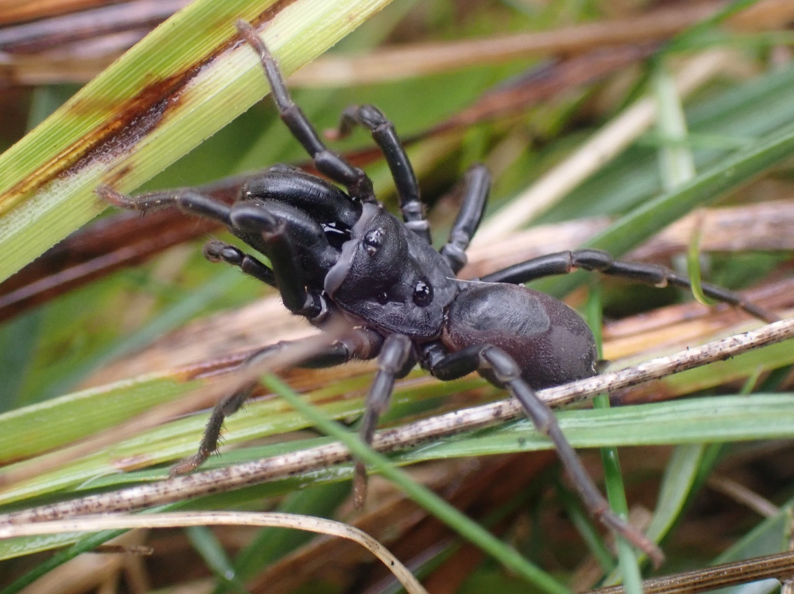
Fig. 1. Adult male Atypus affinis found at High Down.

0 – Summary
The Iford Estate is a large estate in East Sussex, the area covered in this survey includes the 870 hectares surveyed in 2021 (the main part of the Estate) and runs pretty much continuously from the north east edge of Brighton, to Southerham roundabout near Lewes. The satellite part of the Estate, Houndean (180 hectares) that sits to the west of Lewes and is not contiguous with the main part of the Estate, was also added to the survey in 2024, making 1,050 ha in total. The site covers a range of habitats, from arable, to chalk-grassland, to secondary woodland, to grazing marsh, along with ditches and artificial lakes.
The author was commissioned to carry out a repeat of the 2021 baseline survey of the site, in order to inform management of the farm and gauge the effects of any changes in management. The methodology used is in-line with other farm surveys carried out by the author, using a rigorous and repeatable methodology that allows for comparisons between sites, as well temporally, on-site.
The Estate was split into four main habitats/zones; Arable, Brooks, Chalk and Houndean. Three recording sessions were made, with four days recording during each session, split evenly between the four habitats/zones. In each zone, the site was further split into six recording compartments to stratify the time evenly, meaning that there were 24 recording compartments overall, each of which was visited for a total of three hours during the survey. The site was visited in spring (end of April/start of May), June and August.
A total of 9,688 records of 1,741 species were recorded in 2024, including the Houndean data. This fell to 7,033 records of 1,533 species when the Houndean data was removed. This compares to a total of 5,699 records of 1300 species that were made in 2021.
Of these 1,741 species, 1,241 were invertebrates, 373 were vascular plants and 85 were birds. The comparable number of 1,096 invertebrates was much higher than the 866 species recorded in 2021. An incredible 136 invertebrates with conservation status were recorded in 2024, falling slightly to 121 when Houndean is removed (11.0%), much higher than the comparable figure of 76 species (8.8%) made in 2021. Both figures are much higher than the author’s rolling average of 7.0%.
The highest number and proportion of scarce invertebrates occurred on the chalk-grassland again in 2024, with 68 species recorded (compared to 43 in 2021), a proportion of 12.5% (9.9% in 2021). To put this in perspective, the average number of invertebrates with status for an entire survey by the author is 36 species.
The most speciose invertebrate order were the beetles, with 379 species recorded (compared to 285 in 2019) and rising to an incredible 423 species when the Houndean data is added. A bewildering 61 beetles with conservation status were noted in 2024 (falling slightly to 55 when the Houndean data is removed). The Nationally Rare & Endangered tortoise beetle, Cassida denticollis was found on two Chalk compartments. Recent colonists/recolonists like Lagria atripes (Presumed Extinct) and Aulacobaris caerulescens were recorded on the arable. Scarce weevils, like the Nationally scarce a Sirocalodes quercicola that feeds only on fumitories, were well-represented on the site.
An impressive 152 species of spider were recorded in 2021, rising to 171 species in 2024 (but falling to 153 with the Houndean data removed). A total of 23 of these 171 species had some form of conservation status. The endangered spider, Scotina palliardii, was not refound in the quarry in 2024. The non-native species Erigone dentosa was recorded new to East Sussex. Wes Udall spotted the Nationally Scarce Purse-web Spider Atypus affinis at High Down.
A total of 87 species of bee, ant and wasp were recorded in 2024, falling to 68 species when the Houndean data was removed (very close to the 2021 figure of 67 species). Houndean was found to hold the most species out of all four zones and had records of Andrena niveata (RDB2), Halictus eurygnathus (RDB1), Bombus humilis (Section 41) and Bombus ruderatus (Nationally scarce b & Section 41). Andrena gravida was not refound in Adder’s Corner. As well as the Houndean record, Halictus eurygnathus was again found on Arable E but it was also noted in Chalk A and D.
The number of scarce moths rose to ten species from eight in 2021, joining the Scarce Forester was the Section 41 Forester. Butterflies were well represented in 2021 but were the only major group to decline in 2024 (butterflies had a very poor year). Small Blue (which was recorded in seven compartments in 2021 was not recorded at all, neither were Grizzled Skipper or Dark Green Fritillary). Although overall diversity was only one species lower than in 2021 (28 species), most species were down in range.
A total of 193 bugs were recorded, falling to 176 when the Houndean data was removed (this is compared to the 119 species recorded in 2021). Of these, 13 had some form of status. The plant hopper Asirica clavicornis was recorded new to Sussex. Two scarce recent colonist shield bugs were noted; White-shouldered Shieldbug Dyroderes umbraculatus and Sciocoris homalonotus.
The floods in the spring resulted in breeding Redshank on site, and more Lapwing than were observed in 2021. Wetland birds were particularly well-represented in 2024, with Cattle Egret, Marsh Harrier, Curlew, Oystercatcher, Snipe and Greenshank all recorded in 2024 that were not recorded in 2021. Several Nightingale territories were recorded at Houndean. In all, 85 species were noted falling to 82 species when the Houndean data was removed (close to the 80 species noted in 2021).
Stone-curlew initially did well, with three pairs present, only one of which was successful. The rapid growth in stewardship features meant that by June there was little suitable habitat available on the Estate, causing at least three animals to move on to the nearby Balsdean Farm.
A total of 373 vascular plants were recorded across the Estate, falling to 331 species when the Houndean data was removed (close to the total of 325 species recorded in 2021).
Autumn Lady’s-tresses, Bastard-toadflax and Round-headed Rampion were again all recorded in Long Bottom, (while Heath Dog-violet could not be refound). This compartment was the standout compartment of the survey in 2024, with the grazing here being a perfect example for the slope. The Frog Orchid found at High Down in 2021 could not be refound. Arable plants fared slightly better with the addition of Houndean, with the Endangered Narrow-fruited Cornsalad recorded there, joining species like Stinking Chamomile and Dwarf Spurge. The amount of fertiliser used on the farm means that it’s unlikely to ever be great for arable plants.
Several plants of Knapweed Broomrape, a rare plant in Sussex, were added to the list from an arable margin. On the Brooks, only Tubular Water-dropwort and Frogbit were recorded that had status but a wide range of local aquatic and emergent plants were also noted here, most importantly being the first plant of Round-fruited Rush to be recorded in East Sussex since 1955.
Each of the four zones complement each other well and work together at the landscape level. Comparative analysis showed some interesting results though, with the arable areas coming out very well compared to the others in some metrics. More bees were recorded in the Arable and Houndean plots than the Chalk or Brooks (the Brooks scoring particularly badly). This is as much down to grazing on the chalk-grassland and Brooks though, as it is the presence of year-round nectar sources on the arable margins.
Unsurprisingly, the Chalk block held the most species with conservation status and the Brooks the least.
An analysis of Section 41 species showed a decline from 30 species in 2021 to 27 in 2024 (rising to 29 when Houndean was added). This is despite nearly twice as many species with conservation status being recorded in 2024 as were in 2021, and shows how flawed it is to focus on a small sub set of large charismatic species. Using only these species and not all species with status, would paint a very misleading picture, diametrically at odds to the actual changes recorded on site.
It is remarkable how much the Iford Estate has changed in just three short years. The floods in the spring and the knock-on effect of grazing, clear changes to management (many of which have been positive, with some negative) and natural changes to the assemblage of species is remarkable. The large number of additional species recorded in 2024, especially invertebrates other than butterflies and dragonflies, shows that 2024 was not the disastrous year that many people claimed it was for invertebrates. In fact, on average, it was generally a really good year for invertebrate assemblages across all taxa.
The approach by the Estate is hugely commendable, and it is expected that the management carried out here will be refined over the coming years. Areas such as Long Bottom are a huge conservation gain and it’s expected that High Down will recover if the intensity of management is matched by a more nuanced and targeted approach.
Management recommendations are given on a habitat by habitat and a compartment-by-compartment basis. Recommendations for further monitoring and data compilation are also provided.

1 – Introduction
1.1 – The site
The Iford Estate is extremely large, covering some 1,200 hectares (with 1,050 ha covered in this survey) and runs pretty much continuously from the north-east edge of Brighton to Southerham roundabout near Lewes. The satellite site of Houndean is an additional part of the Estate that sits to the west of Lewes and is not contiguous with the majority of the Estate. Houndean was added to the survey in 2024.
Chalk A & B are SSSI units in the Kingston Escarpment and Iford Down SSSI (under the name Iford Down where the compartment is listed in ‘favourable condition’ as of 2022). In 2021, the author agreed with this condition for both units but by 2024 the condition had declined a little — if Chalk B were to be grazed as hard as it was over the winter again, this might start to push the site into ‘unfavourable condition’
Additionally, all of the Brooks (except Brooks – B) are partially in the Lewes Brooks SSSI. All units were assessed as ‘unfavourable declining’ in 2022, seemingly due to pollution and presence of non-native species in ditches.
The site covers a range of habitats, from arable, to chalk-grassland, to grazing marsh with ditches and artificial lakes.

1.2 – The approach
The author was commissioned to carry out a resurvey of the site in order to inform and gauge management of the farm, and make comparisons with the 2021 baseline survey, which was set up and carried out by the author (when comparing with the 2021 survey data, Houndean was removed from the analysis). An accumulative analysis combining both the 2021 and 2024 surveys (including Houndean), is also provided. As this methodology has now been carried out at a range of other sites, comparisons with these site’s summary statistics are also included.

1.3 - Recording
With the addition of Houndean, the site now covers four different 10 km squares (or hectads). The mains site sits in TQ30 to the west and TQ40 to the east. Most of the downland part of the site is in TQ30, while all of the Brooks are in TQ40. The majority of Houndean sits in the hectad TQ31, while just one compartment to the east of Houndean on the edge of Lewes sits in the hectad TQ41.
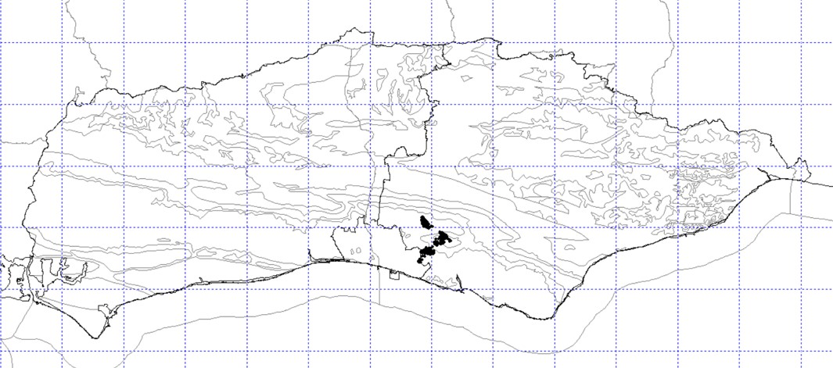
Fig. 2. Location of the site in a recording context.

1.4 – The season
The first half of the survey season of 2024 was incredibly damp, relatively cool and often extremely windy and it was widely reported to have been poor for large invertebrates, especially pollinators. However, this did improve in the latter half of the year and the author mostly experienced 2024 as being an exceptional year for invertebrates in Sussex. The real picture, is therefore more complex than is being stated.

2 – Methodologies
The farm was split into four basic habitats/areas/zones:
- Arable
- Brooks
- Chalk
- Houndean
The fourth area, Houndean (a separate area of land to the west of Lewes but still part of the Estate), was added to the mix in 2024.These areas are all shown in figure 3 below.
Houndean and the Brooks were spatially distinct from the other two habitats, while the Arable and Chalk were mixed together, effectively down to a series of steep sided valleys and hills that have escaped the plough over the years, where they now remain as chalk-grassland. Chalk C, D, E & F are very isolated with limited public access, despite being CROW land. Public access was greater at Houndean than in many areas of the rest of the Estate.
Each of these areas were further split into six recording compartments. On any one day, six hours was spent recording. Houndean and the Brooks were always completed as entire zones but the way the Chalk and the Arable zones were mixed together, meant that sometimes these blocks were mixed up (i.e., four Arable and two Chalk were tackled in one day).
One hour exactly was spent recording in each block. A ‘bioblitz’ approach was used; where all birds, plants, mammals and invertebrates were recorded, where they were field identifiable. Invertebrate specimens were sampled at each site, and stored in alcohol until identification was possible over the winter.
All records were recorded to a generic grid reference at the centre of each recording compartment (a site centroid) or field, within a recording compartment. All records will be passed by the end of March 2024 to the Sussex Biodiversity Records Centre. Any especially rare species recorded, were recorded to a higher resolution using an eight-figure grid reference.
The site was visited on the following twelve occasions in three distinct time periods aimed at maximising the number of species recorded:
Spring  - 25th April 2024  - 29th April 2024  - 4th May 2024  - 9th May 2024 | Mid-summer  - 21st June 2024  - 23rd June 2024  - 24th June 2024  - 27th June 2024 | Late summer/early autumn  - 19th August 2024  - 20th August 2024  - 21st August 2024  - 27th August 2024

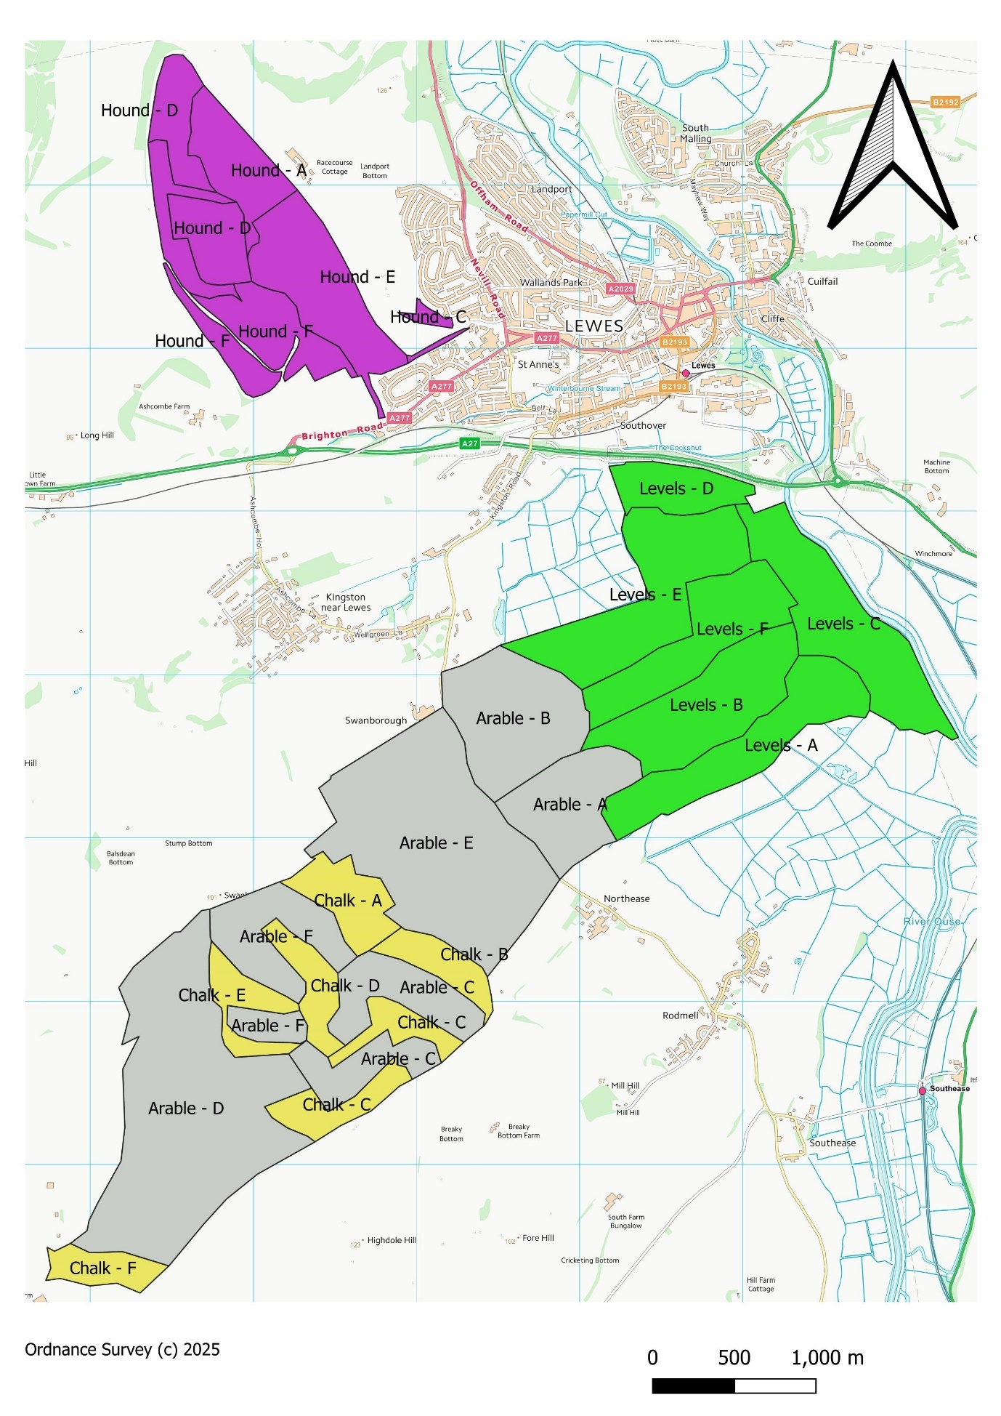
Fig. 3. Location of the 24 recording compartments.

3 – Results
3.1 – Summary of findings
Tab.1. Summary of the findings (with and without Houndean) as compared to the 2021 survey totals. An accumulative total of all survey work carried out is also included here.
Metric | 2021 | 2024 comparable | 2024 inc. Houndean | All years  comparable | All years Houndean
Days in field | 9 | 9 | 12 | 18 | 21
Recording hours | 54 | 54 | 72 | 108 | 126
Records | 5,699 | 7,033 | 9,688 | 12,730 | 15,383
Species | 1,300 | 1,533 | 1,741 | 1,816 | 1,980
Vascular plants | 325 | 332 | 374 | 385 | 416
Bryophytes | 6 | 5 | 12 | 7 | 5
Lichen | 1 | 1 | 1 | 1 | 1
Fungi | 4 | 7 | 13 | 10 | 14
Cyanobacteria | 0 | 0 | 1 | 0 | 1
Birds | 80 | 82 | 84 | 94 | 96
Mammals | 5 | 7 | 7 | 9 | 9
Fish | 3 | 4 | 4 | 4 | 4
Amphibian | 2 | 2 | 2 | 2 | 2
Reptile | 2 | 2 | 2 | 3 | 3
Invertebrate | 866 | 1,096 | 1,241 | 1,301 | 1,422
Inverts with status | 76 | 121 | 136 | 141 | 157
Proportion with status | 8.8% | 11.0% | 11.0% | 10.8% | 11.0%
Beetle | 285 | 379 | 423 | 441 | 478
Bugs | 119 | 176 | 193 | 191 | 206
Spiders | 152 | 153 | 171 | 184 | 197
True flies | 53 | 99 | 122 | 117 | 138
Bees, ants & wasps, etc. | 67 | 68 | 87 | 91 | 105
Moth | 64 | 70 | 86 | 103 | 115
Molluscs | 35 | 38 | 44 | 45 | 51
Butterflies | 29 | 28 | 28 | 33 | 33
Crickets & grasshoppers | 12 | 14 | 14 | 14 | 14
Dragonflies | 14 | 12 | 12 | 14 | 14
Crustacean | 10 | 10 | 10 | 12 | 12
Ticks & mites | 4 | 9 | 10 | 11 | 12
Harvestman | 7 | 9 | 9 | 11 | 11
Caddisfly | 1 | 9 | 5 | 5 | 5
Millipede | 2 | 2 | 5 | 4 | 6
Lacewing | 2 | 4 | 4 | 4 | 4
Leech | 4 | 4 | 4 | 5 | 5
Centipede | 3 | 1 | 3 | 4 | 4
Springtail | 3 | 3 | 3 | 3 | 3
Earwig | 1 | 2 | 2 | 2 | 2
Scorpionfly | 1 | 2 | 2 | 2 | 2
Alderfly | 0 | 1 | 1 | 1 | 1
Cockroach | 1 | 1 | 1 | 1 | 1
Mayfly | 1 | 0 | 0 | 1 | 1
Flatworm | 1 | 1 | 1 | 1 | 1
Pseudoscorpion | 0 | 1 | 1 | 1 | 1
3.2 – Species with conservation status
Conservation status is a complex issue. Each taxonomic group has used a slightly different set of criteria for assessing their species. Within each group, some species are assessed more often or more thoroughly than others. Some are long overdue and as a result there are two systems running at present. Mike Edwards has kindly allowed the author to use this text to explain both systems.
“GB Conservation Status categories are in the process of being upgraded. This means that it is currently necessary to provide values for both systems as not all groups have been dealt with.

The old RDB (Red Data Book) Conservation Status categories were based purely on the number of 10km squares which a species was known to have been recorded from, with a base-line date of 1970. These categories are obviously susceptible to the progressive accumulation of new records over time. This is especially so as, for some species in particular, non-specialist recording has increased significantly. There are also known changes in range and abundance which have been increasingly commented on by specialists.

The old system graded species like this:
RDB 1. Endangered. Species currently (post 1970) known to exist in five or fewer ten-kilometre squares.
RDB 2. Vulnerable. Species in severely declining or vulnerable habitats, or of low known populations. Known to exist (post 1970) in ten, or fewer, ten-kilometre squares.
RDB 3. Rare. Species with small populations, not at present Endangered or Vulnerable, but which are felt to be at risk. Species currently known to exist (post 1970) in fifteen, or fewer, ten-kilometre squares.
RDB K. Species of undoubted RDB rank, but with insufficient information for accurate placement; includes possible recent arrivals.
Nationally Scarce. Species currently (post 1970) known to exist in one hundred, or fewer, ten-kilometre squares.
In some groups these are further sub-divided into:-
Nationally Scarce a. Species currently (post 1970) known to exist in thirty, or fewer, ten-kilometre squares.
Nationally Scarce b. Species currently (post 1970) known to exist in thirty-one to one hundred ten-kilometre squares.

The new IUCN-type Red Data Book Conservation Status categories are based on perceived threat, of which distribution is only one part, the other being related to the population trend over the 10 years previous to the assessment, for the species in question. Such trends may be inferred from accumulated specialist knowledge, but, as the quantity and quality of data improves increasing effort is being made to model such changes. The output of such modelling being then compared with the specialist knowledge. Species with a negative trend may not be inherently rare, it is the decline which is the significant factor.

The new system grades species like this (This is very much a summary, there is considerable detail to this, please consult the group-appropriate published Great Britain Red List for a better understanding of how the gradings have been arrived at):

Regionally Extinct (RE). See group-appropriate Red List for criteria. In general, a sufficiently long time has elapsed since the last record of this species.
Critically Endangered (CR). Species with a very severe decline in population trend or geographic range within the area considered.
Endangered (EN). Species with a severe decline in population trend or geographic range within the area considered.
Vulnerable (VU). Species with a marked decline in trend or geographic range within the area considered.
Near Threatened (NT). Species which are suspected to qualify for Vulnerable, but where the data does no quite support such a category.
Least Concern (LC). Species which show no marked negative population trend or geographic range. Indeed, they may have positive values for either or both.

There will be a number of species where it has been considered that there is insufficient information to provide a supported grading, such species are called Data Deficient (DD). There are also categories for invasive (with anthropogenic agency) species, which are usually assessed as Not Applicable (NA).

The IUCN Red List system was primarily developed for assessing large mammal populations and fish stocks, adapting it for invertebrates is, inevitably, an experimental process and it is to be expected that there will be variability in its application and interpretation between groups. However, each published GB Red List has information on the actual way in which decisions have been arrived at. These should be consulted where necessary.

There is no inherent equivalence between the old and new systems

Great Britain has a considerable environmental gradient from north to south and, to a lesser extent, east to west. Species which are stable in their trend or geographic extent may still be considerably limited by the availability of suitable habitat resources. In order that such species do not get missed from conservation considerations a second, parallel, system of GB scarcity has been developed. This is similar to the old Conservation Status system in that it is based on the number of 10km squares which the species is known from, in a given time period, usually 30 years previous to the date of the assessment.

Categories for this National Scarcity rating are:
NR, with 1-15 10Km occupied squares
NS, with 16 to 100 10Km occupied squares.

Clearly both systems will require periodic revision if they are to remain relevant to the needs of a modern country and the conservation of its fauna.”

Invertebrates


Species accounts
In the following species accounts, this symbol represents a species new to the survey in 2024.

For each invertebrate, the total number of records the author holds for each species is provided to show just how scarce each species is. Here, they vary from 1 (for a species never before recorded by the author) through to 549 for Small Heath (the invertebrate with conservation status that the author records most frequently). This is based on a personal database of 307,984 biological records.

Any conservation statuses now thought to be out of date are provided in brackets.

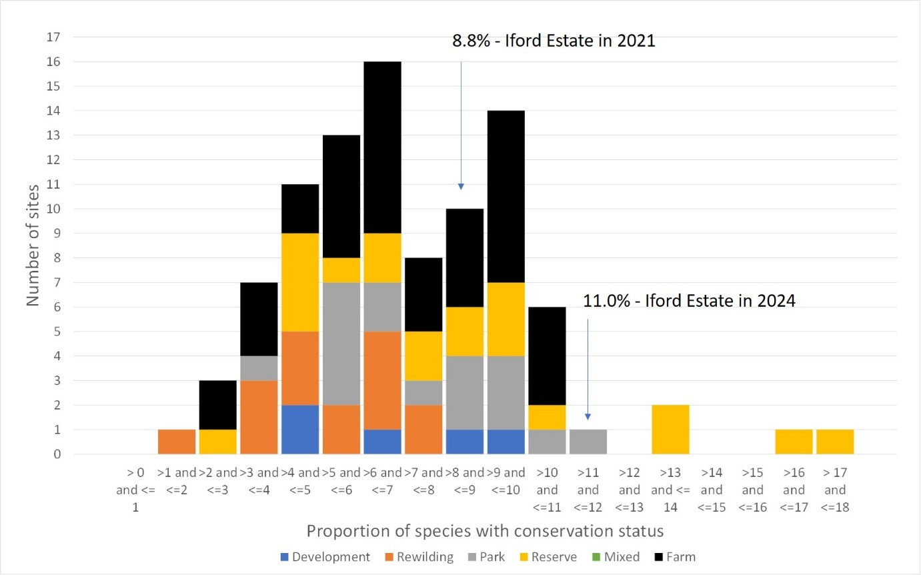
Fig. 4. Frequency distribution of the proportion of invertebrates with conservation status of all the author’s recent surveys, colour-coded by site category (here the Iford Estate is listed as ‘farm’).

The mean proportion of invertebrates with conservation status across all the author’s recent surveys is now 7.0% (it was 6.3% in 2021). Here, the whole Estate comes out at 11.0% (with or without Houndean). This compares to an updated 8.8% from the 2021 survey — both are significantly higher than the author’s rolling average. A second peak has developed since the 2021 survey on this chart around the 9 to 10% mark. The author calls this the “South Downs effect”. It comes from surveying so many farms on the Downs in recent years, which have pushed up the mean. This is because the underlying geology of the chalk is so rare that there is always a large proportion of rare species found on any farm on the Downs.

Araneae (spiders)
Spiders had their conservation statuses updated in 2017 and these are considered fairly up-to-date. The review was perhaps a little over lenient and put several species on the conservation status list that perhaps did not warrant it.

A total of 171 species were recorded across all areas in 2024, including 23 spiders with conservation status. When Houndean was removed from this total, a total of 153 spiders were recorded (just one more than in 2021) and some 20 of these had conservation status. This compares to a total of 152 species of spider recorded in 2021, 16 of which had some form of conservation status. Arable held the most species, with 101 and the Brooks the least, with 65 species.

The Endangered spider Scotina palliardii that was found in the quarry in Chalk A could not be refound in 2024, this does not mean that it wasn’t there however. Spending significant amounts of time searching for one species would violate the methodology and mean that compartment Chalk B would have had far fewer species in if this had been attempted.

Agyneta mollis – (Nationally Rare, Near Threatened & Section 41) – Author’s records = 265
This spider used to be called Meioneta mollis. It no longer warrants the status it has, being a very common spider in Sussex when using a suction sampler. It is a tiny money spider associated with open habitats of almost any kind, from top quality chalk-grassland to a football pitch in the middle of Brighton. In 2024 it was recorded in Arable D and Houndean A, while in 2021 it was recorded just once in Chalk C. It is the spider with conservation status that the author records most frequently.

Agyneta simplicitarsis – Nationally Scarce – Author’s records = 140
This small, nondescript money spider is pretty much restricted to chalk-grassland, where it is usually fairly common. In 2021, it was recorded in Arable D and Chalk C and E. In 2024 it was found in four of the Chalk compartments and Houndean C.

Alopecosa cuneata – (Nationally Scarce) – Author’s records = 126
A striking wolf spider, most commonly found on (but not restricted to) chalk-grassland. This spider is most likely going to lose its status in the next review due to being found increasingly on the Downs by the author and other recorders. In 2021, it was found in two Arable compartments and four Chalk compartments. By 2024, this had fallen to one Arable and three Chalk and there was a strong overlap between years.

Argenna subnigra – Nationally Scarce – Author’s records = 102
This tiny spider that prefers warm, open habitats was recorded in two Chalk compartments in both years only (albeit there was no overlap between the compartments). This suggests that either the species occur at low densities or that detectability is low.

Atypus affinis (Purse-web Spider) – Nationally Scarce – Author’s records = 10
A single wandering male was spotted at High Down (Chalk F) by Wes Udall during a habitat management visit. This is a scarce species in the county and is very hard to detect, spending much of its life underground in its unusual sock-like web. Being a close relative of tarantulas, this spider is well-known in the UK. It is known from the hectad.
Fig.5. The male Purse-web Spider.

Cheiracanthium virescens – Nationally Scarce – Author’s records = 39
This spider is typically found on chalk-grassland and heathland and is quite scarce in East Sussex. It was recorded in two compartments in the Chalk area in both years, suggesting a low population density or low detectability.
Coelotes terrestris – Nationally Scarce – Author’s records = 67
This woodland spider can be quite common under logs and stones, even in very dull and shady secondary woodland. It was recorded new to the survey at Houndean only, unsurprisingly in the wood. It is only scarce due to being regionally restricted to the south east.
Cryptachaea riparia – Nationally Scarce – Author’s records = 29
This spider was once restricted to heathlands and river corridors but in recent years it is being commonly found in arable sites. It was not recorded in 2024 but here it was recorded in Chalk F (High Down) and Houndean A. The Houndean record representing a new hectad record.
Drassodes pubescens – Nationally Scarce – Author’s records = 15
New to the site and new to the hectad, a local ground-dwelling spider. It was recorded here in Arable B only. It looks like a generic Clubiona in the field and is typically only noticed when sorting through specimens.

Enoplognatha mordax – Nationally Scarce – Author’s records = 120
This is an unusual occurrence. In 2018, the author started to notice a spider that looked very like Enoplognatha mordax start to appear in atypical habitats. The true E. mordax is a strict saltmarsh species (in Sussex only known from East Head and Rye Harbour) while these were turning up in wet grassland inland and then by 2020, it was appearing in rank arable vegetation. Specimens were sent to the Natural History Museum for DNA analysis but were found to simply be Enoplognatha mordax, although the author believes it may still prove to be a new species, as to demonstrate such a rapid range expansion into different habitat and different structural vegetation type, is extremely unusual after over a hundred years. Given the proximity to the Continent, it could be that a cryptic species has colonised the UK from the south.

An adult male was swept from high up in rank vegetation on the edge of an arable field in Arable D & E and in Brooks B in 2021 but by 2024 it was found in all four areas, with two in Arable, all six Brooks compartments, one Chalk and two Houndean (11 compartments in all – an incredible expansion).
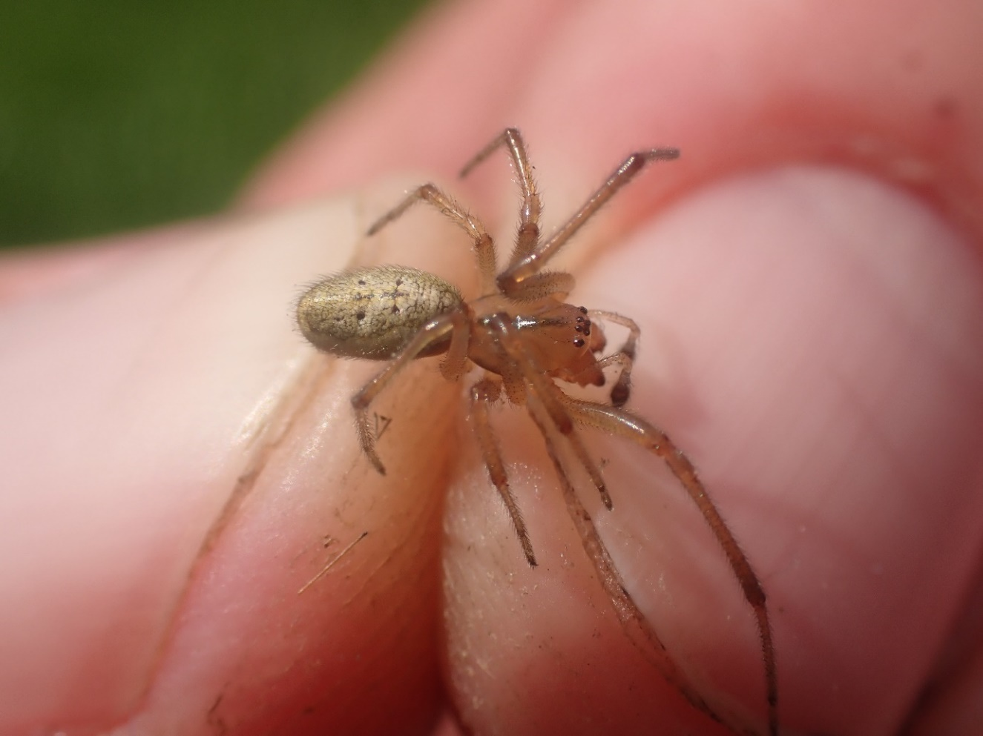
Fig. 6. An adult male Enoplognatha mordax.
Entelecara flavipes – Nationally Scarce – Author’s records = 31
Recorded new to the survey as a single female in Chalk F (High Down). This is a scarce money spider that is almost entirely restricted to chalk-grassland. It is known from the hectad.

Episinus maculipes – Nationally Scarce – Author’s records = 98
A single adult male was swept from Chalk A in September in 2021, where it was also found in 2024. This species is unusual in that it has spread rapidly in the last decade into Sussex, where it is usually found in deep shade. However, in late summer it seems that males do sometimes turn up in open chalk-grassland, as was seen here. The rate at which this species is spreading and the abundance of habitat available to this species, suggests it will not stay nationally scarce for long. In 2024 it was also recorded in Arable E.
Erigone dentosa – Non-native and new to East Sussex – Author’s records = 2
Recorded new to East Sussex from Arable C, only around two months after the author recorded this spider new to Sussex from Climping Dunes in West Sussex. A North American money spider that is likely to spread quickly now it has become established.
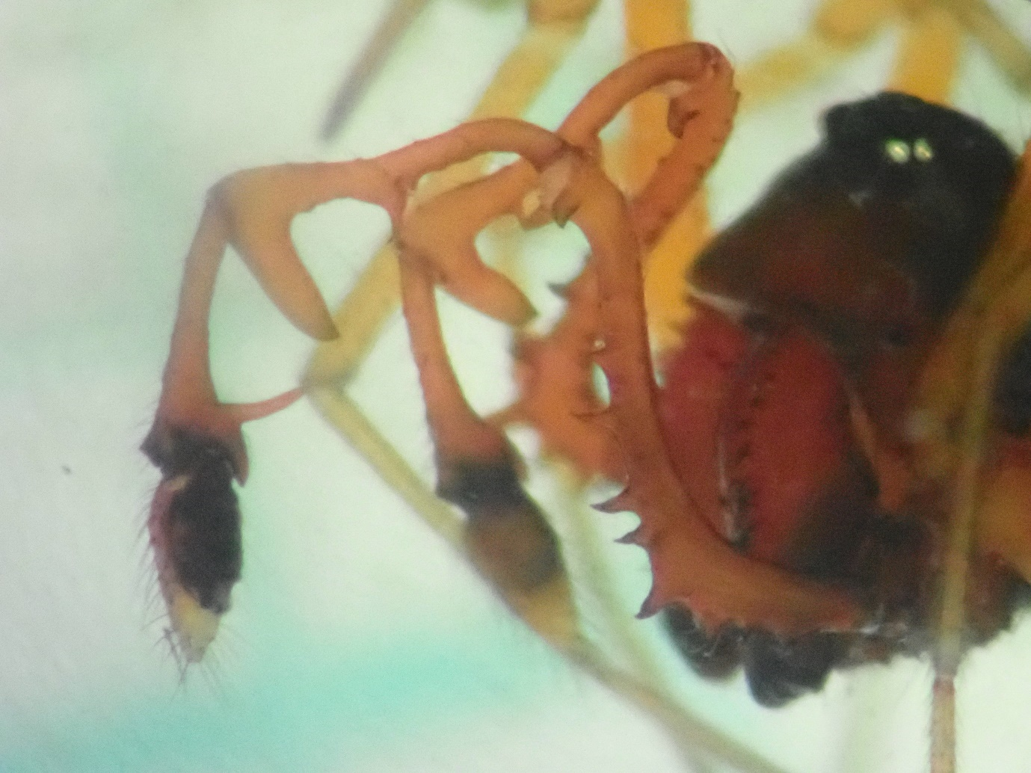
Fig. 7. A particularly well-endowed male Erigone dentosa up close under the microscope.

Ero aphana – (Nationally Scarce) – Author’s records = 51
Found in an ancient farm building around the farm yard in Arable A in both 2021 and 2024 (it was also recorded in Arable B in 2024). This species is rapidly spreading in the UK and will soon no longer warrant the status it has. It is a generalist that seems to do especially well around buildings.

Hypomma fulvum – Nationally Scarce – Author’s records = 16
A money spider that indicates good quality wetland habitats. A genuinely scarce species. It was recorded in B & F in 2021 but it was only noted in B in 2024.

Hypsosinga albovittata – Nationally Scarce – Author’s records = 163
This species requires short, low-nutrient swards, most commonly on the chalk but it will also use acid grassland and occasionally bogs. It was recorded in three Chalk compartments in 2021, rising to four in 2024.

Monocephalus castaneipes – Nationally Scarce & Section 41 – Author’s records = 12
Recorded once from Houndean B, where it was new to the survey and new to the hectad. The spider is perhaps not as scarce as the status suggests (it is much commoner in the west though) an is still fairly uncommon in Sussex. It is a tiny money spider, typical of woodlands.

Nigma puella – Nationally Scarce – Author’s records = 66
Found from Brooks B only where it was beaten from scrub in 2021, but by 2024 it was found in one compartment each in Arable, Chalk and Houndean. This small but attractive spider is almost always beaten from the lower branches of trees and shrubs, more often on hedgerows than it is in woodland. It is much commoner in East Sussex than West.

Pardosa tenuipes – Nationally Scarce – Author’s records = 106
A fairly generalist wolf spider that was collected in Arable C in 2021, but in 2024 it was recorded in four Brooks compartments and Houndean D. The species seems to simply need bare and open ground but with short turf, with few other habitat requirements beyond that. The author finds this species difficult to find except in bulk samples with lots of other wolf spiders, where it is not uncommon.
Phycosoma inornatum – Nationally Scarce – Author’s records = 13
New to the survey and new to the hectad. It was found in the Ivy wall of the ancient barn in in Compartment A by the office. Given how many scarce species are found here, any changes or development should be considered carefully and the Ivy should be left untouched.
Sibianor aurocinctus – Nationally Scarce – Author’s records = 227
This small black jumping spider is not that scarce on warm, broken turf so it is surprising that it has only been recorded once from Houndean D.

Styloctetor compar – (Nationally Scarce) – Author’s records = 105
A fairly common plump money spider that does not warrant the status it has. It was recorded in Chalk B through to E and Brooks A in 2021, falling to just two Chalk compartments in 2024. it simply requires grasslands of no particular type or quality.

Thanatus striatus – (Nationally Scarce) – Author’s records = 71
Recorded new to the survey from Arable D only in 2024. This spider can be fairly common on sites with plenty of litter.
Theridion familiare – Nationally Scarce – Author’s records = 2
A scarce species, this being only the second time the author has recorded it. A female was found in the ancient barn by the office, this being the first East Sussex record since 1993. This is also a new hectad record.

Hymenoptera (bees, ants & wasps, etc.)
A total of 87 species were recorded in 2024 (including Houndean), with 15 of these having some form of conservation status. Removing Houndean makes a comparable statistic with the 2021 survey, this results in 68 species being recorded in 2024, with 11 of these having conservation status. In 2021, 67 species were recorded, with 11 of these having status — the two years then being remarkably similar for bees, ants and wasps.

In 2024, the most species were in Houndean (60), followed by Arable 43 (down from 44 in 2021) , then Chalk 40 (down from 42 in 2021) while only 21 (up from 18 in 2021) species were recorded on the Brooks and this is no doubt down to the lack of forage there. The number of bees, ants and wasps at Houndean being so much higher than all the other zones is a reflection of how much forage there is there. The site is also very sheltered and there is plenty of nesting habitat.

Andrena minutuloides – Nationally scarce a – Author’s records = 41
A single female was recorded on Arable E on the warm sunny margin in 2021, while in 2024 it was recorded once from Houndean A only. It is a fairly widespread species on the Downs but is still scarce nationally.
Andrena niveata – RDB2 – Author’s records = 29
A rare species of bee that is spreading in Sussex, where it can be common on crucifer-rich arable margins on the Downs. Here it was recorded new to the survey in three zones; Arable C, Chalk D and Houndean A.

Bombus humilis (Brown-banded Carder Bee) – Section 41 – Author’s records = 87
In 2021, this bee was recorded at Chalk A, C, D & F but by 2024 it was recorded in 10 different compartments across three different zones; four Arable compartments, three Chalk compartments and three Houndean compartments. This species is scarce but is still widespread on the Downs in Sussex, especially close to the sea. It needs warm, legume-rich grasslands. It was particularly well represented on this Estate
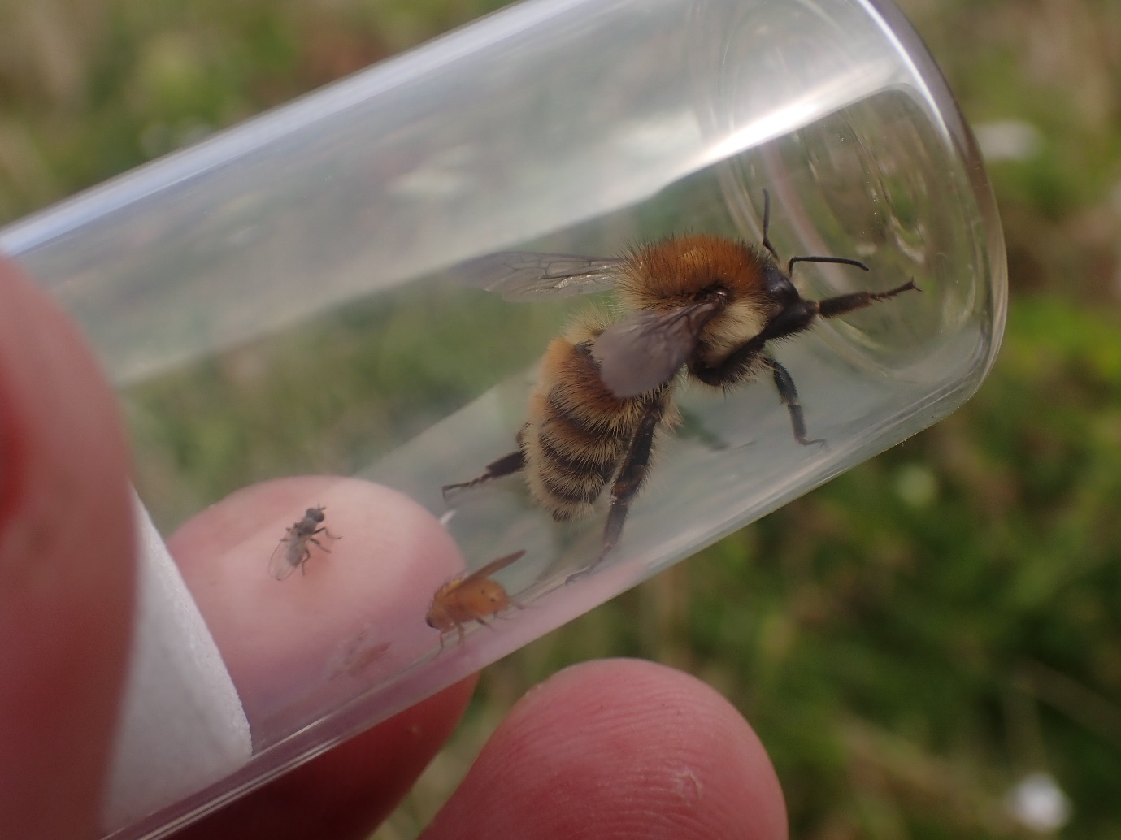
Fig. 8. Bombus humilis in the clover-rich area of Houndean A

Bombus ruderatus – Nationally Scarce & Section 41 – Author’s records = 7
A scarce bumblebee, it was recorded as a single male in Houndean A only.

Bombus rupestris – Nationally scarce b – Author’s records = 26
Although no longer scarce, this species was recorded only once in Chalk D in 2021, but in 2024 it was recorded in Brooks A and Chalk C. It is the cuckoo bee of the well-known Bombus lapidarius.
Dolichovespula media – (Nationally scarce a) – Author’s records = 22
This large wasp is now much commoner and no longer warrants the status it has. It was recorded just once from Houndean C, where it was new to the survey.

Halictus eurygnathus – RDB1, Endangered – Author’s records = 16
A species thought to be extinct until around ten years ago when it was found to be present in this specific area of the South Downs. The author has seen it at Seaford Head, the Brighton Downland Estate and the Lewes Downs but this is pretty much its entire UK distribution.

In 2024, this rare bee was recorded in four compartments in three zones; Arable E, Chalk A & D, and a single male was found at Houndean A. This compares to just a single female that was recorded in Arable E on the 14th June 2021 in a rich arable margin with a strong southerly aspect.
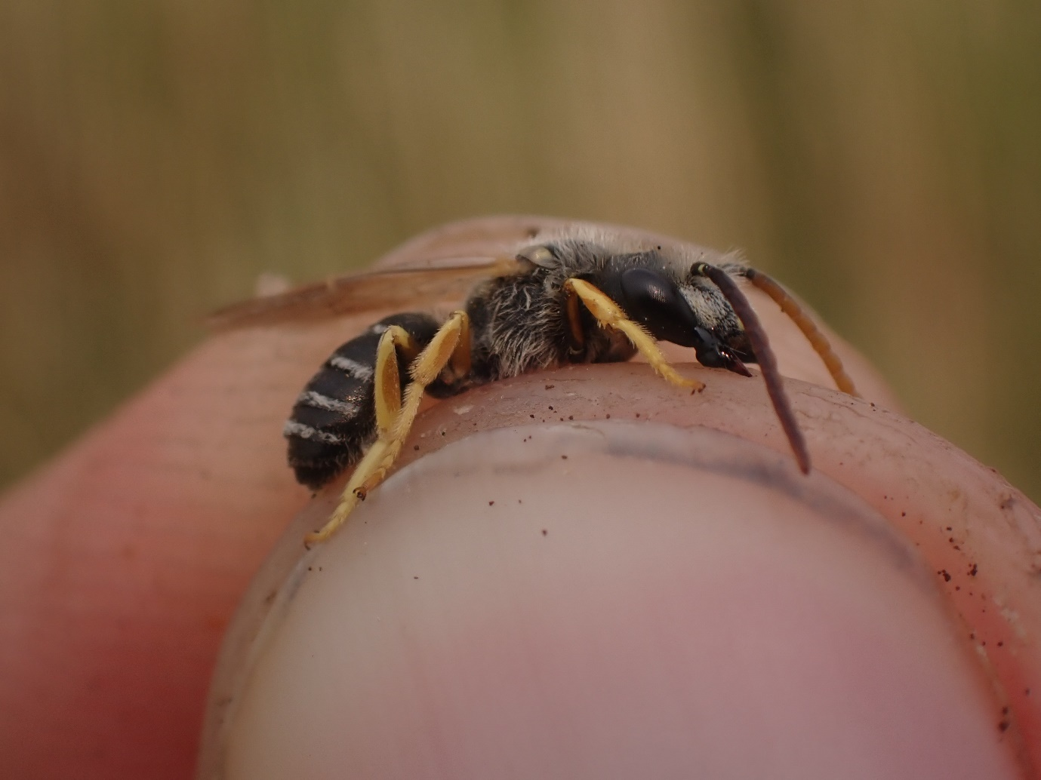
Fig.9. A male Halictus eurygnathus in Chalk D (Home Bottom).

Lasioglossum malachurum – (Nationally scarce b) – Author’s records = 112
Another now widespread and common be that is more typical of clay soils than it is the chalk. No longer warrants the status it has. In 2021, it was recorded in four compartments over all three zones and by 2024 it was recorded in nine compartments over all four zones.

Lasioglossum pauxillum – (Nationally scarce a) – Author’s records = 239
A now extremely common bee that is likely to be widespread across all parts of the site. It certainly does not warrant the status it has, typically being one of the commonest species in the genus in the region. It was found in five compartments in 2021 (but not recorded in the Brooks), while in 2024 it was recorded in 10 compartments across three zones (but again, it was not recorded on the Brooks).

Lasioglossum pauperatum – (RDB3) – Author’s records = 23
Another small black bee that is perhaps closer to Nationally Scarce than RDB. It was recorded new to the survey in 2024 from Chalk E.

Melitta tricincta (Red Bartsia Bee) – (Nationally scarce b) – Author’s records = 38
This bee is now much commoner than the status would suggest, the bee only takes pollen from Red Bartsia, and it can be quite common where the foodplant occurs. It was recorded only at Houndean A.

Nomada fucata – (Nationally scarce a) – Author’s records = 38
This cuckoo bee is a parasite of the very common mining bee, Andrena flavipes. Although listed as Na, this species is now fairly common in the region and no longer warrants the status it has. It was recorded in Chalk E in 2021 and in Chalk D and Houndean D in 2024.
Osmia bicolor – Nationally scarce b – Author’s records = 39
This bee is a well-known chalk-grassland specialist that nests in snail shells. It was recorded new to the survey in 2024, where it was actually recorded on Arable D (on the area of rough grassland to the extreme west of the Estate next Balsdean).
Sphecodes crassus – (Nationally scarce b) – Author’s records = 16
Recorded new to the site in 2024, in Chalk A and E. A cuckoo bee, the host being various species of Lasioglossum. It no longer warrants the status it has.
Stelis breviuscula – RDBK – Author’s records = 4
This parasitic bee was recorded new to the survey at Houndean A. The host bee is Heriades truncorum (which was not recorded). It is perhaps closer to Nationally Scarce than RDB but is very much restricted to the south east.

Coleoptera (beetles)
By far the most speciose group of the survey (more beetles were recorded in 2024 than vascular plants). A total of 423 species of beetle were recorded, more than 10% of the UK fauna. Of these an incredible 61 species had conservation status. Removing Houndean from this results in a comparable figure of 379 species, 55 of which have status. Still a huge leap from the 2021 figures of 285 species, with just 22 with status. This huge leap is hard to explain.

Arable held the most species with 210 (up from 153 in 2021) while strangely, Chalk again held the least species with 173 (up from 118 in 2021). Houndean was a close second to the Arable, with 206 species noted.

Acupalpus exiguus – Nationally Scarce – Author’s records = 111
This small black ground beetle is typically found in flood plain grassland, where it was common in 2024 on the Brooks (recorded in four compartments) while it was not recorded at all in 2021. The reasons for this are not clear but a range expansions seems unlikely.

Agelastica alni (Alder Leaf Beetle) – (Nationally Rare & Data Deficient) – Author’s records = 144
The author recorded this beetle as new to Sussex at Burton Pond only as recently as 2014, it has since become ubiquitous in West Sussex (although it is taking a little longer to colonise East Sussex, it was not recorded in 2021). It was recorded in Arable B and Houndean E.
Amara montivaga – Nationally Scarce – Author’s records = 10
A single animal was recorded at Houndean in compartment D, where it was new to the survey. A sturdy carabid typically found on open places (like arable margins) on the Downs.

Anotylus insecatus – Nationally Scarce – Author’s records = 3
A single animal was recorded in Arable F in 2021, and single animal in Arable D in 2024. This tiny rove beetle is fairly scarce in Sussex (the author has not recorded it between these two records anywhere else) but there are a small cluster of records in the specific area immediately around the Iford Estate.

Aphanisticus pusillus – Nationally Scarce – Author’s records = 61
A very small jewel beetle that feeds on sedges and rushes. Almost only ever found with suction sampler, as it is ground dwelling. It was widespread on the chalk-grassland being found in Chalk A, B, C & E in 2021 and in 2024 it was found in all Chalk compartments, except B (showing it has been recorded in all six compartments in the last five years).
Astrapaeus ulmi – Nationally Rare & Data Deficient – Author’s records = 4
A large and string black and red rover beetle. Recorded new to the survey, where it was found once in Chalk C. A scarce recent colonist. All of the author’s four records come from the Down between Brighton, Lewes and Seaford, and all were found on chalk-grassland.
Bagous lutulentus – Nationally scarce b – Author’s records = 1
A single animal was vac-sampled from a ditch margin in Brooks F. This is the first time the author has encountered this weevil, that feeds only on Water Horsetail.

Brachinus crepitans (Bombardier Beetle) – Nationally Scarce – Author’s records = 32
A striking red and black carabid that is well known for being able to make a small explosion when threatened. On the arable parts of Iford it was common, chiefly under large flint nodules on exposed chalk-grassland. It was recorded in Arable B, C, D & F in 2021 but it was only noted in two of the Arable compartments in 2024.
Calosirus terminatus – Nationally scarce b – Author’s records = 10
Recorded new to the survey in 2024, where single animals were found in both Arable D and Chalk D. This scarce weevil feeds only on Wild Carrot.

Cassida denticollis – Nationally Rare & Endangered – Author’s records = 5
A very rare tortoise beetle, it was recorded twice on the Estate in Chalk A and in Chalk E and is new to the survey. This beetle feeds only on Yarrow and can look superficially like a large version of Cassida prasina below, (which also feeds on Yarrow).
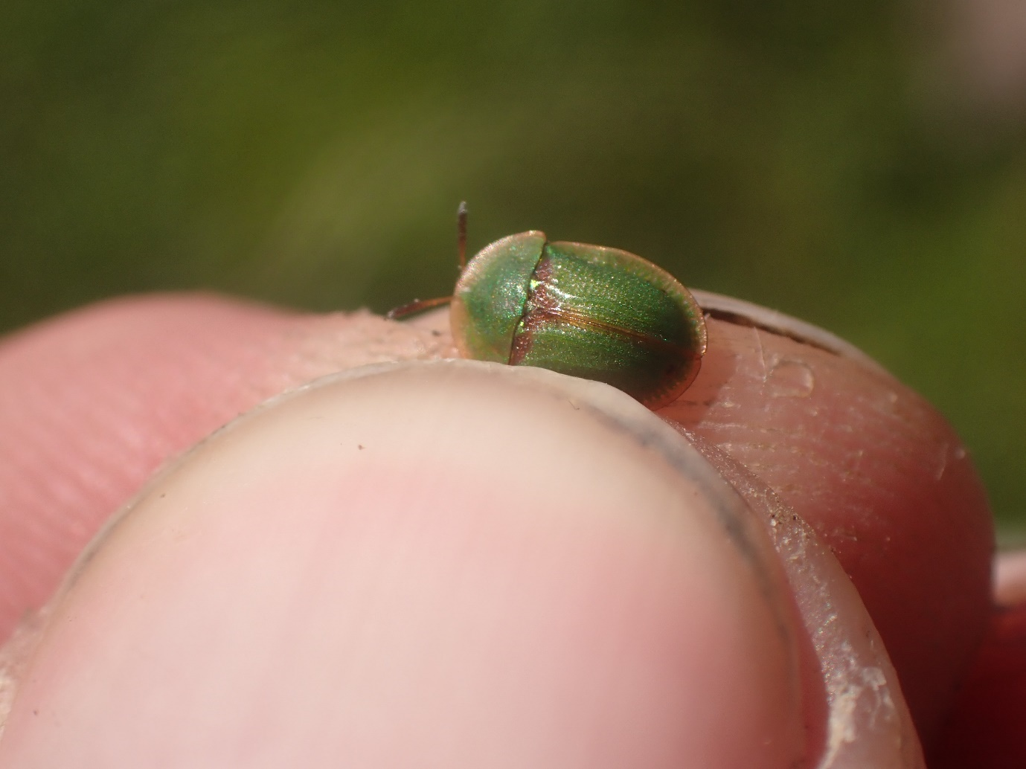
Fig.10. Cassida denticollis.

Cassida nobilis – Nationally Scarce – Author’s records = 42
A striking tortoise beetle with two metallic stripes along the elytra. It is usually found in association with goosefoot and oraches near the coast. In 2021, it was recorded in Chalk D and E only. By 2024 it had been found in seven compartments, four Arable, two Chalk and in one location at Houndean.
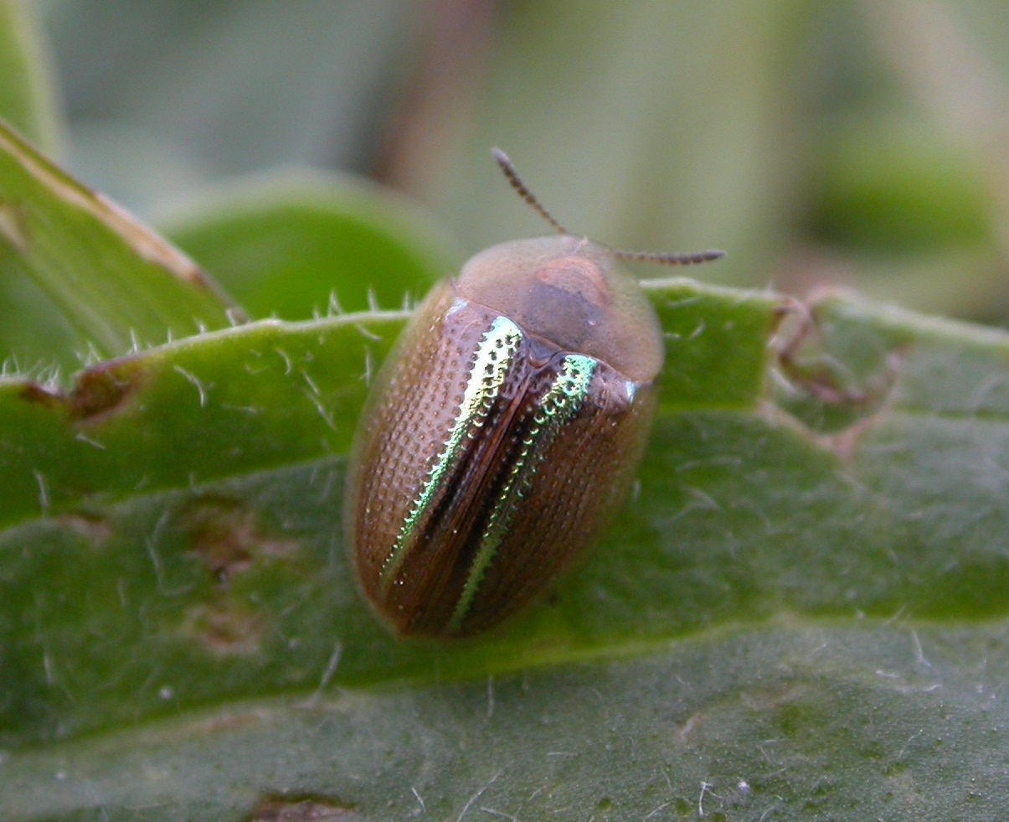
Fig.11. The striking Cassida nobilis.
Cassida prasina – Nationally Scarce – Author’s records = 29
Not recorded at all in 2021 but by 2024 it was found in four of the six Chalk compartments. A local species that feeds only on Yarrow.

Cathormiocerus spinosus – Nationally scarce a – Author’s records = 49
A tiny hedgehog weevil that is usually found by suction sample on chalk-grassland. Here it was recorded in Chalk-grassland A and E in 2021 and then on Chalk E & F in 2024. A flightless species that feeds at the roots of a variety of plant species.

Cryptocephalus bilineatus – Nationally Scarce – Author’s records = 141
A fairly widespread chalk-grassland species on legumes. A tiny black and yellow striped leaf beetle. It was unusually scarce during the 2021 survey, only recorded in Chalk-grassland F, the isolated ungrazed compartment while in 2024 it was recorded in four of the Chalk compartments (none of which were F this time).
Dasytes plumbeus – Nationally Scarce – Author’s records = 35
Not recorded at all in 2021 but recorded in nine compartments across all four zones in 2024. A deadwood species that is commonest in Sussex on the Downs. The fact it wasn’t recorded at all in 2021 is odd, it suggests that three visits might sometimes entirely miss very seasonal species like this one.

Glocianus punctiger – Nationally scarce b) – Author’s records = 31
This species is no longer scarce, it feed on Dandelion which is hardly a scarce species. It was recorded only once in Chalk A in 2021 but in 2024 it was found in one Chalk compartment and one Houndean compartment.
Gymnetron veronicae – Nationally scarce b – Author’s records = 3
A single animal was recorded when sampling the Pink Water-speedwell in Brooks E along with the following species. This species typically feeds on Brooklime.
Gymnetron villosulum – Nationally scarce b – Author’s records = 4
Recorded in numbers from Brooks E, where Pink Water-speedwell was extremely abundant. This wetland weevil specialises in waterside speedwells, especially the two water-speedwells.
Hippodamia variegata (Adonis Ladybird) – (Nationally scarce b) – Author’s records = 93
This ladybird is typically found associated with mayweeds and is no longer as scarce as the status suggests, it is surprising that it was not recorded in 2021. In 2024, it was noted in one Arable plot and one Houndean plot.

Hydrophilus piceus (Great Silver Diving Beetle) – Nationally Scarce & Near Threatened – Author’s records = 13
This huge beetle is well known due its size and (once) rarity. It is now much commoner than it was. It was recorded on Brooks C & D only in 2021 and as a larva in 2024 in Brooks F.
Hypera meles – (Nationally scarce b) – Author’s records = 40
This weevil no longer warrants the status it has; it is fairly common feeding on clovers. It was recorded new to the survey at Chalk F.

Isochnus sequensi – RDBK – Author’s records = 2
A scarce flea weevil that feeds on willows. It was recorded new to the survey in Arable B, and is the first record the author has made of this beetle in 12 years, as well as being their only Sussex record.

Lagria atripes – Regionally Extinct – Author’s records = 9
A single animal was beaten from a hedge in Arable B and is new to the survey. Until around five years ago, this species was thought to be extinct in the UK but it has made a come-back recently, reaching into East Sussex from Kent.
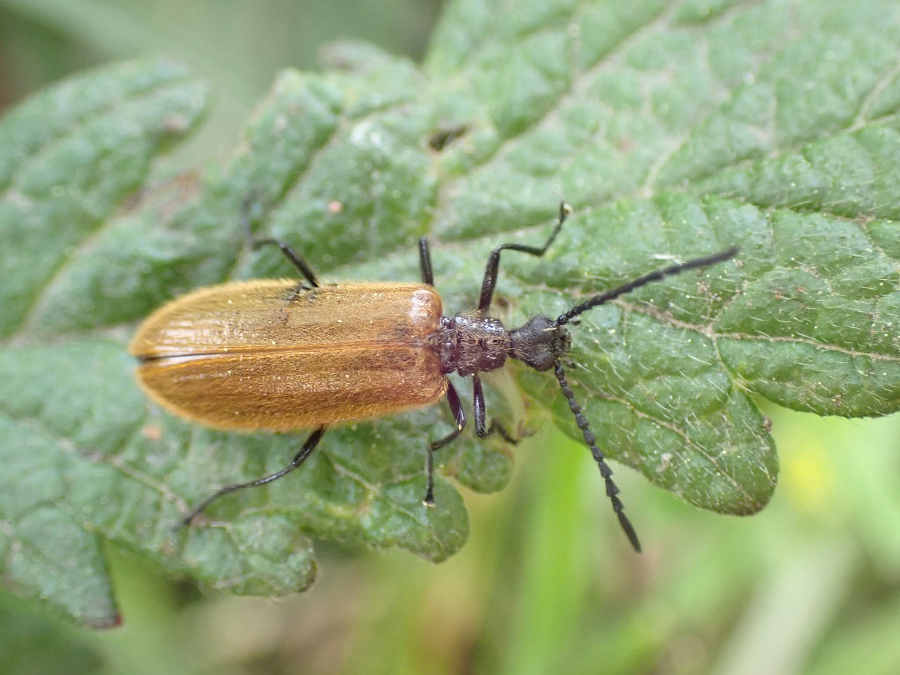
Fig.12. Lagria atripes taken at Blean in Kent.
Larinus carlinae – (Nationally scarce b) – Author’s records = 45
Recorded new to the survey in 2024, where it was found in Brooks B to D. This weevil feeds on thistles and no longer warrants the status it has.

Limnoxenus niger – Nationally Scarce & Near Threatened – Author’s records = 30
Another scarce species that is actually fairly widespread in the south east. A water beetle, typical of the east Sussex brooks and levels. It was recorded in Brooks C, D and F but is likely to be even more widespread across the Brooks here. Indeed, by 2024 it was noted in all the Brooks compartments except E.
Lissodema denticollis – Nationally Scarce – Author’s records = 5
A scarce saproxylic beetle, that is especially associated with decaying Ash. It was recorded once in Houndean B, where it was new to the survey.

Longitarsus obliteratus – Nationally Scarce – Author’s records = 4
A tiny, all-black flea beetle associated with chalk-grassland, where it feeds on labiates such as Wild Thyme, Wild Basil and Wild Marjoram. It was new to the survey here in Chalk E only.

Melanobaris laticollis – Nationally scarce a – Author’s records = 14
This scarce weevil feeds only on Hedge Mustard. It is not clear why a weevil with such a common food plant should be so scarce. By the end of the 2021 survey, it was found in six different sites. Arable A, B, D & F and Chalk C & D. In the 2024 survey, it was noted only in Arable F and Chalk D.
Mordellestina parvula – Nationally Scarce – Author’s records = 18
Recorded new to the survey in Chalk E. A scarce/local species of tumbling flower beetle, that is associated with flower-rich sites.

Nephus quadrimaculatus – (RDB2) – Author’s records = 12
Recorded in both years, only from the ancient barn by the office in Arable A. A tiny, four-spotted ladybird that has spread in recent years and longer warrants the status it has.
Orchesia micans – Nationally Scarce – Author’s records = 4
A narrow saproxylic beetle, beaten from dead Sycamore branches in the woodland of Arable E, where it was new to the survey.
Panageus bipustulatus – Nationally Scarce – Author’s records = 6
Recorded new to the survey in Houndean C. A striking black and red ground beetle, typically found on low-nutrient sites.
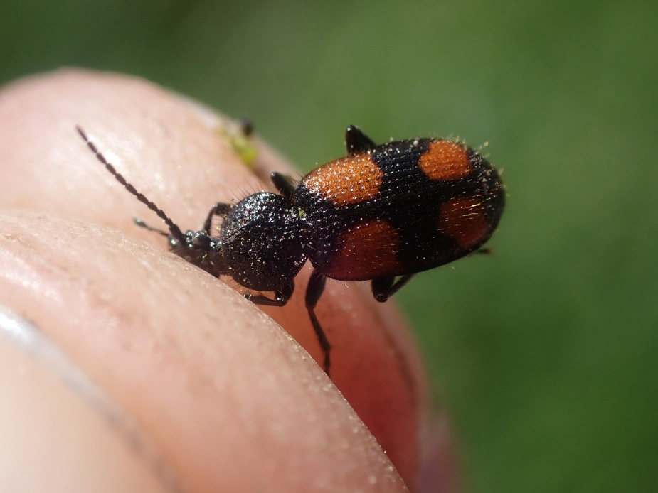
Fig.13. Panageus bipustulatus.

Paracymus scutellaris – Nationally Scarce – Author’s records = 3
This scarce water beetle is usually associated with acid pools and Sphagnum but does occasionally occur in other wetlands, here it was recorded in Brooks D. The only other records the author has for this species are from the Ashdown Forest.

Pedius longicollis – Nationally Scarce – Author’s records = 2
Recorded new to the survey from Brooks A. A scarce carabid associated with floodplain grassland.

Peltodytes caesus – Nationally Scarce – Author’s records = 31
A fairly widespread water beetle on Sussex brooks and levels. It was recorded in four compartments on the Brooks in 2021, falling to three in 2024.

Perapion affine – Nationally scarce a – Author’s records = 4
A scarce weevil that feeds on Common Sorrel and is usually found on chalk-grassland, here it was new to the survey in Arable E.

Phalacrus championi – Nationally scarce a – Author’s records = 14
Recorded in 2021 in Arable C and in 2024 in Arable D only. A tiny black beetle associated with smutted grasses.
Platynaspis luteorubra – Nationally scarce a – Author’s records = 46
A small myrmecophile ladybird, usually associated with Lasius niger ants. It was recorded new to the survey in 2024, being found on Chalk F (High Down) and Houndean A & F.

Podagrica fuscicornis – (Nationally Scarce) - Author’s records = 38
Along with the following species, this is now a fairly common flea beetle that feeds on mallows, it is surprising it was not recorded in 2021. It was recorded in three zones in 2024 and was most common in the Arable zone.

Podagrica fuscipes – (Nationally Scarce) – Author’s records = 30
This flea beetle feeds on mallows and as a result is not that scarce, it being a common plant. It does not warrant the status it has. Here recorded on Arable C and F in 2021, while it was recorded in Arable C through to F in 2024 (as well as being recorded in once compartment each in the Brooks and Houndean).

Protapion difforme – Nationally scarce b – Author’s records = 189
Found on Brooks B & F only in 2021 but only in Chalk F (High Down) in 2024. This small but distinctive weevil is common in the region but is scarcer nationally. It feeds on clovers.
Protapion filirostre – Nationally scarce b – Author’s records = 9
A scarce weevil that feeds on Black Medick, meaning it is commonest on the Downs and on arable margins where the food plants grows. It was recorded once in Houndean D, where a great deal of the foodplant was growing.
Protapion varipes – Nationally scarce b – Author’s records = 23
A scarce weevil in Sussex that for some reason is restricted to East Sussex and mostly the Weald. It was new to the survey in 2024, where it was found just once in Chalk D.
Pseudorchestes pratensis – Nationally scarce b – Author’s records = 25
A small, grey flea weevil that feeds on Knapweeds. It was new to the survey in 2024, where it was recorded in Chalk C & F.

Rhagonycha lutea – Nationally Scarce – Author’s records = 51
A small, arboreal soldier beetle that was recorded new to the Estate in 2024. It was recorded only at Houndean, where it was noted in C and F.
Rhantus frontalis – Nationally Scarce – Author’s records = 10
Recorded new to the survey in Brooks C. Not that scarce a water beetle in the south east on nice grazing marshes.

Rhinocyllus conicus – (Nationally scarce a) – Author’s records = 77
Recorded on Brooks A only in 2021, and Arable E only in 2024. This weevil feeds on thistles; therefore, it’s not as scarce as its status would suggest and will almost certainly lose it in the review.
Scirtes orbicularis – Nationally Scarce – Author’s records = 1
Recorded new to the survey, this being the first record the author has made of this species (which seems to be restricted to the best wetlands). A single animal was recorded in Brooks E.

Scymnus schmidti – Nationally scarce b – Author’s records = 92
A small, black, nondescript ladybird that was recorded in every chalk-grassland compartment except E in 2021 and in 2024 it was recorded in four Chalk compartments, two Arable ones and Houndean A. It is usually fairly common on chalk-grassland but rarely away from it.

Sirocalodes quercicola – Nationally scarce a – Author’s records = 4
A single animal was vacuumed from Arable F, where it was new to the Estate. This is a very scarce species that feeds on fumitories.
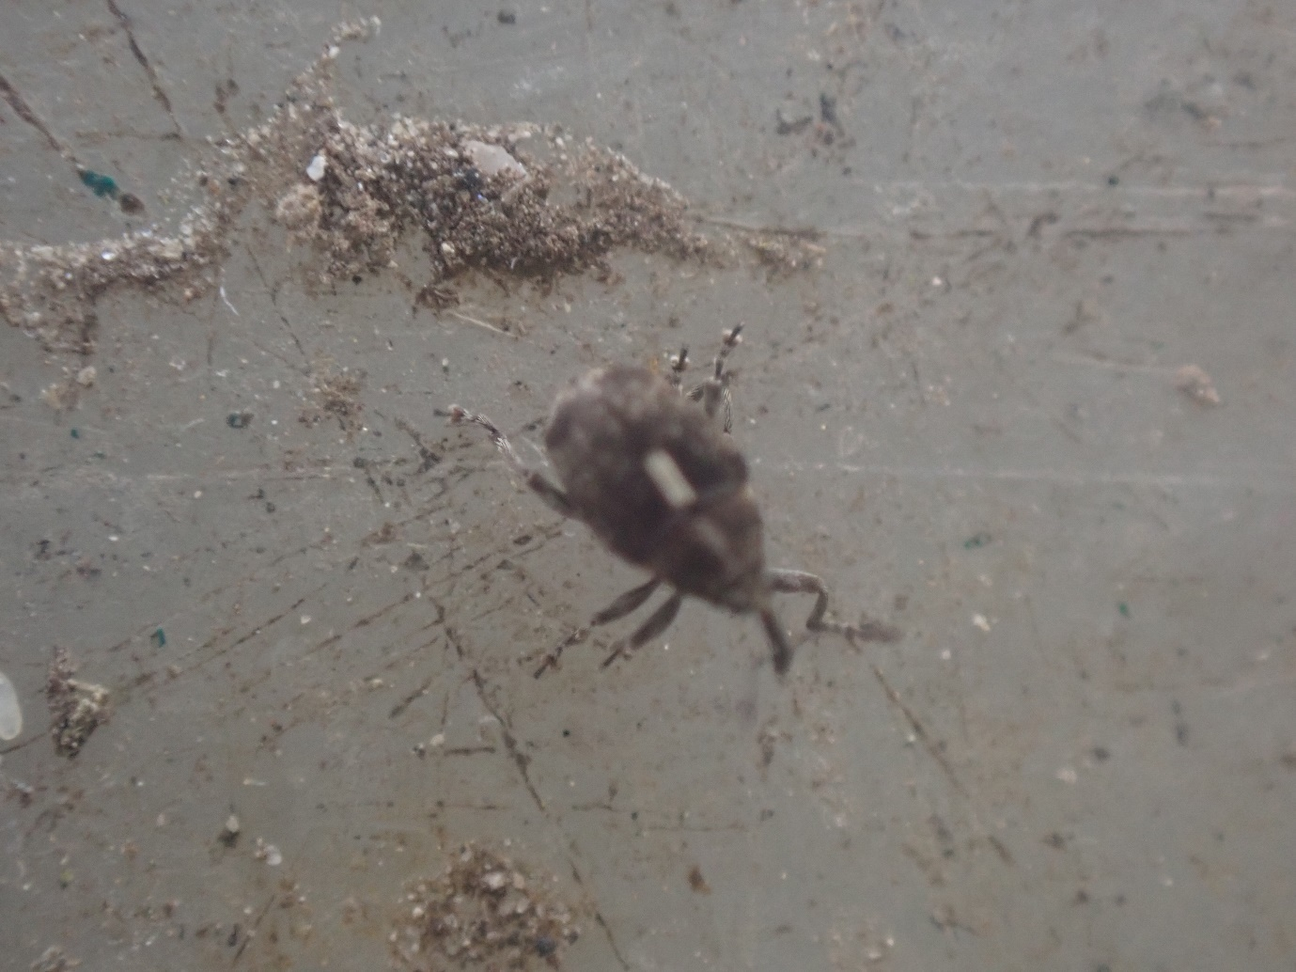
Fig.14. A terrible photo of the scarce Sirocalodes quercicola.

Sitona waterhousei – Nationally scarce b – Author’s records = 35
A scarce species of weevil that feeds on Common Bird’s-foot-trefoil. It was new to the survey in 2024, where it was found in Chalk A only.
Squamapion cineraceum – Nationally scarce a – Author’s records = 29
A tiny apionid weevil that feeds only on Selfheal. It was recorded new to the survey in Chalk C & D
Stenocarus ruficornis – Nationally scarce b – Author’s records = 79
A scarce weevil that feeds on poppies, it is commonest on arable margins on the Downs where it can be quite common — it is surprising that it wasn’t recorded it 2021. By 2024, it was found in seven compartments (two Arable, three Chalk and two at Houndean).
Stenus canescens – Nationally scarce b – Author’s records = 2
A scarce wetland rove beetle, it was recorded new to the survey in Brooks D.

Strophosoma faber – Nationally scarce b – Author’s records = 52
Recorded in A, C & D in 2021, this weevil feeds at the roots of a wide range of plants. By 2024, it was again found in three Chalk compartments but was also found in one Arable plot.
Tasgius pedator – Nationally Scarce – Author’s records = 2
Recorded new to the survey in Houndean C. A scarce rove beetle associated with open swards, this being only the second time the author has recorded this species.
Trichosirocalus rufulus – Nationally scarce a – Author’s records = 3
A tiny weevil that feeds on Ribwort Plantain (although Hoary Plantain seems more likely). Here it was recorded new to the survey from Chalk C & D.
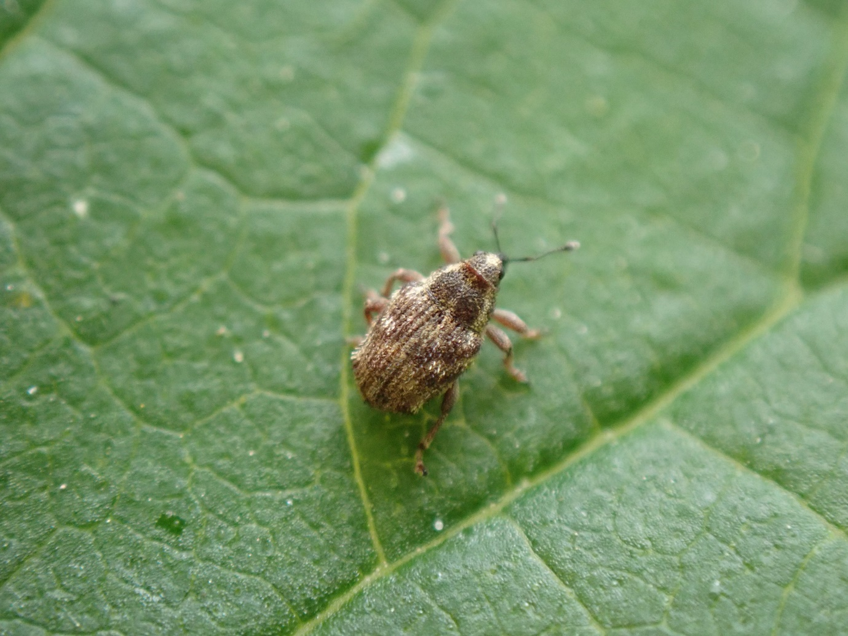
Fig. 15. Trichosirocalus rufulus.

Tychius lineatulus – Nationally scarce a – Author’s records = 5
Recorded new to the survey in Chalk D. This is a scarce weevil that feeds on clovers.

Tychius schneideri – Nationally scarce b – Author’s records = 16
A small but striking stripey weevil that feeds only on Kidney Vetch. In 2021, it was recorded in Chalk A, D & E, while in 2024, it was only noted in Chalk E.
Tychius squamulatus – Nationally scarce b – Author’s records = 5
A scarce weevil associated with legumes. It was recorded new to the site from Chalk E.
Zaclades exiguus – Nationally scarce b – Author’s records = 53
This weevil is now fairly common on arable margins where the foodplant (cranesbills) grow. It is surprising it wasn’t recorded in 2021. In 2024, it was noted in five compartments (three Arable blocks and two Chalk blocks).

Diptera (true flies)
A total of 122 species of fly were recorded in 2024, with just four of these having conservation status. Removing Houndean returns 99 species from the comparable area, with the same four species with status. Only 53 species of fly were recorded in 2021, with four of these having some form of conservation status. The author does not cover flies in as much detail as other invertebrate groups but has made more of an effort over the last year, which may explain some of this increase.

Most flies were recorded on the Arable (74 species), with the least on the Chalk (35 species).

Atylotus rusticus – Nationally Rare – Author’s records = 29
A large and striking horsefly with large green eyes. A single adult female was beaten from a hedgerow in compartment A on the arable section near to the farm yard in 2021, while in 2024 it was recorded in Arable B & C. This is more of a Brooks species and it is surprising that it was not detected there in either year.
Cheilosia cyanocephala – Nationally Scarce – Author’s records = 1
This is a complex and difficult family of hoverflies and this is the first record of this species made by the author. It is a downland species and was recorded once from Arable F in 2024 but was only noticed when picking through the specimens over the winter.
Myopa pellucida – (RDB3) – Author’s records = 3
This spring active species of conopid (a parasitoid of bees that lays its eggs inside adult bees, eating them alive) is now much commoner than the status would suggest, Falk notes this as now being one of the most frequent Myopa species of southern England. It was new to the survey in 2024, being found in Arable C and Chalk D.
Stratiomys longicornis – Nationally Scarce – Author’s records = 9
Once thought to be tied solely to brackish waters, this wetland species has clearly spread over recent years. A larva was discovered in a ditch as new to the survey in Brooks F.

Cockroaches
One species of cockroach was recorded.

Lesser Cockroach – Nationally Scarce – Author’s records = 126
It was common on the survey and was recorded in every chalk-grassland plot as well as Arable C & D in 2021 and by 2024 it was found in the Arable plots and every Chalk plot except F. This species is usually found on coastal sites but given the proximity to the coast here, it is not surprising that this species is so abundant on the site. It was not recorded at all at Houndean though.

Lepidoptera – butterflies
Butterfly conservation statuses were updated in 2022.

A total of 29 species of butterfly were recorded in 2021, nine of which had some form of conservation status. In 2024, the total number of species remained close to this total, at 28 (with or without Houndean removed from the data set) but the number of butterflies with status fell to six species. Small Blue, Grizzled Skipper and Dark Green Fritillary were all not recorded in 2024 but were in 2021. In 2022, Dark Green Fritillary was added to the Red List as Near Threatened.

The Small Blue butterfly, which feeds only on Kidney Vetch and was recorded in low numbers on every chalk-grassland block in 2021 (except the ranker and ungrazed Chalk F). Additionally, it was also recorded in two arable blocks, Arable E & F, where they were adjacent to the chalk-grassland and these are wandering adults. Yet by 2024, it was not recorded once on the entire survey. It may be that the timing of the visits did not align with the flight period of this species in 2024, an artefact of only doing three visits. Or it may be for some other reason, as the Kidney Vetch feeding weevil Tychius schneideri was also much harder to find in 2024.

The most species were found on the Chalk (20), with 16 species each found on the Arable and Houndean and just 10 species on the Brooks.

Adonis Blue – Near Threatened – Author’s records = 75
Feeds only on Horseshoe Vetch. In 2021, it was commonest on the rich slope in Chalk A but it was also recorded in C and E. A wandering adult was also noted on the arable margin of Arable E. The species needs short turf but not too hard grazed so as to remove all the nectar sources when the adults are flying. The best habitat by far was in Chalk A but C and E were too hard grazed to support thriving colonies. By 2024, it was again recorded on Chalk A, C & E. It was common on all three slopes in 2024 but Chalk E was the best example of habitat in 2024.

Chalk Hill Blue – Near Threatened – Author’s records = 89
In 2021, it was recorded at Chalk A where it was common but also on Chalk F, where it was represented by a single individual. In 2024, it was again common in Chalk A but it was also common on Chalk E. Like the above species, this species feeds only on Horseshoe Vetch as larvae.

Dingy Skipper – Vulnerable, Section 41 – Author’s records = 93
Recorded in Chalk compartments sections C, D and F in 2021, while it was only represented by a single animal in 2024 in Chalk F (High Down). This widespread but now uncommon butterfly and its presence here is encouraging. It feeds on Common Bird’s-foot-trefoil but it also feeds on Horseshoe Vetch occasionally. Chalk C was very hard grazed by sheep during the butterfly’s spring flight period, and would likely be the reason why it wasn’t present there.

Silver-spotted Skipper – Vulnerable – Author’s records = 43
Elevated to Vulnerable from Near Threatened in 2022. Recorded in Chalk A and C only in 2021, while in 2024 it was only noted once in 2024 from the nice patch of grassland at the base of the slope at Chalk B. This species has spread in recent years and is now widespread on the Downs in short, warm, south facing turf — here ever there is Sheep’s Fescue and bare ground.

Small Heath – Vulnerable & Section 41 – Author’s records = 549
A fairly common butterfly that likes short turf, with fine grasses. It was perhaps the most widespread species with cons status across the whole survey recorded in 15 of the 18 compartments in 2021, including all of the chalk-grassland blocks. In 2024 it was recorded in 19/24 compartments, again including all of the Chalk compartments.

Despite its status (which moved from Near Threatened to Vulnerable in 2022), this is still a widespread and common butterfly.

Wall – Endangered, Section 41 – Author’s records = 124
Elevated to Endangered in 2022. A scarce butterfly, it can sometimes be common on the Downs. It feeds on fine grasses but needs some exposed bare ground, especially chalk. It is most common on farmland on the Downs now. It was recorded in 2021 in Arable C and F and Chalk A and E, while in 2024 it was recorded only once, in Chalk C.

Lepidoptera – moths
A total of 64 species were recorded in 2021, with just two species with conservation status noted. By 2024, a total of 86 species of moth were recorded, ten of which had some form of conservation status. With Houndean removed from the data, the more comparable figure of 70 species were recorded, nine of which had status. This significant increase in the number of scarce moths is hard to explain.

The Chalk, as with butterflies, held the most species with 41 species (up from 37 in 2021) and again the Brooks had the least, with only 20 species (up from 19). Houndean was second with 34 species.

The research BAP is a list of moth species that was never meant to carry equivalence to the actual BAP list. It was meant to guide funding towards research to understand why these common species were declining. However, this nuance has been lost and they are now often quoted as being BAP species when they are not. Here, this includes species like the Cinnabar moth.

Blackneck – Near Threatened – Author’s records = 10
Recorded new to the survey in 2024, where a single adult was recorded from Chalk F (High Down). The larvae feed on the foliage of Tufted Vetch.
Broad-barred White – Near Threatened – Author’s records = 19
A larva of this species was recorded in Chalk C where it was new to the survey. It is most commonly found as a larva on downland, where it feeds on the foliage of yellow composites.

Coleophora lixella – Nationally scarce b – Author’s records = 4
A scarce field-identifiable Coleophora micro moth that feeds on Wild Thyme only. It was recorded here new to the survey from Chalk E.
Figure of Eight – Endangered – Author’s records = 20
A winter active moth with a striking larva that can be beaten off scrub foliage in the spring. Although it is listed as Endangered, it is still relatively common, the status reflects a significant decline of this species. A single larva was recorded from Houndean B.
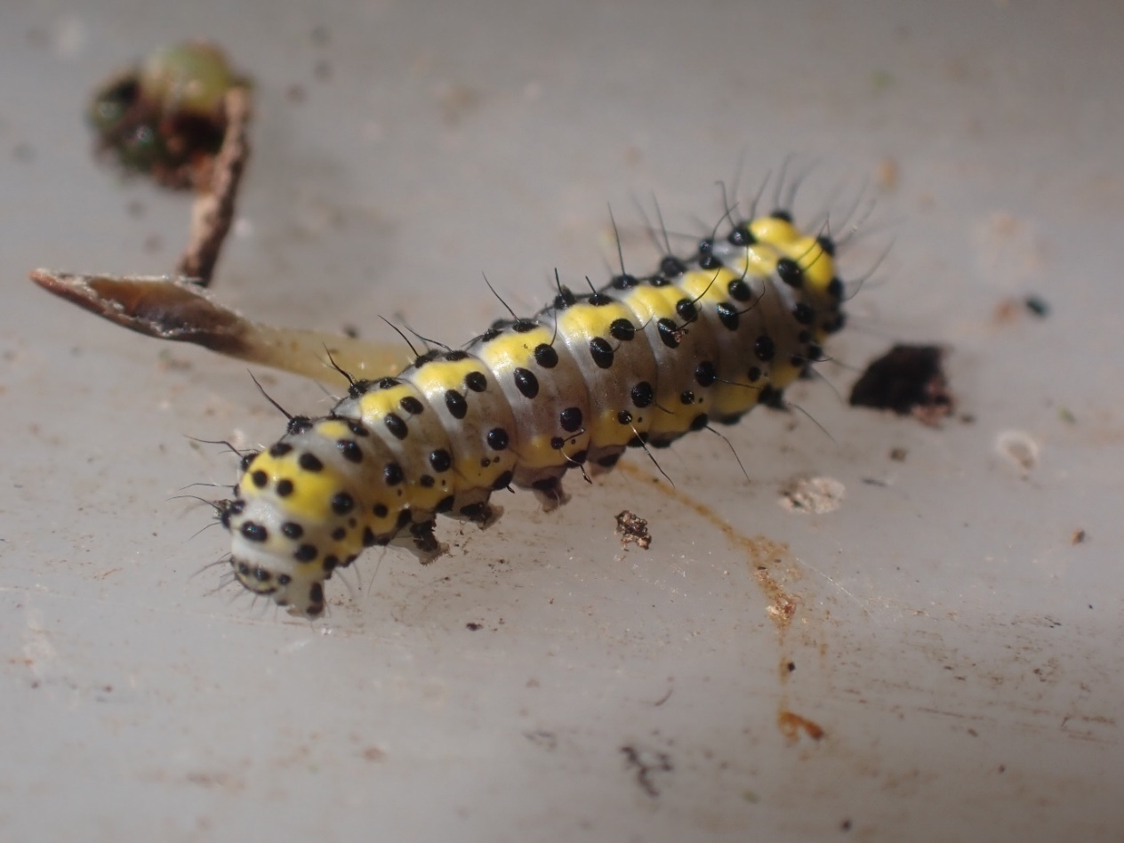
Fig. 16. Figure of Eight larva.
Forester – Section 41 – Author’s records = 7
Recorded once from Chalk B in June. A scarce species that feeds on Common Sorrel, it was recorded here new to the survey.
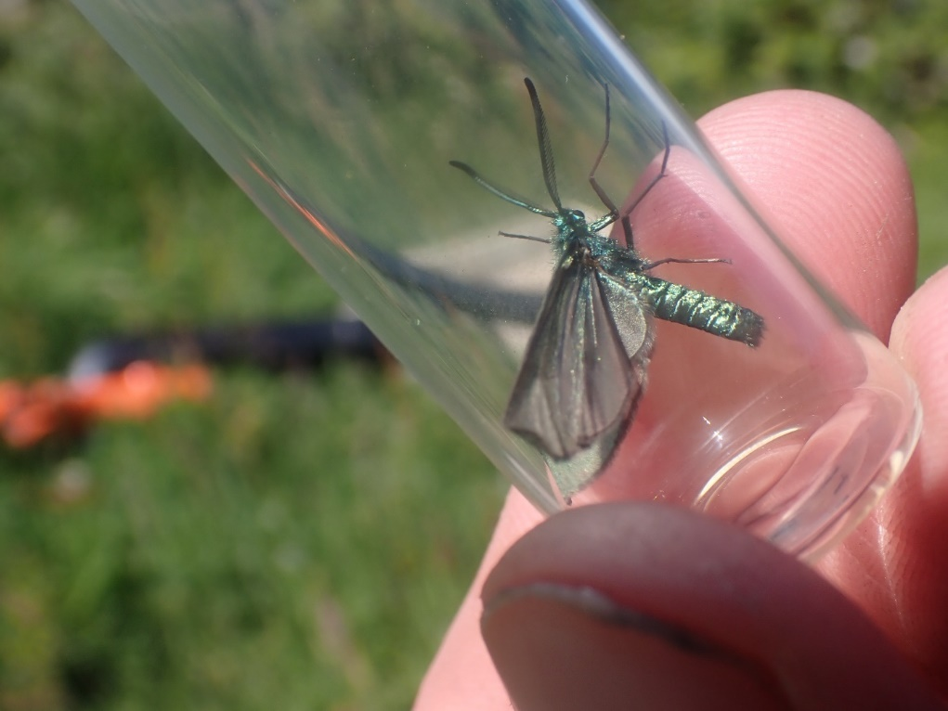
Fig. 17. A male Forester moth, showing the clubbed tip to the antennae of the male.

Oncocera semirubella – Nationally scarce b – Authors records = 8
This striking micro moth was recorded new to the survey in Chalk D only, where several animals were seen. These are the first records the author has of this species in Sussex, where it feeds on Common Bird’s-foot-trefoil.
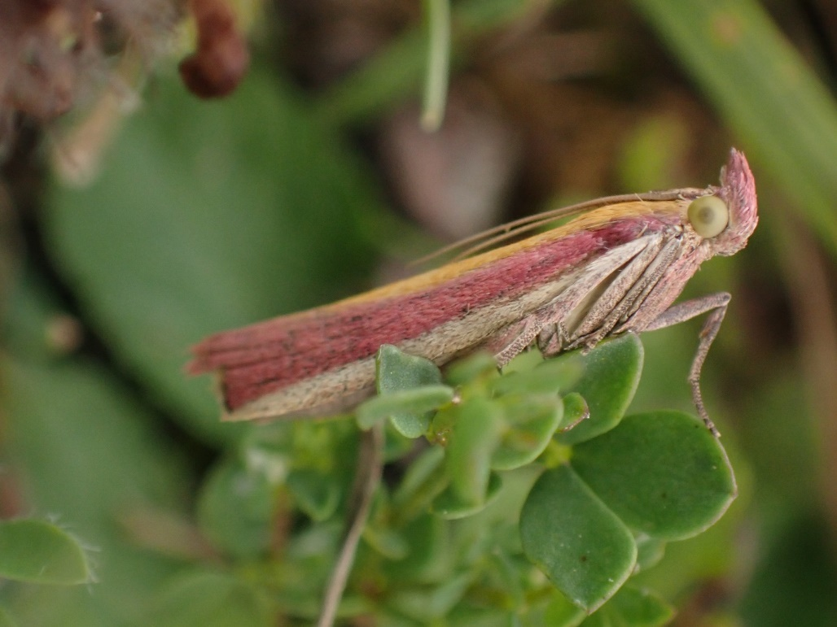
Fig.18. Oncocera semirubella.
Mouse Moth – Vulnerable – Author’s records = 71
Larvae were recorded in Arable E and Chalk A, where they were new to the survey. The larvae feed on a very wide range of plants, being a generalist. This is still a common species in the wider landscape, but has suffered significant declines in recent years.
Rhopobota stagnana – Nationally scarce b – Author’s records = 14
A local species on downland that feeds only on scabiouses, here most likely Small Scabious. It was noted in Chalk E only, where it was new to the survey.

Scarce Forester – Nationally Rare & Near Threatened – Author’s records = 17
Abundant on the well managed grasslands of Chalk A and B only in 2021 but only a single animal was found during the 2024 survey in Chalk A. It feeds on Knapweed on chalk-grassland, and requires plenty of nectar sources to thrive.
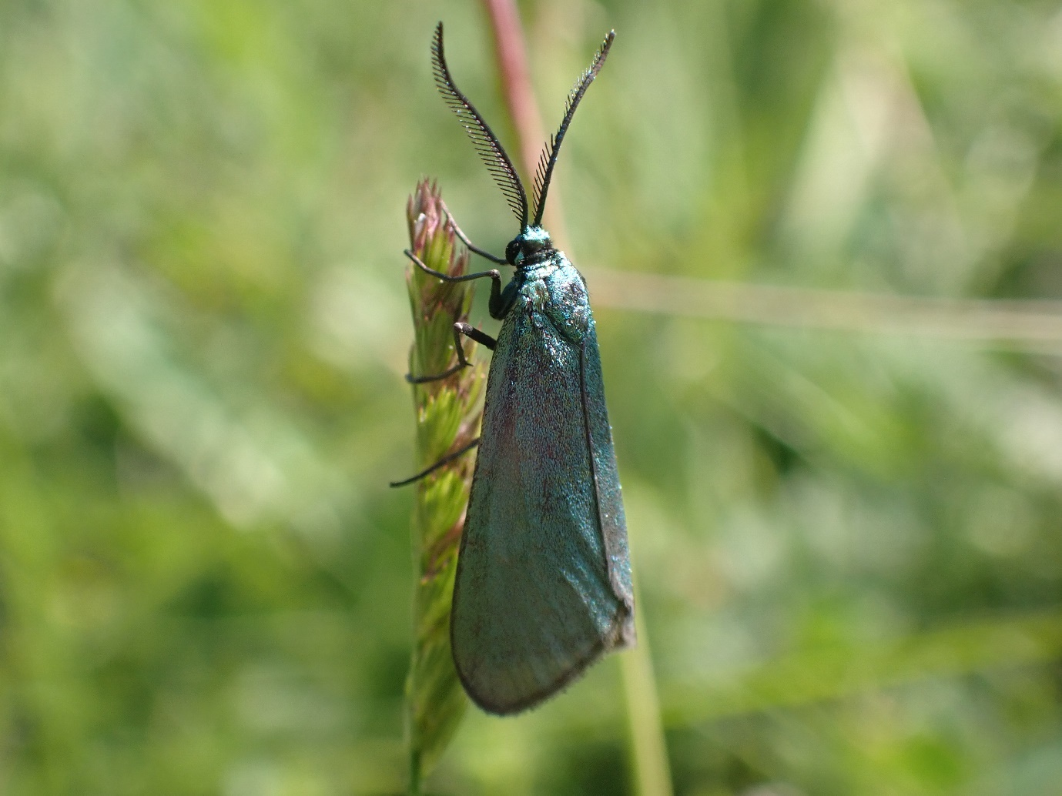
Fig. 19. A male Scarce Forester showing the antennae being pectinate to the tip (compare the club-tipped antennae of the male Forester above).

Scythris picaepennis – Nationally scarce b – Author’s records = 42
Feeds on Common Bird’s-foot-trefoil where it is readily suction sampled from short turf. In fact, it was recorded from all six Chalk compartments in 2021, but by 2024 it was recorded only from Chalk C and E.

Mollusca (slugs and snails)
A total of 35 species were recorded in 2021,with just one species with status recorded. By 2024, that figure was 44 species, with the same species with status recorded (the more comparable figure of 38 species was noted when Houndean was removed from the data, with the same one species with status being present. The Brooks and Houndean shared the top slot in 2024, both with 21 species each, while the Chalk had the least species, with 16 recorded.

Segmentina nitida (Shining Ramshorn) – Nationally Scarce, Section 41 – Author’s records = 8
Found in one ditch on Brooks D/SSSI area and then later in the season in Brooks F too in 2021. In 2024, it was recorded in the same ditch in Brooks D but was also found in Brooks E (it was not however noted in Brooks F). This is an important species on the Brooks in the region and is part of a guild of molluscs that are particularly evident on East Sussex brooks. It is already known from the site.
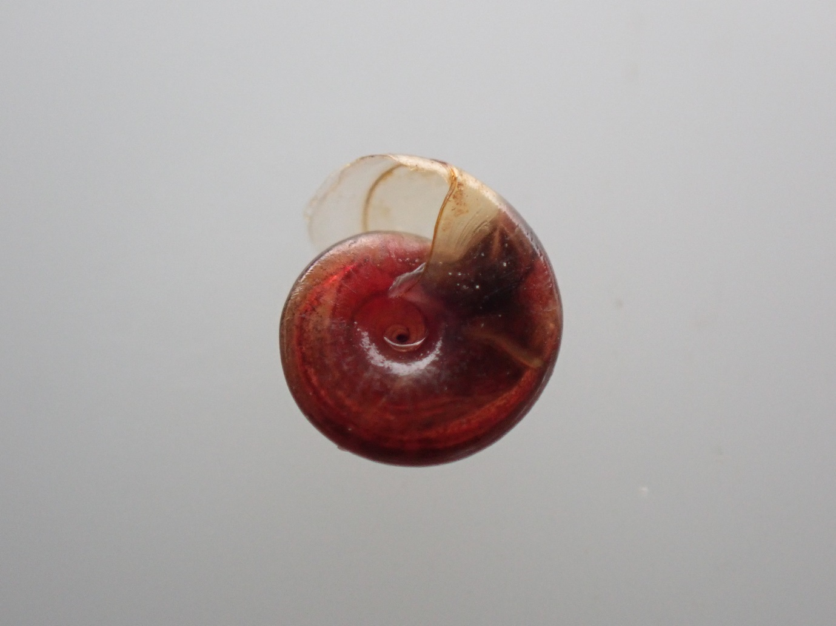
Fig. 20. The blood red Segmentina nitida with one of its characteristic radial lines.

Hemiptera (true bugs)
A total of 119 species were recorded in 2021, with only five having some form of conservation status. By 2024, this had rose to an impressive 193 species, with 13 of these having some form of conservation status. With Houndean removed from the data, the more comparable figure of 176 was made, with 12 of these having status.

The most species, 109, were recorded on the Arable in 2024 (up from 66 in 2021), while the least, 72 (up from 45 in 2021) were recorded on the Brooks.
Aquarius paludum – Nationally Scarce – Author’s records = 7
This large pondskater was recorded new to the survey in 2024 on Brooks E, where it was recorded on of the Swanborough fishing lakes. This skater typically lives on large ponds.
Asirica clavicornis – Nationally scarce b – Author’s records = 53
Recorded new to Sussex from Arable A. This plant hopper is spreading throughout the UK and may no longer warrant the status it has.

Catoplatus fabricii – Nationally scarce b – Author’s records = 16
A scarce lacebug that feeds on Oxeye Daisy, and it is almost entirely limited to this foodplant where it grows on chalk-grassland. In 2021, it was recorded in Chalk A only in both 2021 and 2024.
Corixa affinis – Nationally Scarce – Author’s records = 10
A local species of water boatman, that is typically found in grazing ditches and levels near the coast in the east of the country. Here it was recorded new to the survey in Brooks F.
Criomorphus williamsi – Nationally scarce b – Author’s records = 2
Recorded new to the survey from Houndean C. A local plant hopper that feeds on grasses.
Deraeocoris olivaceus – Nationally scarce b – Author’s records = 4
A striking red plant bug that is most often found on Hawthorn, here a single adult was found new to the survey in Brooks A.
Iassus scutellaris – Nationally scarce a – Author’s records = 5
A large green leafhopper that feeds on elms. A single animal was beaten from elm in Arable A, where it was new to the survey.

Lasiosomus enervis – Nationally scarce b – Author’s records = 10
This species appears to be spreading and does not have any specific habitat requirements beyond often being found near litter. It was recorded in 2021 on Arable C and F and in 2024 on just Arable C.

Lygus pratensis – (RDB3) – Author’s records = 480
Although listed as RDB3, this is now one of the commonest bugs in the region in late summer and no longer warrants the status it has at all. It is surprising that it was only recorded in Chalk A & B, and Brooks A in 2021 but by 2024 it was noted in eight different compartments in all four zones, with the most recorded in Houndean, where it was noted in three compartments.

Megalonotus praetextatus – Nationally scarce b – Author’s records = 48
In 2021, this groundbug was widespread on the arable blocks where instead of using its usual foodplant stork’s-bill it was found to be using crane’s-bills, a trend in more recent years on the Downs meaning this species is no longer tied to sandy sites. It was widespread being recorded in Arable C, D and F during the survey. By 2024 it was found only in Arable C and Houndean C.
Ribautodelphax pungens – Nationally scarce b – Author’s records = 1
Recorded new to the survey on Chalk A, as well as being new to the author. A small and scarce leafhopper restricted to the south of England, where it feeds on Tor-grass on chalk-grassland.
Saldula orthochila – Nationally Scarce – Author’s records = 3
This shorebug is found on dry sites away from water, quite unlike the other species in the family. It is typically found on the Downs, especially on arable margins. It was recorded new to the Estate in 2024 in Arable B.
Scarab Shieldbug – Nationally Scarce – Author’s records = 58
Recorded new to the survey in 2024, where this diminutive, ground dwelling shieldbug was found in Arable C and Chalk E & F. It feeds on violets and pansies, and will use Field Pany in arable margins and Hairy Violet in chalk-grassland.
Sciocoris homalonotus – Not Assessed – Author’s records = 3
This shieldbug is a very recent colonist to Sussex, this is only perhaps the third or fourth Sussex record. It was recorded from Arable E in spring.
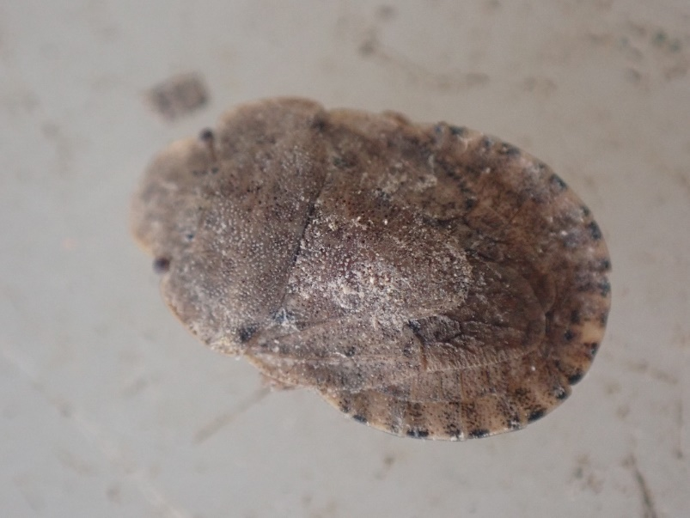
Fig.21. Sciocoris homalonotus suction-sampled from an arable margin.
White-shouldered Shieldbug Dyroderes umbraculatus – Not Assessed – Author’s records = 1
Another recent colonist, this is the author’s only record (other than seeing it on Jersey). It was recorded on the edge of the track walking up Great Rise in Brooks E.
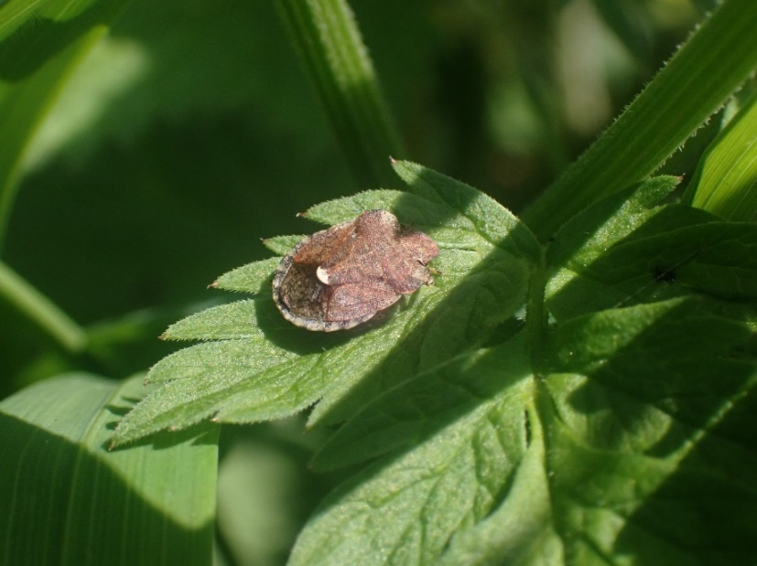
Fig.22. White-shouldered Shieldbug.

Odonata (dragonflies & damselflies)
Twelve species of dragonfly and damselfly were recorded in 2024 (with or without the Houndean data removed), with just one species with status recorded (this down slightly from 14 in 2021, again with one species with status).

All 12 species were recorded in the Brooks, while only one species was recorded in each of the Chalk and Houndean blocks.

Variable Damselfly – Near Threatened – Author’s records = 45
A fairly widespread damselfly on the Brooks of Sussex and richer waterways of the county. In 2021, adults and nymphs were found in Brooks D, E & F and in 2024 it was recorded in all six of the Brooks compartments.

Orthoptera (crickets and grasshoppers)
A total of 14 species were recorded in 2024 (with or without the Houndean data removed), none of which had status (compared to 12 in 2021). Due to the proximity to Caste Hill, any areas that looked suitable for Wart-biter were searched during the final visit and an effort to listen out for them by ear was made but none were recorded. As the author was also surveying Balsdean in 2024 and found a new population there, Buglife were informed and searched a tenanted area of the Iford Estate that the author is not surveying (adjacent to Castle Hill) and found a thriving population there in quite atypical habitat.

The number of species per block was very similar, with 10 species recorded in all blocks except the Brooks, which had just nine species.
Birds
A total of 85 species of bird were recorded in 2024 (falling to 82 when Houndean was removed from the data). This compares to 2021, when a total of 80 species of bird were recorded. Birds of Conservation Concern 5 (BoCC5), Schedule 1, IUCN Red List and Section 41 listed species are all used here to assess whether each species has ‘conservation status’.

A total of 44 species of conservation concern were recorded in 2024 (43 with the Houndean data removed), compared to 41 in 2021. The most species of bird were recorded on the Brooks (67), while the least were recorded on the Chalk and at Houndean (37 species on each). The most birds with conservation status were recorded on the Brooks (38) with the least on the Chalk and Houndean (19 each).
Cattle Egret – Amber Listed – BREEDING UNLIKELY
Three animals were seen flying over the Brooks in compartments E & F in spring. This is a rapidly expanding colonist to the county, so although breeding is unlikely at present it is not out of the question.

Cetti’s Warbler – Schedule 1 – BREEDING
Recorded on five compartments on Brooks (but not F) as well as Arable D in 2021, where this outspoken bird was perhaps the most obvious passerine. In 2024 it was recorded in five of the six Brooks plots again (but not C) but is likely present and breeding in all six. Scrubby ditch margins are this species’ favourite habitat on this site, which is an abundant feature.

Corn Bunting – Red Listed, Section 41, Critically Endangered – BREEDING
Recorded on 11 plots in 2021, most widespread on the Chalk (five) and least widespread on the Brooks (two). It was recorded in fewer areas in the main block in 2024 (just eight), with none on the Brooks, the same five plots on the Chalk and on just three of the arable areas. Additionally, it was recorded in two of the new Houndean compartments.

Cuckoo – Red Listed, Section 41, Vulnerable – LIKELY BREEDING
Only recorded once on Brooks A in 2021, where a singing bird was seen during the second visit. In 2024, an animal was heard singing on the escarpment from the office but the visit was aborted due to low cloud on the top of the Downs, so it was not possible to pin this animal down to a specific location (let alone whether it was even actually on the Estate), as a result it is not included in the records/analysis at the compartment level. Likely to be breeding on the site but Cuckoo have very large territories and are easy to miss if the survey visits are not aligned with their main calling period.

Curlew – Red Listed, Endangered & Section 41 – MIGRANT
Recorded as a migrant in Brooks A and B in 2024. Not breeding.

Dunnock – Amber List, Section 41 – BREEDING
Widespread across the site where it was recorded in 11 of the 18 plots in 2021, but was least widespread on the arable (only recorded in two plots). By 2024, it was recorded in 20/24 compartments, being found in five compartments of each of the four zones. A common garden and hedgerow bird where ever scrub is found.

Gadwall – Amber List – UNKNOWN
Recorded new to the survey in Brooks B in 2024. This species could be breeding in the area but no evidence of this was noted.

Great Black-backed Gull – Amber List, Endangered (Non-breeding) – NOT BREEDING
This large (mostly) maritime gull rarely breeds far from the coast, it was recorded in Brooks B as new to the survey in 2024, where it was seen loafing around the lake.

Greenfinch – Red Listed, Endangered – LIKELY BREEDING
This familiar garden bird was recorded in exactly half of the recording areas with three samples in each of the three recording areas in 2021 By 2024, it weas recorded in 14/24 plots and was found in all four zones, being commonest on the Brooks where it was recorded inn all six compartments.

Greenshank – Amber Listed – MIGRANT
A Greenshank was heard in the flooded area of Brooks E in the spring, a local migrant that does not breed in the south of England.

Herring Gull – Red Listed, Section 41, Endangered – NOT BREEDING
Widespread as fly overs only and occasionally feeding in fields but not breeding. Recorded in seven out of 18 plots in all habitats in 2021, by 2024 it was recorded in 10/24 plots, being recorded in all four zones but commonest on the Brooks, where it was recorded in five zones.

Hobby – Schedule 1 – NOT BREEDING
In 2021, a single bird was seen in September over Chalk C and was almost certainly a migrant. In 2024, a bird was seen on several occasions over the lake in Brooks B but also in Brooks F. It was further seen over Chalk C.

House Sparrow – Red List, Section 41 – BREEDING
Breeding around the houses and yards. In 2021, it was recorded in two Arable (A & B) plots and three Brooks plots but not on the Chalk. In 2024 it was recorded in six plots across all four zones.

House Martin – Red Listed, Vulnerable – POSSIBLE BREEDING
In 2021, it was thought to be breeding around Arable A but most records were of flying birds and migratory birds beyond this. Recorded in eight compartments in all three habitats. However, by 2021 it was only recorded once, over Brooks D. The slightly earlier final visit is likely the reason why this is the case.
Kingfisher – Schedule 1 – UNLIKELY BREEDING
Recorded new to the survey in Brooks E in 2024. It’s presence here likely down to the opening up of some ditches here, providing feeding opportunities.

Kestrel – Amber Listed, Vulnerable – POSSIBLE BREEDING
Widespread around the site, recorded in 10 of the 18 plots in all habitats in 2021. Least widespread on the Brooks. Possibly breeding somewhere on the Estate but no evidence was found. By 2024, it was only noted in 9/24 plots but was recorded in all four zones, being commonest on the Chalk and the Arable.

Lapwing – Red Listed, Section 41, Endangered – BREEDING
Recorded as a fly-over on Brooks B and displaying and likely breeding on Brooks E in 2021. In 2024, Lapwing were much more numerous and breeding was likely in several parts of the Brooks due to the wet spring. They were recorded in A, B, E & F and likely breeding in at least E.

Linnet – Red Listed, Section 41, Endangered – BREEDING
Widespread and recorded on all Chalk, all Brooks and four of the Arable plots and it is likely breeding in all these areas. In 2024, it was recorded in 17/24 plots, including all Brooks plots and all but Chalk F of the Chalk plots. It was only recorded in two plots at Houndean.

Mallard – Amber Listed – BREEDING
Unsurprisingly, most common on the Brooks where it is most likely breeding in all the different compartments there in 2021 and 2024. It was recorded in all six Brooks plots, as well as one plot each in Arable and Chalk (fly overs).
Marsh Harrier – Amber Listed & Near Threatened – POSSIBLE BREEDING
Up to three animals were recorded (including immatures) on Brooks B, but animals were also seen in Brooks E & F and flying over Arable D. Breeding is possible somewhere on the Estate, or at least the wider brooks.

Meadow Pipit – Amber Listed – BREEDING and MIGRATORY
Definitely heard singing on Chalk A & B in both years, but beyond this most records are likely to be fly overs from migrants. Recorded on 14 of the 18 compartments and widespread across the habitats in 2021, falling to 10/24 in 2024. Singing birds were recorded in Houndean C and Arable D, as well as on the chalk escarpment (Chalk A & B).

Mistle Thrush – Red Listed, Vulnerable – POSSIBLE BREEDING
Widespread but scattered around the site and possibly breeding in 2021 (6/18 compartments). By 2024 it was only found in 3/24 compartments in Arable and Chalk only.

Moorhen – Amber Listed, Vulnerable – BREEDING
Recorded on the Brooks (3 plots) and Arable (one plot) in 2021 where it is likely breeding. In 2024, it was noted in four of the six Brooks compartments.

Nightingale – Red Listed & Vulnerable – BREEDING
Recorded new to the site from Houndean only (although animals have also been heard singing on the main part of the Estate). At least two (maybe three) singing birds were heard in Houndean D & E. This bird needs dense, impenetrable scrub to breed.
Oystercatcher – Amber Listed – NOT BREEDING
Recorded new to the survey in Brooks B, where they were associated with the flooded fields.

Quail – Amber Listed, Schedule 1 – BREEDING
A single animal was heard singing in June in Arable D but only briefly in 2021 and a near identical encounter occurred to the south west of Arable D in 2024. A small, migratory game bird that has boom and bust years. The same territory was heard from Pickers Hill in 2023.

Redshank – Amber Listed - CONFIRMED BREEDING
Recorded in Brooks E only, where birds were heard chipping on the first and second visits, especially so on the 2nd visit, meaning the author was at this stage very close to the nest/chick. Later a chick was spotted by Ben Taylor but unfortunately, they were observed to be predated by birds of prey. Nevertheless, this is an important record for the Brooks as Redshank are very scarce as breeding birds in Sussex now.
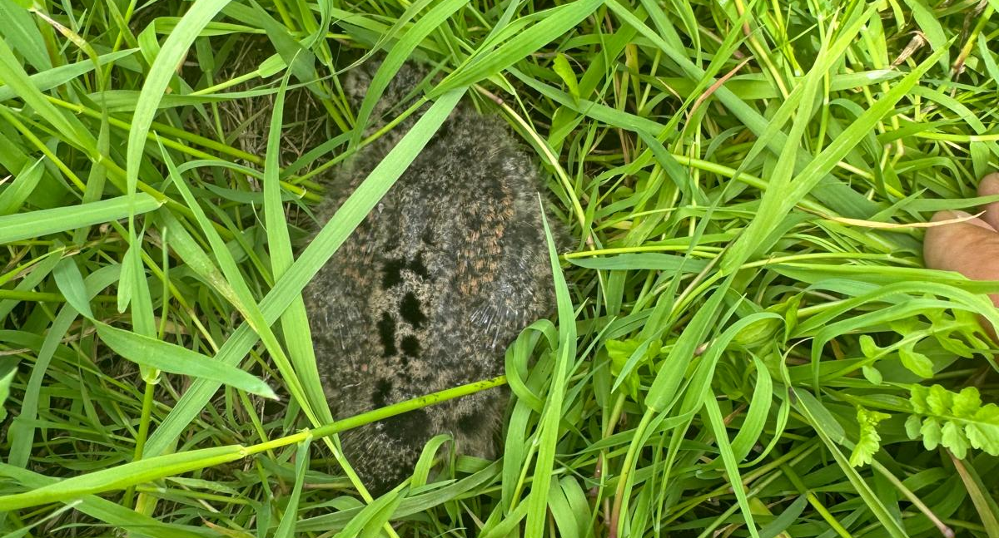
Fig.23. Redshank chick © Ben Taylor.

Reed Bunting – Amber Listed, Section 41 – BREEDING
A widespread passerine on the Brooks, where it was recorded in all but Brooks D in 2021 and in all six Brooks compartments in 2024. Likely breeding in all six of these compartments.
Rook – Amber Listed, Near Threatened - BREEDING
Another new addition to BoCC5. Most widespread on the Downs and least widespread on the arable plots in 2021 but by 2024 it was most widespread on the Arable and recorded on all four zones. Breeding in Arable A.

Sedge Warbler – Amber Listed - BREEDING
Recorded on the Brooks only where it was recorded in comps Brooks B & F in 2021, where it was likely breeding. In 2024 it was recorded in D & F.

Shelduck – AMBER LISTED – UNLIKELY BREEDING
Recorded on Brooks B around the scrape in 2021 and in 2024 it was also recorded in Brooks B but also E. Unlikely breeding but not out of the question somewhere on the Brooks.

Skylark – Red Listed, Section 41, Vulnerable - BREEDING
A common breeding bird around the site, especially on the arable and Brooks blocks but less so on the chalk-grassland. In 2024, it was found in 14/24 compartments across all four zones, and was commonest in the Arable block (5/6).

Snipe – Amber Listed – NOT BREEDING
Recorded new to the survey in 2024, when a single animal was kicked up from a ditch in August.

Song Thrush – Red Listed, Section 41 – LIKLELY BREEDING
Recorded on three plots each on the Chalk and the Brooks each. Likely to be breeding. In 2024, it was recorded in 14/24 compartments across all four zones and is likely breeding in all of them.

Sparrowhawk – Amber Listed – POSSIBLE BREEDING
Recorded on Arable A and Chalk A & F in 2021, while in 2024 it was recorded in Arable C & Houndean A. It could well be breeding on site in some of the smaller more wooded areas.

Stock Dove – Amber Listed – LIKELY BREEDING
Recorded in two Arable, one Chalk and one recording area in the Brooks. A hole-nesting bird that requires fairly large holes (and therefore trees). In 2024, it was recorded in three plots each on Arable and Brooks, once on the Chalk and not recorded at all at Houndean.

Stone-curlew – Red List, Vulnerable & Section 41 – CONFIRMED BREEDING
Three pairs were present on the Estate in 2024 but animals were only noted in Arable D. Two pairs were definitely unsuccessful and a third pair fledged one bird. At least three birds went on to move onto a bare area at Balsdean when the vegetation grew too high on Iford.

Starling – Red Listed, Section 41, Vulnerable – LIKELY BREEDING
Recorded on all three areas in 2021 but most widespread on the Brooks. Likely to be breeding around the buildings across the Estate. By 2024, it was recorded in all areas except the Chalk, but was again commonest on the Brooks.
Swift – Red Listed & Endangered – NOT BREEDING ON SITE
Recorded in in three zones in 2024 (one compartment each in Arable, Brooks and Houndean). Not thought to be breeding on site, but animals could be moving in from the local towns and villages to feed above the farm.
Teal – Amber Listed – NOT BREEDING
Recorded new to the survey in Brooks B on the lake, not thought to be breeding.

Wheatear – Amber List – NOT BREEDING
Not breeding but picked up in three places on the Arable & Brooks as a migrant in the spring and in the autumn in 2021, and again in three compartments in Arable & Chalk in 2024.

Whimbrel – Red Listed, (Critically Endangered as a breeding bird) – NOT BREEDING
Birds were heard calling in flight on migration over Chalk C & D in spring 2021. In 2024, birds were heard in three of the Brooks compartments and were regularly seen using the site to feed, as well as being heard flying over Arable D. Not breeding.

Whitethroat – Amber Listed – BREEDING
This species was on the amber list, then was removed and is now back again on it, as of BoCC5. In 2021, it was recorded in 16/18 compartments (including all Arable plots). In 2024, it was recorded in 17/24 compartments, including all the Chalk ones. Requires low and patchy scrub to breed.

Woodpigeon – Amber Listed - BREEDING
It was only recorded in 14 of the 18 plots in 2021. In 2024, it was recorded in 19 out of 24 plots but is likely present and breeding in all of them.

Wren – Amber Listed – BREEDING
It was widespread and recorded in 13 of the 18 plots in 2021, while in 2024 it was recorded in 16 out of 24 plots and is likely breeding in all areas.

Yellowhammer – Red Listed, Section 41 - BREEDING
In 2021, it was recorded on all the chalk-grassland plots where it was most widespread, no doubt down to the scrub there. It was further noted in two arable plots and one plot on the Brooks. In 2024. It was recorded in four plots on the Chalk, and two plots each in the other three zones. Breeding likely around the Estate.

Yellow Wagtail – Red Listed, Section 41, Near Threatened – PROBABLY MIGRANT
It was surprising that no Yellow Wagtails were picked up on the Brooks as a breeding bird. In fact, in 2021 it wasn’t picked up until the final visits when a number of over-flying migrants were recorded. In September, it was picked up in half of all the plots spread evenly across the habitats. Some large flocks of 10+ birds were noted flying low over the Downs. However, in 2024 it was only noted once in Brooks C. This is likely down to the slightly earlier final visit in 2024 missing the peak migration of this bird. Breeding is still thought to be unlikely.
Fish
Five species were recorded on the Brooks only, including one with conservation status. This compares to three species in 2021 (Three-spined Stickleback, Nine-spined Stickleback and Rudd). The fifth additional species was Common Carp, swimming around the flooded field centres in spring in Brooks A.

European Eel – Critically Endangered & Section 41
A young Eel was netted from a ditch in Brooks C. Likely to be present across the entirety of the Brooks.

Mammals
A total of seven species were recorded in 2024. The most species were recorded in the Arable (6), with the least on the Brooks and Houndean (4 each).

Brown Hare – Section 41
Recorded only on Arable D and Chalk C only in 2021, but in 2024 it was recorded in 6/24 plots (two Arable, three Chalk and one Brooks). The author was surprised to not see more hares on the site, especially during the spring visits but this was double the number of compartments they were seen in in 2021.

Badger – Protected
Recorded in Arable C, D and Chalk F as latrines, set and a skull respectively in 2021. In 2024, the same set was found in Arable D and signs were again spotted in Chalk F. A latrine was also noted in Houndean A.

Herptiles
This kind of survey is not great at picking up herptiles, as more specific techniques are required. Despite this, two reptiles (and a further two amphibians) were recorded. Slow-worm was not recorded in 2024. Two amphibians were recorded in 2024 (Smooth/Palmate Newt immatures and Marsh Frog).

Common Lizard – Schedule 5, Section 41
Noted only on Chalk-grassland B & F but likely to be far more widespread than this.

Grass Snake – Schedule 5, Section 41
Recorded new to the survey on the Brooks only, where it was recorded in Brooks B & E.

Vascular plants
A total of 373 species of vascular plant were recorded in 2024, with eight of these having conservation status (this falls to 331 species when the Houndean data is removed, and just seven species with status). This compares closely to the total of 325 vascular plants that were recorded in 2021, with nine species with some form of conservation status.

Arable held the most species, with 209 (followed closely by Houndean with 207) and Chalk held the least species with 149. Chalk and Houndean both held the most species with status (3 each – falling from 5 species on 2021, in the case of the Chalk), while Arable and Brooks held the least (the same numbers/species as were recorded in 2021).

The best area for rare chalk-grassland plants was Long Bottom/Chalk-grassland E. Here, Autumn Lady’s-tresses, Bastard-toadflax, and Round-headed Rampion were all seen on the south facing slope of this valley. However, Frog Orchid and Heath Dog-violet were not recorded in 2024. Long Bottom looked fine for Heath Dog-violet, it just could not be refound. The management at High Down was not in favour of summer-flowering orchids in 2024.

Autumn Lady’s-tresses – Near Threatened
This distinctive but small late flowering orchid was found to be common in Long Bottom (Chalk E) in August 2021. Some were also found to the south of Adder’s Corner in Chalk C. This plant does well in hard-grazed sites, and can even flower well during/after periods of hard grazing. It was also found in Chalk A in 2021 but in 2024 it was not noted here (just Chalk C and E). It was especially numerous in Chalk C (which had a very hard spring graze with sheep).
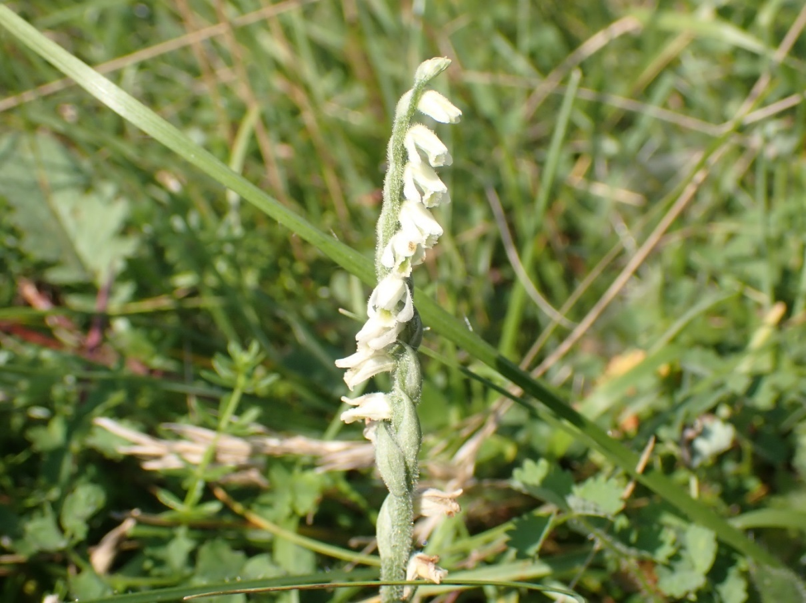
Fig. 24. Autumn Lady’s-tresses.

Bastard-toadflax – Nationally Scarce
A scarce plant of the best, shortest and most diverse chalk-grassland slopes. It was found quite by chance to be in one specific area of chalk-grassland in Chalk E/Long Bottom in June 2021 but was also flowering in September. Very little of the plant was present but more could be present in this valley. Reducing summer grazing would likely benefit this plant. It was again found in this exact area in 2024 but is very hard to find — the author couldn’t refind it to show the Estate staff on a training course there in September.

The plant, despite being very small, has its own shieldbug. An extensive search was made around this area using the suction sampler but it was not found.

Dwarf Spurge – Vulnerable
Noted in one specific arable margin in Arable D in September 2021 and again in August 2024. However, it was numerous at Houndean, where it was found in four of the six compartments (all of the arable plots). This is a good indicator but not the rarest of arable plants. It tends to like areas that have low nutrients on chalky arable land but can occasionally tolerate richer soils.
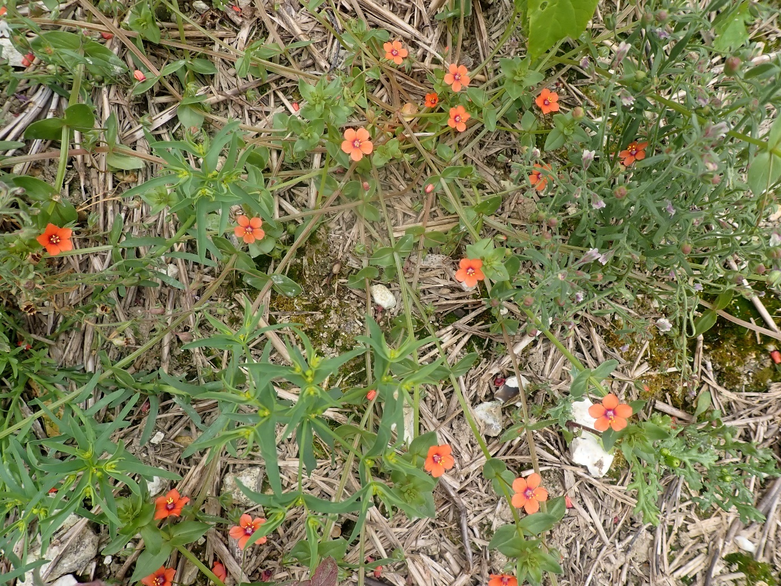
Fig.25. Dwarf Spurge (bottom left), Small Toadlfax (top right) growing with Scarlet Pimpernel and Groundsel growing on the edge of the wood in Houndean D.

Frogbit – Vulnerable & Section 41
Recorded in every compartment on the Brooks except Brooks A (which was especially enriched but it is likely to be there somewhere) in both years of survey. Despite being on the red list, this plant is still common in ditches on brooks/levels in Sussex. An early successional species of the water column, it disappears when ditches grow over.

Narrow-fruited Cornsalad – Endangered
The only new plant with status to be recorded in 2024 and it holds the most significant threat level of all the species listed here. Although this plant can be common on low-nutrient arable margins on the Downs (such as high and tight field corners that escape the plough and drain more freely). Here it was recorded in one area of Houndean A, close to the hedge to the north-east of the compartment.
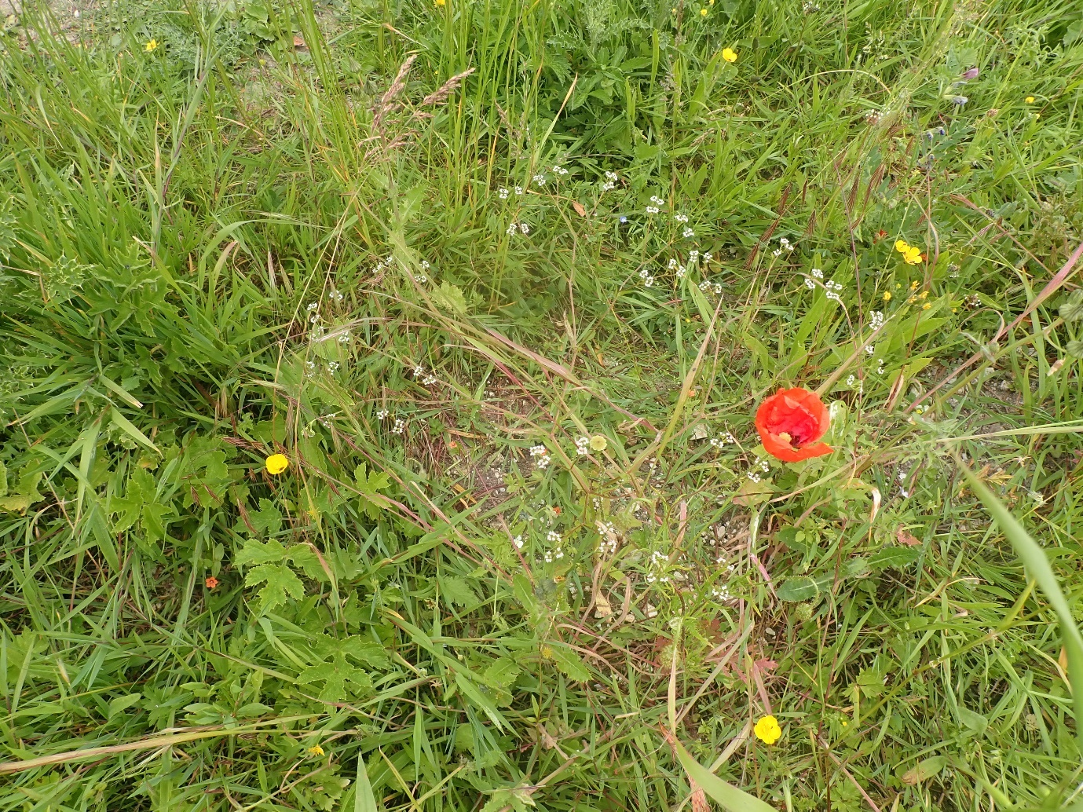
Fig.26. The lone specimen of Narrow-fruited Cornsalad.

Round-headed Rampion – Nationally Scarce
A well-known chalk-grassland plant in Sussex. AKA the Flower of Sussex. In 2021, it was recorded in all Chalk compartments except B (but it was likely to be there somewhere). Indeed, in 2024 it was found in all Chalk compartments except Chalk F (which was either too rank or too hard grazed in 2024).

Stinking Chamomile – Vulnerable
A single plant was found along an arable margin in Arable C in 2021 but by 2024, this stinky plant was much more widespread. It was recorded in C & D (it was especially common in one field corner to the south west of Arable D next to Chalk F). It was also found along the field margin next to the wood in Houndean D. This arable weed can handle fairly high nutrients, unlike many of the rarer arable plants.
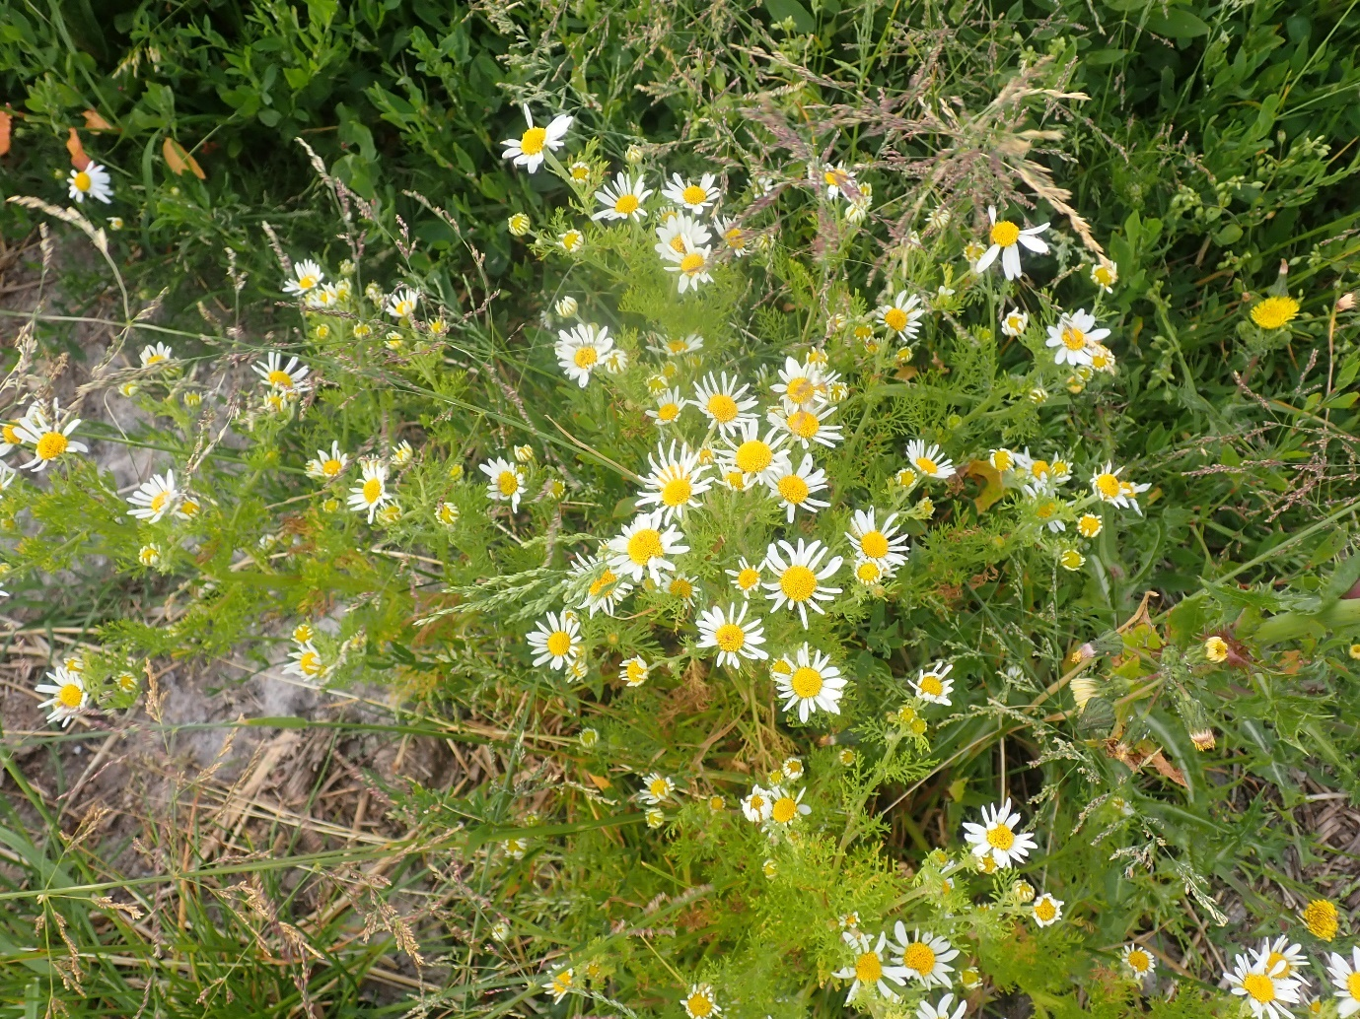
Fig. 27. Stinking Chamomile.

Tubular Water-dropwort – Vulnerable & Section 41
A plant of recently/well-managed ditch margins on the Brooks. A poor competitor, it quickly loses ground to Reeds and coarser emergent plants. In 2021, it was only recorded in one ditch in Brooks F. It was recorded in the same place only in 2024.

Other plants of notes

Knapweed Broomrape – Least Concern
A scarce plant in Sussex, this is the first time the author has recorded it in the county. Broomrapes are entirely parasitic on other plants, stealing their nutrients via their roots (hence the plant has no green pigment). Knapweed Broomrape specifically parasitises Greater Knapweed, the leaves of which can be seen immediately behind the broomrape in figure 28 below. It was not recorded here in 2021 and according to the Flora of Sussex (2018), this seems to be a new colony.
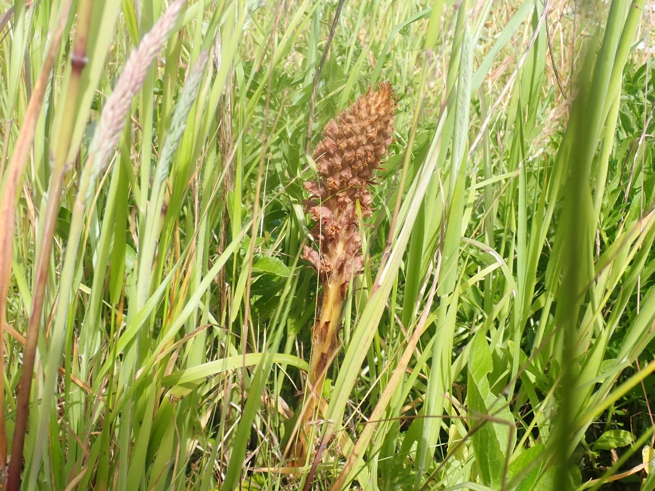
Fig. 28. Knapweed Broomrape.

Round-fruited Rush – (Vulnerable at the England level)
A single plant was found on a ditch edge in Brooks B in August. This is the first East Sussex record since 1955. Many thanks to Frances Abraham and Nick Sturt for their confirmation of the ID. A local species of fens, marshes and wet grassland that can tolerate brackish conditions (leading to it often being confused with Saltmarsh Rush).
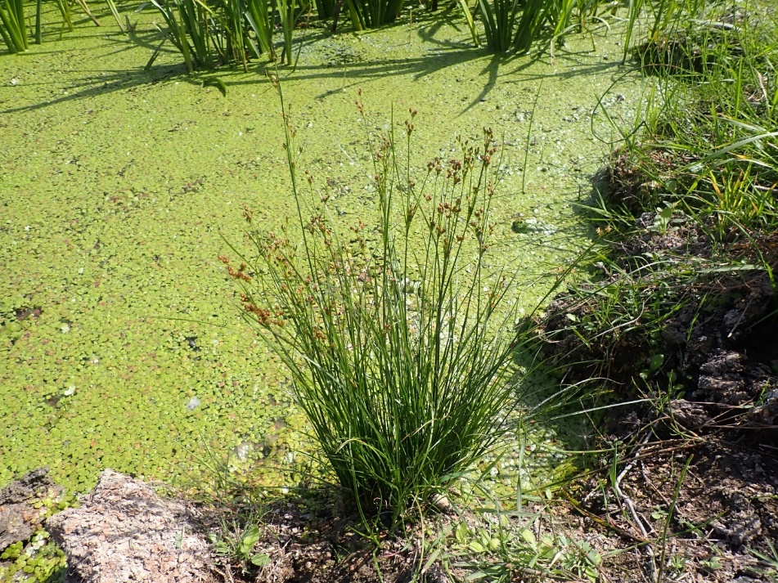
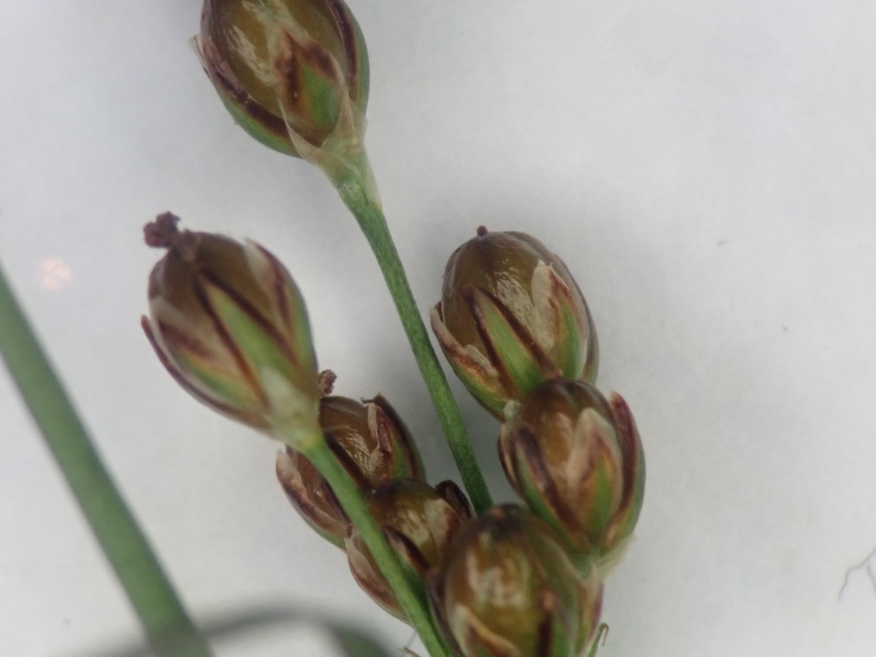
Figs. 29 & 30. Round-fruited Rush in situ., followed by the distinctive fruits under the microscope.

Tormentil – Least Concern
A scattering of Tormentil was found on the clay cap towards the top of Chalk B. This is an acid loving plant, and suggests that the very top of this compartment is edging towards chalk-heath. Although, finding any more such species, like Heather and Bell Heather here, is thought to be unlikely.

4 – Conclusions and analysis
4.1 – Comparative analysis at the broad habitat/landscape level
Tab. 2. Comparative analysis between the four zones at the landscape level in 2024.
Metric | Arable | Brooks | Chalk | Houndean | ALL
Total species | 933 | 757 | 746 | 905 | 1980
Species with status | 83 | 73 | 93 | 66 | 193
Proportion | 8.9% | 9.6% | 12.5% | 7.3% | 9.7%
Invertebrates | 655 | 494 | 546 | 634 | 136
Inverts with status | 55 | 30 | 68 | 42 | 141
Proportion | 8.4% | 6.1% | 12.5% | 6.6% | 11.0%
Vascular plants | 209 | 181 | 149 | 207 | 372
Plants with status | 2 | 2 | 3 | 3 | 8
Birds | 55 | 67 | 39 | 39 | 85
Birds of Conservation Concern 5 | 25 | 38 | 19 | 19 | 44
Mammals | 6 | 4 | 5 | 4 | 7
Unique species (by compartment)* | 143 | 150 | 125 | 168 | 586
Unique species (by habitat)** | 174 | 286 | 198 | 207 | 865
Beetles | 210 | 201 | 173 | 206 | 423
Spiders | 101 | 65 | 90 | 97 | 171
Bugs | 109 | 72 | 93 | 94 | 193
Bees, ants & wasps | 43 | 21 | 40 | 60 | 87
True flies | 74 | 41 | 35 | 64 | 122
Molluscs | 18 | 21 | 16 | 21 | 44
Butterflies | 16 | 10 | 20 | 16 | 28
Moth | 32 | 19 | 41 | 34 | 86
Dragonflies & damselflies1 | 6 | 12 | 1 | 1 | 12
Crickets & grasshoppers | 10 | 9 | 10 | 10 | 14

Unique species are those that are only found in any one compartment of the survey. This has been calculated in two different ways here.
*This figure is the total number of species that were only found in one of the 24 recording compartments across the whole survey.
**This figure of the total number of species that were only recorded in one of the three broad habitats. Clearly it is much easier for a species to score as unique this way as it only has to occur in 1/3 samples (as opposed to 1/24 in the above metric). Hence, this figure is much higher.
The former figure works better on the fine scale, and the latter at the landscape level. The latter is probably a better figure for ironing out recording biases, it is clear that totals are much closer to one another at the landscape level, with the Brooks coming out higher than the others, no doubt due to wetland species not being found in any of the other three habitats, while at the compartment level, Houndean has the most unique species. The woodland there and the anomalous Houndean C will be contributing to this.

4.2 - Comparative analysis by compartment
Tab. 3. The highest and lowest figure per habitat from the 2021 survey are included here for completeness. The highest scoring compartment for any metric is highlighted in green, and the lowest in red. While the highest scoring compartment of the whole survey is highlighted in bold, and the lowest in white font.
 | Arable |  |  |  |  |  | Chalk-grassland |  |  |  |  |  | Brooks
 | A | B | B | D | E | F | A | B | C | D | E | F | A | B | C | D | E | F
Total species | 312 | 265 | 261 | 243 | 272 | 194 | 276 | 266 | 299 | 243 | 279 | 242 | 269 | 296 | 236 | 247 | 245 | 182
Species with status | 23 | 18 | 19 | 23 | 21 | 16 | 40 | 27 | 43 | 30 | 31 | 24 | 20 | 25 | 30 | 22 | 20 | 19
Proportion | 7.4 | 6.8 | 7.3 | 9.5 | 7.7 | 8.2 | 14.5 | 10.2 | 14.4 | 12.3 | 11.1 | 9.9 | 7.4 | 8.4 | 12.7 | 8.9 | 8.2 | 10.4
Total inverts | 194 | 149 | 165 | 145 | 174 | 130 | 173 | 172 | 167 | 141 | 159 | 147 | 162 | 183 | 114 | 137 | 123 | 114
Status | 8 | 4 | 8 | 8 | 9 | 8 | 24 | 15 | 21 | 16 | 16 | 10 | 5 | 8 | 7 | 5 | 2 | 8
Proportion inverts with status | 4.1 | 2.7 | 4.8 | 5.5 | 5.2 | 6.2 | 13.9 | 8.7 | 12.6 | 11.3 | 10.1 | 6.8 | 3.1 | 4.4 | 6.1 | 3.6 | 1.6 | 7.0
Birds | 36 | 32 | 16 | 21 | 29 | 12 | 24 | 23 | 31 | 21 | 21 | 22 | 35 | 36 | 41 | 34 | 33 | 14
BoCC5 | 15 | 14 | 8 | 13 | 12 | 8 | 14 | 11 | 18 | 13 | 11 | 10 | 14 | 16 | 22 | 16 | 16 | 9
Plants | 84 | 81 | 79 | 78 | 67 | 53 | 78 | 66 | 98 | 80 | 98 | 68 | 70 | 78 | 79 | 72 | 82 | 51
Plants with status | 0 | 0 | 1 | 1 | 0 | 0 | 2 | 0 | 2 | 1 | 4 | 2 | 1 | 1 | 1 | 1 | 2 | 2
Unique | 54 | 38 | 17 | 27 | 24 | 19 | 27 | 21 | 22 | 20 | 20 | 32 | 29 | 36 | 29 | 18 | 22 | 18

There is so much data displayed in table 4 below, that describing it all here qualitatively as well does not feel like a useful exercise; however, a few highlights are given here as bullet points.
- Houndean B (the wood) scores lowest for the most metrics than any other compartment.
- Arable E & F & Chalk B were also underperforming.
- Arable D, Brooks E, Chalk E & F, Houndean A, E & F were the standout compartments.
- One species of mollusc in Chalk F is a sign of how undergrazed it has been.
- A decline in species with status on the SSSI (chiefly, Chalk B), is a direct response to inappropriate grazing there over the winter.
- The grazing regime at Long Bottom (Chalk E) was spot on in 2024, the data reflects this.
- Houndean had high species-richness but a low content of rare species.
- Houndean A held the most bees, ants and wasps. Partly down to the clover ley there but more down to the sunny, floristic margin to the east.

Tab. 4. Analysis at the compartment level. See table 3 above for a key to the colours and formats used here.
Zone | Arable |  |  |  |  |  | Brooks |  |  |  |  |  | Chalk |  |  |  |  |  | Houndean
Metric | A | B | C | D | E | F | A | B | C | D | E | F | A | B | C | D | E | F | A | B | C | D | E | F
Total species | 354 | 341 | 330 | 320 | 289 | 293 | 312 | 277 | 300 | 274 | 2939 | 250 | 275 | 293 | 274 | 272 | 270 | 312 | 353 | 239 | 320 | 349 | 364 | 357
Species with status | 21 | 25 | 30 | 34 | 22 | 27 | 24 | 35 | 26 | 26 | 38 | 30 | 37 | 18 | 30 | 31 | 45 | 30 | 31 | 8 | 16 | 20 | 15 | 21
Proportion | 5.9 | 7.3 | 9.1 | 10.6 | 7.6 | 9.2 | 7.7 | 12.6 | 8.7 | 9.5 | 13.0 | 12.0 | 13.4 | 6.1 | 10.9 | 11.4 | 16.7 | 9.6 | 8.8 | 3.3 | 5.0 | 5.7 | 4.1 | 5.9
Total inverts | 244 | 237 | 245 | 209 | 207 | 223 | 210 | 175 | 190 | 177 | 156 | 151 | 213 | 199 | 199 | 194 | 192 | 233 | 242 | 170 | 220 | 229 | 239 | 249
Status | 11 | 18 | 15 | 16 | 12 | 15 | 10 | 10 | 8 | 8 | 13 | 11 | 26 | 7 | 19 | 23 | 31 | 20 | 16 | 5 | 10 | 13 | 6 | 8
Proportion with status | 4.5 | 7.6 | 6.1 | 7.7 | 5.8 | 6.7 | 4.8 | 5.7 | 4.2 | 4.5 | 8.3 | 7.3 | 12.2 | 3.5 | 9.5 | 11.9 | 16.1 | 8.6 | 6.6 | 2.9 | 4.5 | 5.7 | 2.5 | 3.2
Birds | 26 | 23 | 23 | 24 | 22 | 17 | 25 | 39 | 30 | 29 | 42 | 33 | 16 | 21 | 20 | 12 | 15 | 19 | 21 | 18 | 15 | 14 | 20 | 26
Birds with status | 10 | 8 | 12 | 14 | 10 | 11 | 14 | 23 | 16 | 17 | 22 | 17 | 9 | 9 | 9 | 7 | 10 | 8 | 12 | 3 | 5 | 5 | 8 | 12
Plants | 78 | 76 | 59 | 84 | 56 | 51 | 73 | 59 | 73 | 64 | 91 | 63 | 44 | 66 | 54 | 64 | 59 | 56 | 86 | 36 | 81 | 100 | 102 | 77
Plants with status | 0 | 0 | 1 | 2 | 0 | 0 | 0 | 1 | 1 | 1 | 1 | 2 | 1 | 1 | 2 | 1 | 3 | 0 | 2 | 0 | 0 | 2 | 1 | 1
Unique | 43 | 36 | 15 | 17 | 18 | 14 | 20 | 19 | 22 | 34 | 33 | 21 | 17 | 28 | 13 | 14 | 18 | 35 | 26 | 50 | 31 | 29 | 12 | 20
Beetles | 68 | 66 | 89 | 67 | 60 | 97 | 75 | 68 | 66 | 65 | 64 | 65 | 68 | 52 | 69 | 70 | 71 | 73 | 81 | 44 | 60 | 70 | 81 | 91
Bugs | 48 | 40 | 40 | 31 | 27 | 39 | 38 | 21 | 27 | 19 | 23 | 19 | 42 | 33 | 31 | 31 | 29 | 43 | 34 | 22 | 39 | 32 | 39 | 35
Spiders | 41 | 40 | 34 | 37 | 35 | 27 | 27 | 30 | 26 | 26 | 19 | 19 | 40 | 36 | 37 | 30 | 25 | 47 | 37 | 30 | 37 | 46 | 32 | 39
Bees, ants & wasps | 15 | 17 | 20 | 13 | 13 | 7 | 10 | 8 | 11 | 3 | 5 | 2 | 11 | 12 | 14 | 21 | 17 | 17 | 24 | 8 | 23 | 21 | 20 | 21
Flies | 26 | 22 | 27 | 18 | 25 | 16 | 20 | 8 | 11 | 15 | 9 | 16 | 6 | 11 | 11 | 7 | 6 | 14 | 25 | 20 | 17 | 21 | 19 | 20
Butterflies | 3 | 7 | 4 | 8 | 7 | 3 | 5 | 3 | 8 | 0 | 7 | 1 | 6 | 7 | 8 | 5 | 7 | 10 | 10 | 2 | 6 | 5 | 10 | 9
Moths | 9 | 8 | 5 | 12 | 9 | 9 | 6 | 6 | 6 | 9 | 3 | 6 | 13 | 13 | 6 | 9 | 13 | 8 | 6 | 9 | 11 | 10 | 6 | 7
Molluscs | 8 | 7 | 8 | 5 | 8 | 9 | 8 | 10 | 12 | 15 | 7 | 10 | 9 | 13 | 8 | 7 | 8 | 1 | 9 | 13 | 5 | 7 | 8 | 5
Dragonflies& damselflies | 4 | 4 | 0 | 1 | 1 | 0 | 3 | 6 | 10 | 6 | 9 | 4 | 0 | 1 | 0 | 0 | 0 | 0 | 0 | 1 | 0 | 0 | 0 | 0
Crickets and groppers | 5 | 6 | 4 | 1 | 6 | 5 | 6 | 3 | 3 | 6 | 5 | 4 | 5 | 5 | 6 | 4 | 5 | 8 | 5 | 2 | 6 | 6 | 4 | 8

4.3 – Invertebrate analysis using Pantheon
The data was run through the BRC’s Pantheon database (an online data base for analysing large lists of invertebrate species), at the landscape level (the whole farm) and at the habitat level. The data is presented in the following table.

Tab. 5. The first figure shows the number of qualifying species in each block for each assemblage, the second number shows the arbitrary number of species required for that assemblage to be in favourable condition. A resource/habitat in green is in favourable condition, one in red in unfavourable condition (2021 data).
Assemblage | ALL/Landscape | Arable | Chalk | Brooks
Rich flower resource | 48/15 | 34/15 | 31/15 | 10/15
Open short sward | 45/13 | 16/13 | 44/13 | 4/13
Bare sand and chalk | 23/19 | 15/19 | 15/19 | 3/19
Scrub edge | 19/11 | 12/11 | 12/11 | 3/11
Scrub-heath and moorland | 15/9 | 5/9 | 13/9 | 1/9
Reed-fen and pools | 10/11 | 2/11 |  | 9/11
Bark and sapwood decay | 10/19 | 7/19 | 2/19 | 4/19
Open water on disturbed mineral sediments | 7/6 |  |  | 7/6
Saltmarsh and traditional brackish marsh | 2/9 | 2/9 |  | 2/9
Heartwood decay | 2/6 | 1/6 |  | 1/6
Epiphyte fauna | 2/3 | 1/3 | 1/3 | 1/3
Slow flowing rivers | 1/4 |  |  | 1/4
Undisturbed fluctuating marsh | 1/4
Total | 13 | 10 | 7 | 12

Tab. 6. The first figure shows the number of qualifying species in each block for each assemblage, the second number shows the arbitrary number of species required for that assemblage to be in favourable condition. A resource/habitat in green is in favourable condition, one in red in unfavourable condition (2024 data).
Assemblage | ALL/Landscape | Arable | Brooks | Chalk | Houndean
SQI | 138 | 134 | 117 | 137 | 120
Open short sward | 67/13 | 29/13 | 6/13 | 58/13 | 21/13
Rich flower source | 51/15 | 25/15 | 11/15 | 30/15 | 35/15
Bare sand and chalk | 31/19 | 15/19 | 2/19 | 19/19 | 11/19
Bark and sapwood decay | 25/19 | 14/19 | 10/19 | 3/19 | 17/19
Scrub edge | 23/11 | 15/11 | 4/11 | 16/11 | 19/11
Scrub-heath and moorland | 21/9 | 13/9 | 2/9 | 17/9 | 12/9
Reed-fen and pools | 8/11 | 1/11 | 7/11 |  | 1/11
Open water on disturbed mineral sediments | 8/6 |  | 8/6
Undisturbed fluctuating marsh | 3/4 |  | 3/4 |  | 1/4
Heartwood decay | 3/6 | 3/6 |  |  | 1/6
Saltmarsh and traditional brackish marsh | 3/9 | 2/9 | 3/9 | 2/9 | 2/9
Epiphyte fauna | 3/3 | 2/3 | 2/3 | 3/3 | 1/3
Fungal fruiting bodies | 2/7 | 1/7 |  |  | 1/7
Exposed sea cliff | 1/?? | 1/?? |  | 1/??
Slow flowing rivers | 1/4 |  | 1/4
Sphagnum bug | 1/8 |  | 1/8
Total | 16 | 12 | 13 | 9 | 12

These habitats that are thrown out by grouping invertebrates together with common needs by Pantheon, should be taken with a pinch of salt. This is because the way they are assessed as being in favourable condition is extremely arbitrary and as much an assessment of how much recording effort there has been. However, internal comparisons between the different plots (and the different years of survey) can be analysed in this way with a little more confidence, because recording effort has been consistent.
The analysis here is remarkably similar to the 2021 analysis, the big difference is that eight of the assemblages were now in favourable condition (as compared to five in 2021), however this is almost certainly down to the addition of Houndean and the associated increased recording effort (as the individual zones have not changed a huge amount in this regard).
The Brooks only scored in favourable condition for one assemblage; open water on disturbed mineral sediments. Arable was the same but with far few species associated with flowers and nearly twice as many species associated with short swards. The Chalk just reached the minimum threshold for ‘bare sand & chalk’ to be in favourable condition. This is very hard to achieve, especially with just three visits. There were again many more species associated with open short sward but about the same number associated with flowers. The addition of Houndean brought ‘bark and sapwood decay’ into favourable condition at the landscape level (but not in any of the for zones). Houndean scored best for ‘rich flower source’ of the whole survey, reflecting the large number of bees seen there.
Clearly, at the landscape level, the whole farm will have more assemblages, and more of these will be in favourable condition due to the increased recording effort. Lower down the tables, the smaller unfavourable assemblages are actually of limited relevance to the site, perhaps with the exception of the ‘reed-fen and pools’. This is effectively the fauna of the more open ditches. It was very close to being in favourable condition in 2021, however this fell slightly in 2024 (this was likely down to the flooded nature of the site in the spring making access to the ditches in most places impossible).
Only one habitat was in favourable condition on the Brooks, ‘open water on disturbed mineral sediments’. Grazing marsh is often very uniform and hard grazed, it holds on to any input for longer than the chalk and can often be dull for invertebrates. Almost all of the interest on the Brooks lay in the ditches. This is backed up by the lack of nectar loving species here (the Brooks being the only broad habitat to have ‘rich flower source’ in unfavourable condition).
Rich flower source (effectively just a list of bees) was surprisingly close between Chalk, Arable and Houndean. This could be seen as the Arable being as good as the Chalk. OR, it could be the converse, that the Chalk is as poor as the Arable. The reality is closer to the former. In many places, there are some rich arable margins with a wealth of nectar sources. Chalk D & E were alive with flowers and pollinators but the rest of the chalk had fewer pollinators in 2024, down to over (or under) grazing. The scores for Arable, Chalk and Houndean are impressive though, considering that each only received three days of surveying a piece.

4.4 – Accumulative analysis by compartment
In the following tables, the total species recorded in each compartment in 2021 and 2024 is combined.
Tab.7. Accumulative analysis at the landscape scale. The highest scoring metric is highlighted in green, the lowest in red.
 | Arable | Brooks | Chalk | TOTAL
Total species | 1,143 | 942 | 946 | 1,817
Species with status | 107 | 89 | 115 | 209
Proportion | 9.4% | 9.4% | 12.2% | 11.5%
Total inverts | 806 | 623 | 679 | 1,301
Inverts with status | 68 | 38 | 79 | 141
Proportion of inverts with status | 8.4 | 6.1 | 11.6 | 10.8%
Birds | 68 | 79 | 49 | 94
Birds with status | 34 | 46 | 27
Vascular plants | 249 | 218 | 196 | 385
Plants with status | 2 | 2 | 5 | 9
Unique | 329 | 343 | 300 | 942
Beetles | 257 | 243 | 214 | 441
Bugs | 121 | 85 | 103 | 191
Spiders | 129 | 94 | 111 | 184
Bees, ants & wasps | 62 | 29 | 55 | 91
Flies | 86 | 50 | 45 | 117
Butterflies | 22 | 16 | 28 | 33
Moths | 47 | 30 | 60 | 103
Molluscs | 22 | 26 | 19 | 45
Dragonflies& damselflies | 8 | 13 | 2 | 14
Crickets and groppers | 11 | 11 | 11 | 14

This analysis irons out stochastic events, such as poor seasons that might affect one or more taxa, inappropriate grazing in one specific area or flood, for example. Each year that is added to this analysis edges closer to (but can never actually reach) the absolute number of species present on the site and its compartments.

Tab.8. The highest scoring compartment for each metric in any zone is highlighted in green and the lowest in red. The highest scoring metric at the landscape scale is highlighted in bold, with the lowest of the survey in white.
Zone | Arable |  |  |  |  |  | Brooks |  |  |  |  |  | Chalk
Metric | A | B | C | D | E | F | A | B | C | D | E | F | A | B | C | D | E | F
Total species | 498 | 464 | 448 | 440 | 469 | 382 | 441 | 443 | 406 | 386 | 382 | 338 | 405 | 404 | 434 | 393 | 411 | 438
Species with status | 34 | 37 | 37 | 44 | 39 | 35 | 33 | 46 | 37 | 33 | 42 | 37 | 58 | 35 | 52 | 49 | 55 | 43
Proportion | 6.8 | 8.0 | 8.3 | 10.0 | 8.3 | 9.2 | 7.5 | 10.4 | 9.1 | 8.5 | 11.0 | 11.0 | 14.3 | 8.7 | 12.0 | 12.5 | 13.4 | 9.8
Total inverts | 339 | 308 | 319 | 281 | 316 | 283 | 290 | 277 | 240 | 235 | 209 | 214 | 283 | 276 | 284 | 264 | 273 | 308
Status | 17 | 20 | 19 | 21 | 20 | 20 | 13 | 14 | 12 | 10 | 13 | 16 | 38 | 18 | 30 | 34 | 36 | 24
Proportion inverts  with status | 5.0 | 6.5 | 6.0 | 7.5 | 6.3 | 7.1 | 4.5 | 5.1 | 5.0 | 4.3 | 6.2 | 7.5 | 13.4 | 6.5 | 10.6 | 12.9 | 13.2 | 7.8
Birds | 42 | 38 | 26 | 34 | 43 | 23 | 45 | 56 | 46 | 42 | 49 | 36 | 29 | 29 | 33 | 24 | 26 | 28
Birds with status | 17 | 17 | 14 | 20 | 19 | 14 | 20 | 30 | 23 | 22 | 26 | 19 | 17 | 14 | 19 | 14 | 14 | 14
Plants | 111 | 111 | 98 | 121 | 103 | 74 | 100 | 103 | 110 | 101 | 116 | 81 | 85 | 89 | 112 | 102 | 106 | 89
Plants with status | 0 | 0 | 1 | 2 | 0 | 0 | 0 | 1 | 1 | 1 | 1 | 2 | 2 | 1 | 2 | 1 | 3 | 2
Unique | 67 | 57 | 15 | 36 | 33 | 26 | 24 | 37 | 29 | 27 | 35 | 23 | 22 | 31 | 17 | 23 | 27 | 53
Beetles | 117 | 114 | 148 | 111 | 121 | 125 | 122 | 115 | 99 | 93 | 84 | 87 | 104 | 91 | 117 | 121 | 118 | 107
Bugs | 58 | 48 | 46 | 39 | 36 | 45 | 43 | 35 | 31 | 26 | 27 | 24 | 45 | 44 | 39 | 38 | 42 | 52
Spiders | 65 | 54 | 47 | 46 | 47 | 42 | 43 | 56 | 33 | 35 | 26 | 25 | 52 | 51 | 52 | 38 | 44 | 63
Bees, ants & wasps | 25 | 25 | 26 | 17 | 27 | 9 | 12 | 15 | 12 | 6 | 7 | 5 | 15 | 20 | 21 | 31 | 24 | 21
Flies | 31 | 29 | 32 | 24 | 34 | 23 | 26 | 11 | 15 | 21 | 12 | 18 | 15 | 18 | 20 | 13 | 14 | 19
Butterflies | 5 | 10 | 7 | 11 | 17 | 9 | 7 | 6 | 12 | 2 | 8 | 3 | 12 | 9 | 15 | 11 | 11 | 17
Moths | 18 | 12 | 7 | 17 | 17 | 10 | 10 | 12 | 8 | 11 | 7 | 8 | 23 | 21 | 11 | 16 | 16 | 24
Molluscs | 13 | 7 | 9 | 8 | 10 | 10 | 12 | 14 | 13 | 18 | 14 | 17 | 9 | 14 | 9 | 7 | 9 | 3
Dragonflies& damselflies | 5 | 5 | 0 | 1 | 5 | 0 | 5 | 7 | 13 | 11 | 9 | 8 | 1 | 2 | 0 | 0 | 0 | 0
Crickets and groppers | 6 | 7 | 6 | 6 | 8 | 6 | 6 | 5 | 5 | 8 | 5 | 6 | 7 | 5 | 6 | 6 | 6 | 10

4.5 – Analysis of Schedule 41/BAP/Species of principle conservation importance in England
There is a suggestion that Defra may focus only on the species on the Section 41 list to gauge the success of ELMS. The author strongly believes that this is a mistake and will lead to many important features being missed, mainly because the Section 41 list typically targets big, obvious species and misses any nuance. It is also not reactive — the list is old and does not update as much as other conservation statuses can do.
The author strongly suggests that not too much is read into this list. As can be seen, it misses out many invertebrate orders almost in their entirety and many of the rarest species from this survey are not on the Section 41 list. A total of 30 species were noted as being classed as Section 41 species in 2021, this fell to 29 species in 2024 (including Houndean) and 27 without the two species that were only recorded at Houndean. Although this may seem like the site has declined, however nearly twice as many rare and scarce species were recorded in 2024 than in 2021, just not those on the Section 41 list. This shows how unreliable it is to assess a site based just on these particular species.
Tab. 9. Summary of Section 41 species present in 2021.
Clearly in 2021, the chalk-grassland held the most Section 41 species on average per plot but collectively, it only held one more species than the Brooks. Chalk C held half of all of the Section 41 specie of the whole survey. The heavy weighting of birds on this list and the lack of invertebrate interest makes this extremely misleading. Chalk A for example is poorly represented here while it came out as the most important compartment of all for invertebrates in the main analysis above. As many of these species are not on the Section 41 list, this compartment scores badly in table 9 above, while Chalk C does very well.
By 2024, this had almost completely changed, with Chalk now showing the lowest number of Section 41 species out of the original three zones (mainly down to the lack of butterflies in 2024 — in many ways, this was nothing to do with site management). In 2024, the Brooks held the most Section 41 species, mainly down to an increase in birds due to the flooding.

Tab. 10. Summary of Section 41 species present in 2024.

4.6 – External analysis - Tab.11. Summary statistics for many of the author’s three-visit farm surveys. Highest scoring sites shown in green.

Site | Iford arable | Iford chalk | Iford brooks | Cockhaise | Woodsland | Clapham Farm | Haymans Farm | Undisclosed site 2 | Alciston Court | Hoyle Farm | Hermitage  Farm | Hackhurst Farm | Iford arable | Iford brooks | Iford chalk | Iford Hound
Area (ha) | 464 | 109 | 297 | 151 | 128 | 178 | 60 | 265 | 180 | 100 | 53 | 39 | 464 | 297 | 109 | 180
Year | 2021 | 2021 | 2021 | 2020 | 2020 | 2020/21 | 2022 | 2022 | 2022 | 2023 | 2023 | 2023 | 2024 | 2024 | 2024 | 2024
County | East | East | East | East | East | East | West | East | East | West | East | East | East | East | East | East
Geology | Chalk | Chalk | Clay | Clay | Clay | Chalk/clay | Clay | Clay | Chalk/clay | Sand/Clay | Clay | Clay | Chalk | Clay | Chalk | Chalk
Records | 1990 | 1995 | 1709 | 1697 | 1871 | 1635 | 1719 | 2049 | 1956 | 2169 | 2342 | 2297 | 2,555 | 2,211 | 2,270 | 2,655
Total species | 719 | 657 | 650 | 746 | 768 | 782 | 799 | 883 | 726 | 904 | 933 | 925 | 933 | 757 | 746 | 905
Mean species per compartments | 257.8 ± 15.8 | 267.5 ± 9.0 | 245.8 ± 15.5 | 282.3 ± 13.2 | 296.7 ± 24.3 | 249.8 ± 9.5 | 277.3 ± 6.70 | 333.3 ± 12.9 | 260.7 ± 9.7 | 293.5 ± 13.6 | 313.5 ± 15.8 | 294.7 ± 19.3 | 321.5 ± 10.6 | 284.2 ± 17.5 | 282.8 ± 6.7 | 320.2 ± 20.3
Invertebrates | 472 | 433 | 396 | 473 | 464 | 499 | 538 | 531 | 441 | 621 | 633 | 603 | 655 | 494 | 546 | 634
Inverts with status | 27 | 43 | 19 | 14 | 15 | 40 | 43 | 20 | 23 | 56 | 43 | 29 | 55 | 30 | 68 | 42
Proportion with status | 5.7% | 9.9% | 4.8% | 3.0% | 3.2% | 8.0% | 8.0% | 4.0% | 5.2% | 9.0% | 6.8% | 4.9% | 8.4% | 6.1% | 12.5% | 6.6%
Spiders | 90 | 84 | 71 | 78 | 83 | 77 | 113 | 113 | 78 | 111 | 118 | 109 | 101 | 65 | 90 | 97
Beetles | 152 | 118 | 135 | 151 | 135 | 158 | 151 | 149 | 130 | 181 | 189 | 184 | 210 | 201 | 173 | 206
Hymenoptera | 44 | 42 | 17 | 30 | 34 | 30 | 28 | 33 | 34 | 44 | 36 | 36 | 43 | 21 | 40 | 60
True flies | 33 | 24 | 25 | 39 | 45 | 21 | 34 | 47 | 39 | 49 | 36 | 37 | 74 | 41 | 35 | 64
True bugs | 66 | 58 | 45 | 78 | 69 | 81 | 82 | 77 | 67 | 108 | 98 | 86 | 109 | 72 | 93 | 94
Moths | 26 | 37 | 20 | 31 | 27 | 26 | 54 | 36 | 31 | 45 | 58 | 62 | 32 | 19 | 41 | 34
Butterflies | 16 | 22 | 15 | 15 | 19 | 21 | 20 | 16 | 21 | 22 | 15 | 18 | 16 | 10 | 20 | 16
Dragonflies | 2 | 2 | 13 | 7 | 12 | 7 | 8 | 12 | 1 | 2 | 8 | 8 | 6 | 12 | 1 | 1
SQI (Pantheon)* | 122 | 132 | 113 | 108 | 108 | 124 | 129 | 110 | 112 | 135 | 120 | 114 | 134 | 117 | 137 | 112
Mammals | 5 | 5 | 3 | 6 | 5 | 3 | 4 | 8 | 4 | 2 | 7 | 5 | 6 | 4 | 5 | 4
Birds | 54 | 46 | 65 | 58 | 50 | 49 | 48 | 56 | 48 | 42 | 46 | 41 | 55 | 67 | 39 | 39
Birds with status | 28 | 23 | 33 | 21 | 16 | 25 | 22 | 22 | 20 | 18 | 20 | 14 | 25 | 38 | 19 | 19
Plants | 182 | 164 | 174 | 200 | 241 | 223 | 185 | 271 | 228 | 214 | 199 | 159 | 209 | 182 | 149 | 207
Plants with status | 2 | 5 | 2 | 0 | 0 | 7 | 0 | 1 | 2 | 5 | 0 | 0 | 2 | 2 | 3 | 3

4.7 – Conclusion
It is remarkable how much the Iford Estate has changed in just three short years. The floods in the spring and the knock-on effect of grazing, clear changes to management (many of which have been positive, some negative) and natural changes to the assemblage of species is remarkable. The large number of additional species recorded in 2024, especially invertebrates other than butterflies and dragonflies, shows that 2024 was not the disastrous year that many people claimed it was for invertebrates. In fact, on average, it was generally a really good year for invertebrate assemblages across all taxa.
The approach by the Estate is hugely commendable, and it is expected that the management carried out here will be refined over the coming years. Areas such as Long Bottom are a huge conservation gain and it’s expected that High Down will recover if the intensity of management is matched by a more nuanced and targeted approach.

5 – Management recommendations
The original recommendations made in 2021 have been left in here where appropriate and added to with 2024’s survey season observations.

5.1 – Arable
Arable – A
This block is the first block surrounding the farm yard and office, and as such is off the Downs and part way towards the Brooks. Although extremely biodiverse, it does not hold a lot of rare or scarce species. In the arable areas themselves, there was little diversity due to the amount of fertiliser used and the lack of arable margins etc. Much of the interest here lay in the farmyard and old buildings itself.
The ancient barn next to the office has a significant number of scarce species in it and these should be considered (especially the old Ivy) if any work is done here. This includes one Section 41 spider and a number of other spiders that are very rare in the county.

Arable – B
Similar to A but a little more diverse with some secondary woodland blocks and some small areas of grassland. There are little to no arable margins here, and this would be the main recommendation for Arable A and B. The hard surfaced track meant that this area (see figure 31) was slightly less interesting than in 2021. The large woodland pond that has been opened up in this compartment will have certainly increased biodiversity here but it is very enriched.
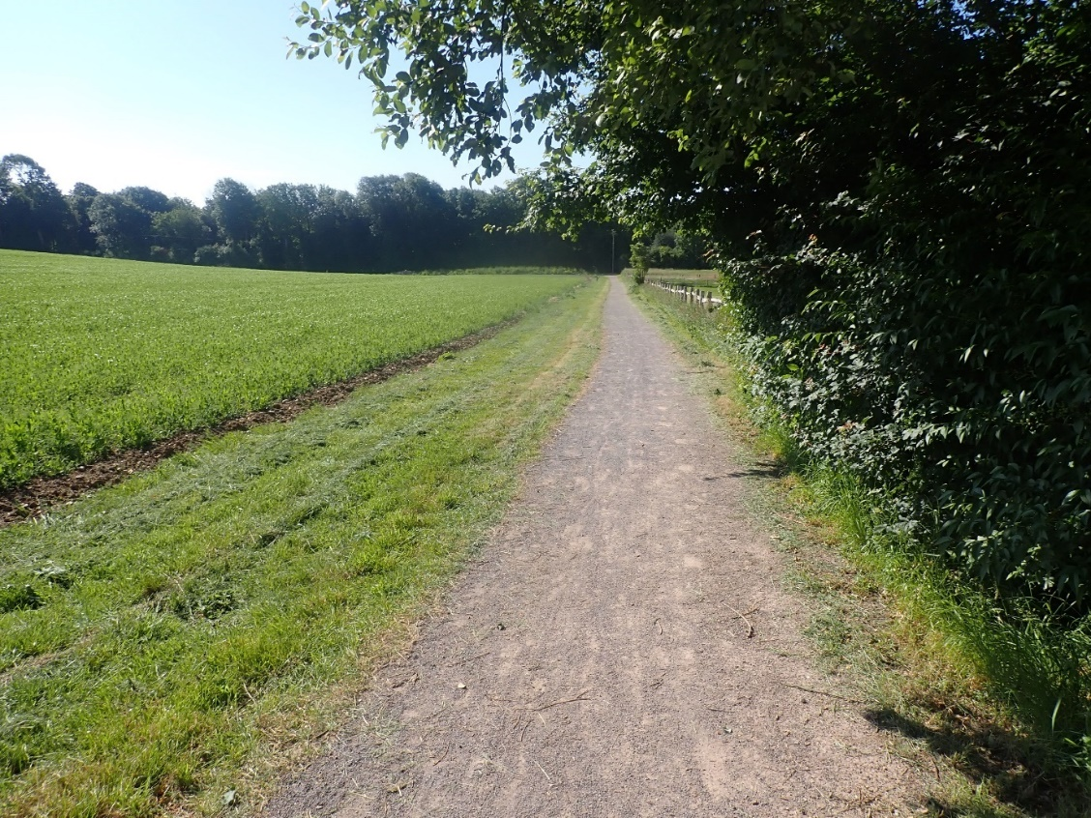
Fig. 31. Hard surfaced track in Arable B.
Arable – C
The first of the three arable blocks on the top of the Downs. In terms of management recommendations, these three are best treated as one. Along with the three chalk-grassland valleys (Chalk C, D & F), the large number of Red-legged Partridge put down here in the autumn will be having a significant impact on the biodiversity here, especially invertebrates.
In 2024, many of the margins grew rapidly, making them unsuitable for Stone-curlew by the end of June. The mix here was dominated by Charlock, which grew incredibly rapidly (there were three pairs on the site in the spring). By the end of June, at least three animals had moved on to the nearby Balsdean Farm and did not seemingly return to Iford and attempt another brood. It is suggested the Estate are more reactive to such unexpected events, at present the Stone-curlews are restricted almost entirely to where crops have failed.
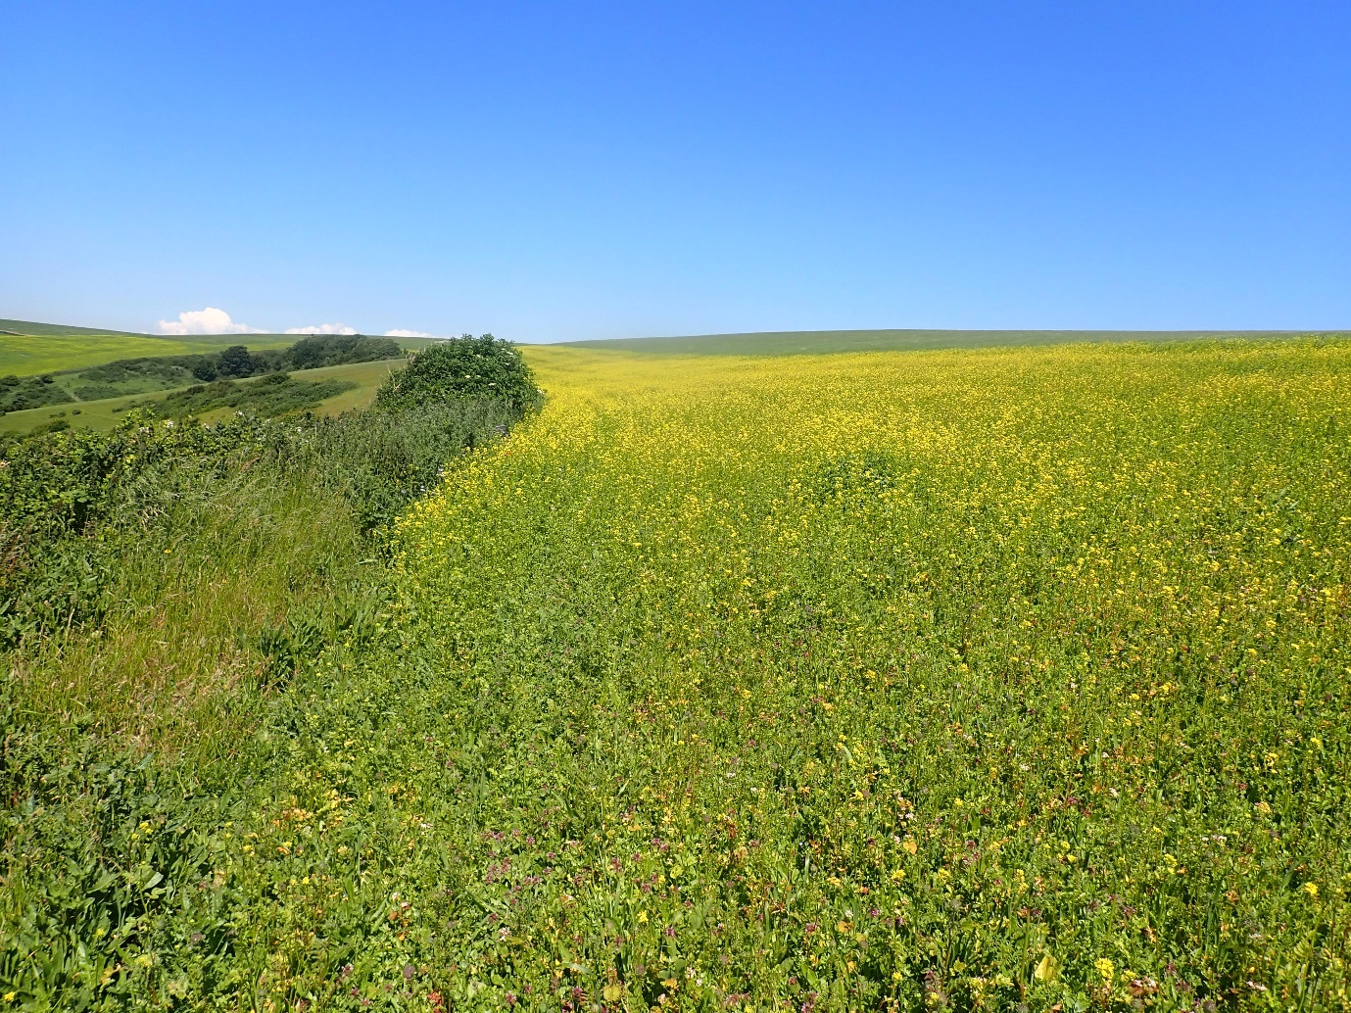
Fig. 32. The rapidly growing Charlock mix in Arable C.

Arable – D
The second of the arable recording blocks on the Downs and the largest block of the entire survey. Clearly it is not possible to get everywhere on a site this big, even with nine days on the ground and many areas will not have been recorded.
A large arable margin with two distinctively different margins runs along the main track here. The eastern-most margin was extremely good for species associated with bare chalk in 2021 (but this had been managed differently in 2024 and was much less interesting) while the western margin is a little ranker and grassier but has a wealth of nectar sources (however it did feel like this was becoming much ranker, with a tendency to become more dominated by Red Fescue and less flowering plants). The two working together are really good for species such as bees, that need both of these resources.
More of an effort was made to look at the grassland parcel to the west of this compartment (contiguous with Balsdean) and the west facing slope that is now almost entirely dominated by scrub.
The grassland compartment is not especially exciting, and invertebrate diversity and interest here was very low.
There is a small amount of Tor-grass dominated grassland still present to the north of the scrubby area (on a south-facing bank). Several species of note were seen here, such as the scarce chalk-grassland bee Osmia bicolor and Horseshoe Vetch is still present clinging on here.
This is a Local Wildlife Site; any work that is done here will need to be extremely well-considered. It will be costly and will need to take the form of a long-term rotational plan, with annual aftercare more likely being significantly more effort and cost than any capital works. Arisings will have to be removed but it may be possible to do something here as long as scrub clearance work is done piecemeal, followed by aftermath grazing, followed by more cutting, then more grazing etc. The worst thing that could be done here is if the slope is all cut down at once and no plan of aftercare factored in as it will all simply grow back but with even less of the original grassland present (as the arising will choke what little is left of that).
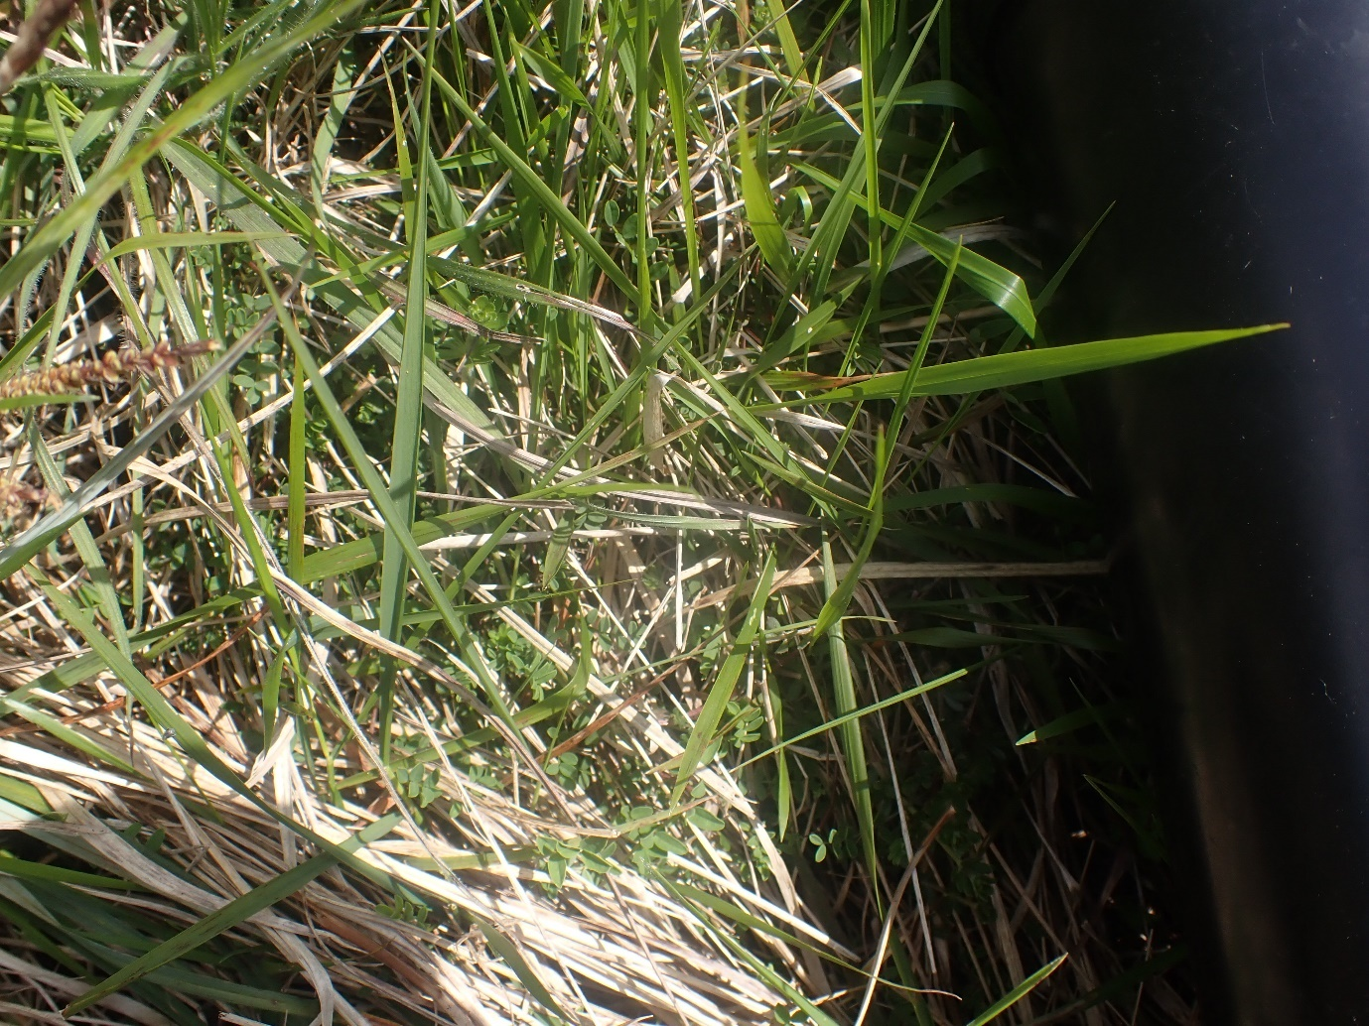
Fig. 33. Horseshoe Vetch just clinging on, despite the more dominant Tor-grass.
Arable – E
This is the block that was mainly dominated with Oilseed Rape in 2021, between the road and the Downs. It had some exceptional arable margins that held some key rare species (albeit in part due to their proximity to Chalk A).
The arable margin here was incredibly rich in flowers, even in September. With a wealth of Common Bird’s-foot-trefoil (although by 2024, this margin had declined a little) but the botanical diversity here was especially rich. Without these margins, this plot would have scored much lower though. The fact that the margin here was left to flower well into September is extremely positive. Many farms flail their margins wholesale close to the end of harvest and this has a negative impact on wildlife.
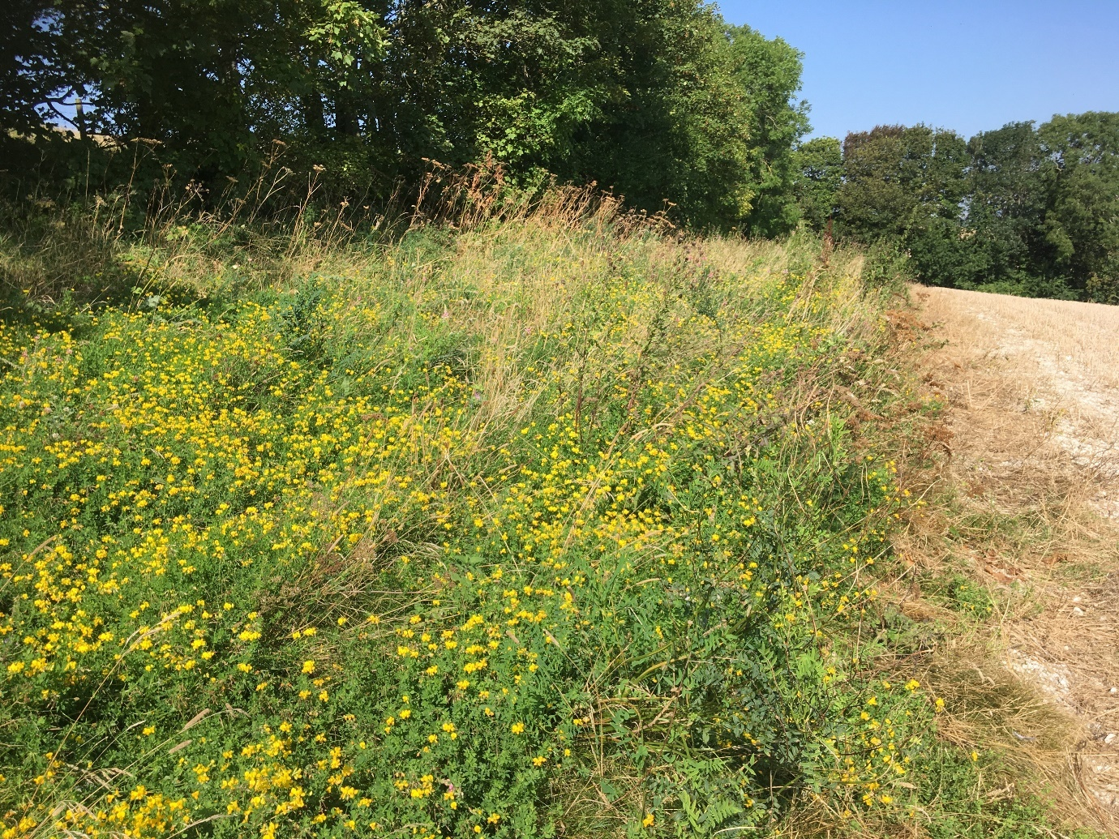
Fig.35. A wealth of Common Bird’s-foot-trefoil on an arable margin in September 2021.

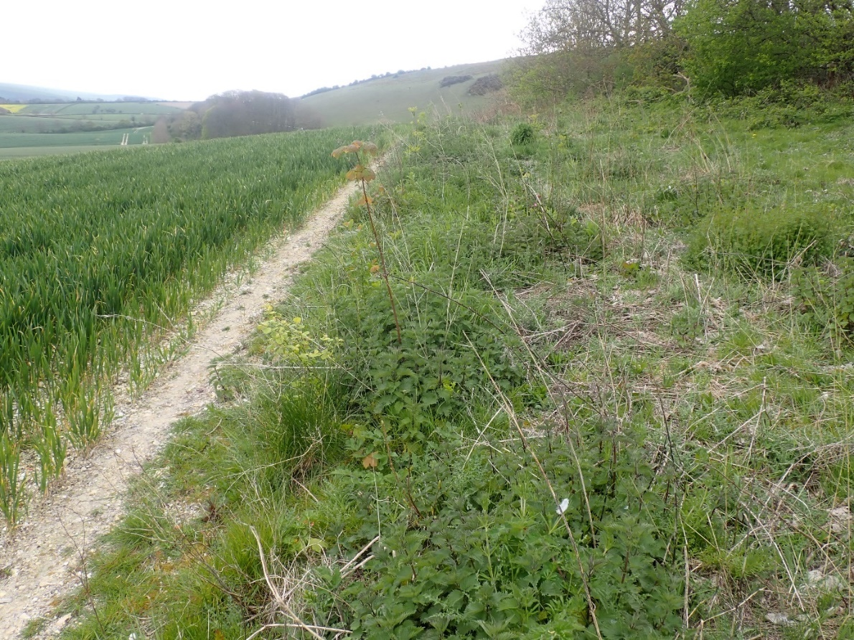
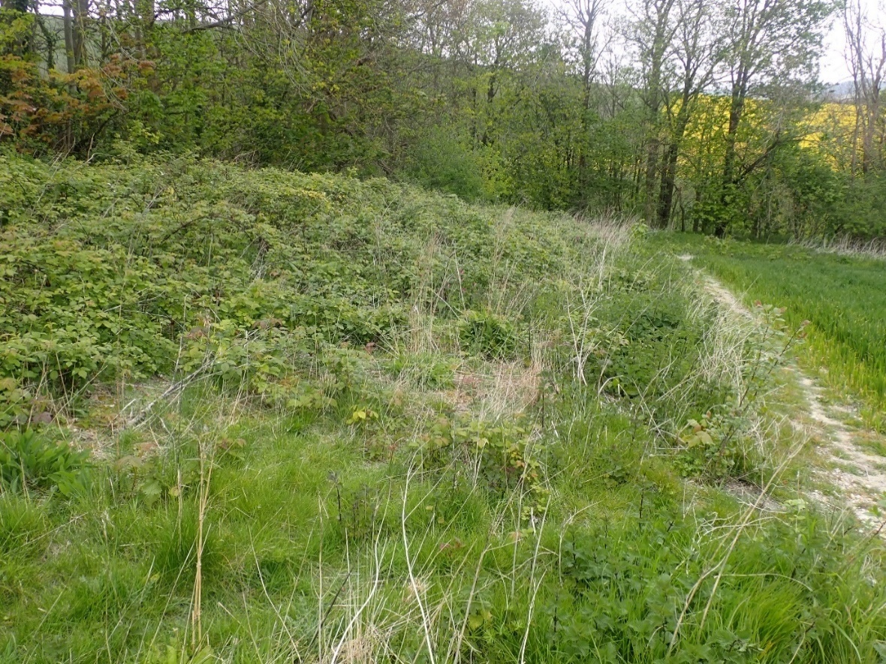
Figs. 36 & 37. The same margin is getting increasingly Bramble and Nettle dominated, with much more coarse grass (taken in late April 2024).
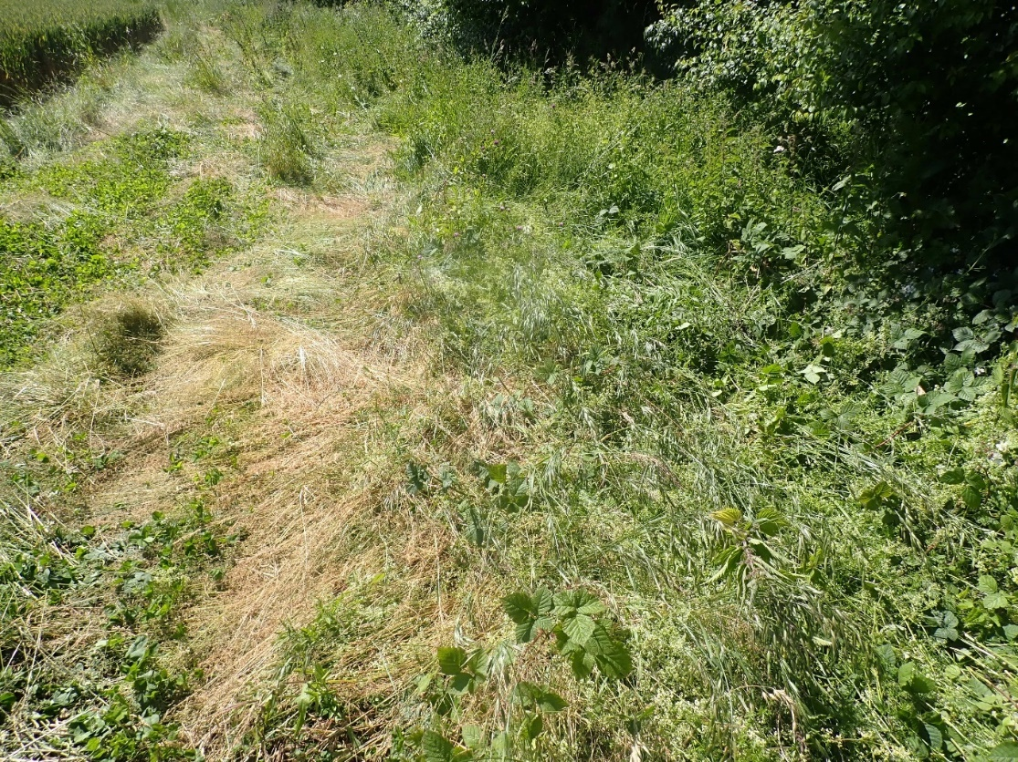
Fig. 38. The same margin in late summer 2024.
It may be that the annual monitoring of these margins is contributing to nutrient build up and that they may need ‘resetting’ more frequently.
Against the woodland on a particularly warm south-facing area, bee hives were observed. The author cannot recall if they were there in 2021 but the margins was clearly parked on regularly and recently by people attending the hives – something not observed in 2021. Honey Bees are best thought of as livestock and do nothing for biodiversity, in fact their presence here will have a negative impact on our wild bees and other pollinators.
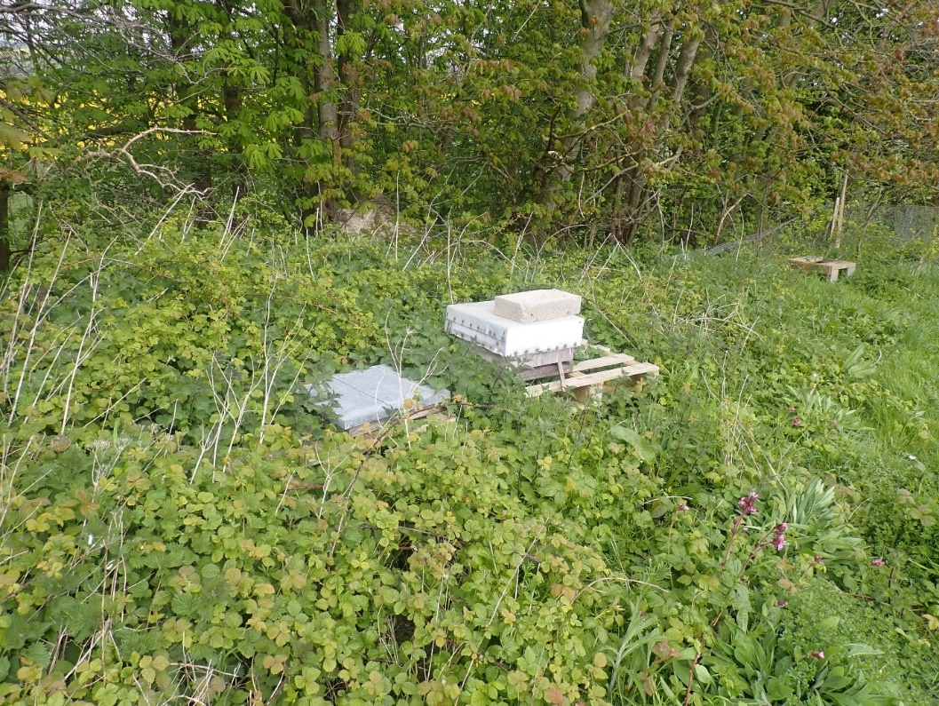
Fig.39. Bee hives are often put down thinking they will benefit biodiversity.
Arable – F
The last of the arable blocks on the top of the Downs and the most northern block of the three. Recommendations here follow that of Arable C.

5.2 – Chalk
Unlike the other two blocks, the chalk-grassland compartments all had names that seemed more relevant to use than the more arbitrary grouping of fields in the Arable, Brooks and Houndean blocks.

Chalk A (North Hill) – part of the SSSI
This was exceptionally well managed with livestock off during the key months in 2021. Equally though the site was clearly well grazed through the previous winter, as the sward was short at the right time of year in late April 2021. However, by 2024 this compartment has become undergrazed, with even the very short CG2 slope shown in figure 40 below becoming dominated by Upright Brome — a clear indicator that the grazing isn’t quite strong enough. Away from this slope (especially to the west of it), the compartment is becoming almost entirely dominated by Upright Brome. Winter sheep grazing and some intermittent light summer cattle grazing will be vital over the next 12 months.
One particular area of very tight south-facing, species-rich chalk-grassland (CG2) was especially rich in terms of plants and held the majority of the rare species in the compartment. It was perhaps the most important area of chalk-grassland surveyed in 2021 (while in 2024, this baton was passed to Long Bottom/Chalk E as the grazing there was spot on).
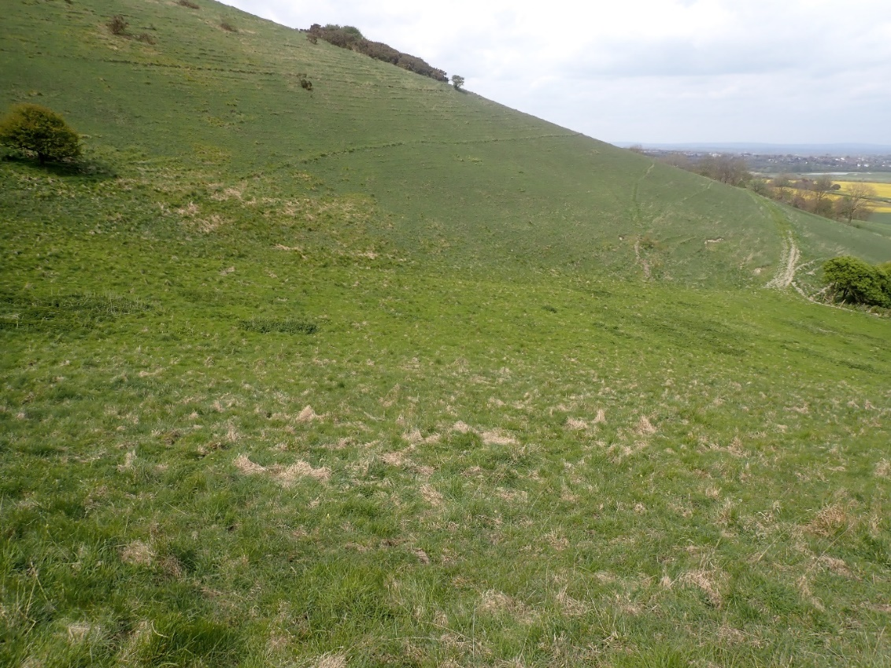
Fig. 40. The rich area of CG2 on Chalk Late April 2024.
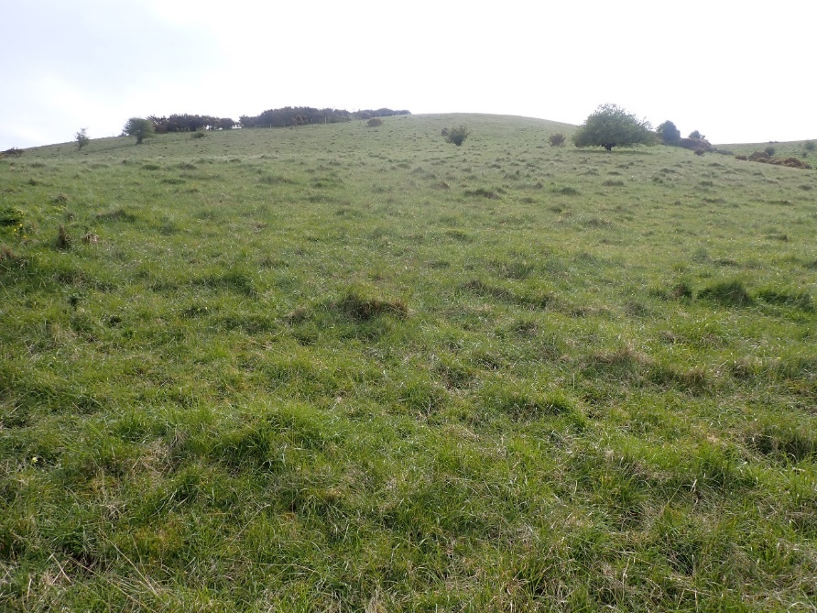
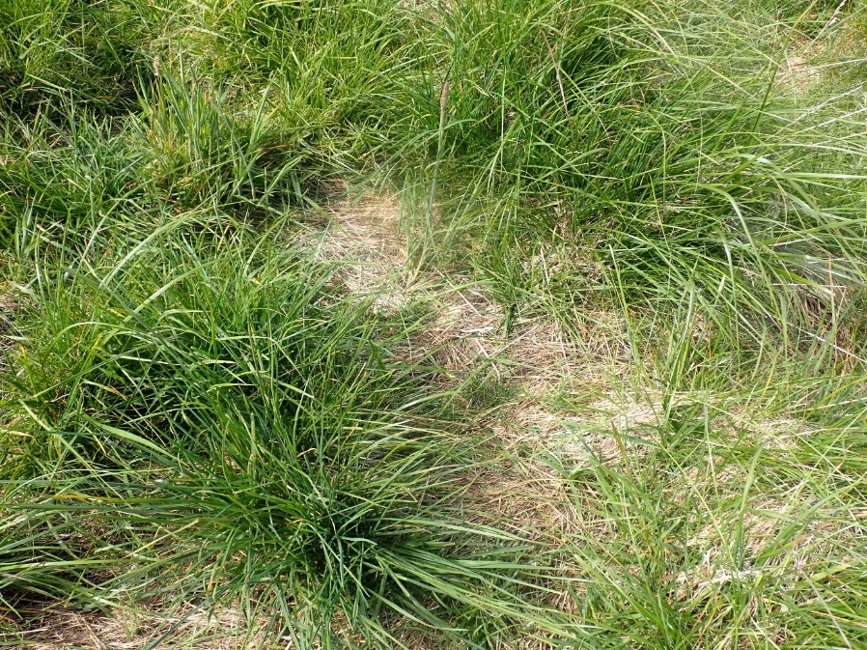
Fig.41 & 42. The westernmost part of Chalk A is really undergrazed, becoming dominated by Upright Brome, with dense litter developing under this. It is important to not allow this litter to further build up, it prevents warmth from reaching the soil and inhibits germination space of poor competing plants. Although this grass is palatable, livestock are likely to graze the shorter areas disproportionately more than they will the longer, ranker areas. This means that it may be necessary to keep animals off the nice south-facing slope in order to prevent it being damaged, in order to push animals harder on the ranker areas/majority of the slope.

Chalk B (Front & Sutton Hill) - SSSI
As above, the grazing had been held off throughout the summer months and the grazing regime here was spot on in 2021 yet by 2024, cattle had been pushed extremely hard on this slope through the winter of 2023/24 because the animals could not be moved onto the Brooks due to the floods. This caused significant damage to the sward through heavy poaching on such a steep slope (something that should be avoided, especially on steep slopes in wet winters), with many flowers not flowering later in the year and the site flipping from one of the best compartments of the survey to one of the worst. Small amounts of bare ground creation are important but 50% bare ground on pristine chalk grassland is damaging (2-5% is more than enough). Rare and chalk-grassland specialist invertebrates were almost non-existent in 2024, showing how quickly damage can be done to such sensitive sites. Any inverts overwintering in or close to the soil surface would have been greatly damaged by this and it could take many years for the grassland to recover.
In 2021, the author wrote “this area had even more flowers though, being a little ranker. Very typical for north-facing chalk-grassland, it was dominated by Devil’s-bit Scabious later in the year and held many orchids in the summer”. The following image is a shot of the slope in August 2024, even after livestock had been off the slope all summer. There were barely any flowers to be seen.
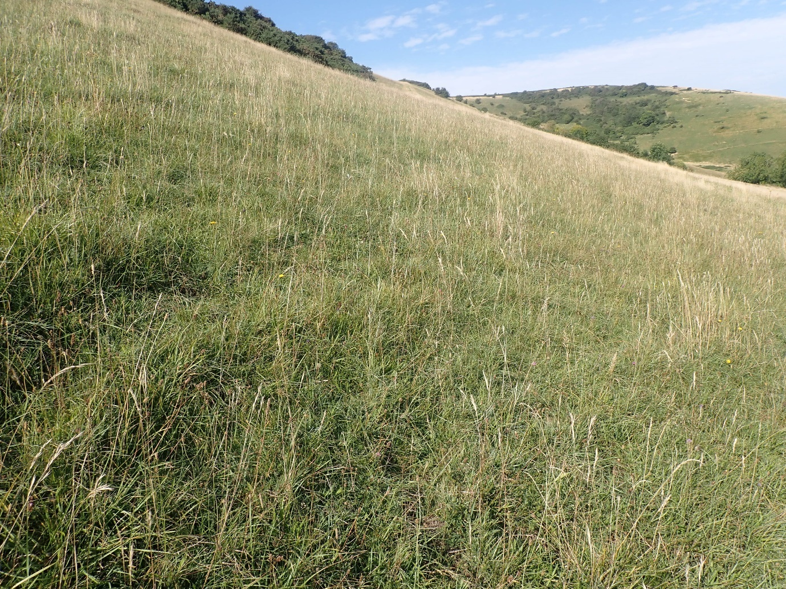
Fig. 43. Chalk B in August 2024.

The author was surprised to see the large block of Gorse being cut and dropped at the top of this slope at the end of June in the bird breeding season. This will have negatively impacted ground nesting birds attempting late broods. This really should not be tackled until August and should be done on a rotation, with the arisings removed in order to give the grassland a chance to recover. Cutting and dropping will simply make the Gorse come back thicker and stronger, effectively copsing the plant, the cutting mainly being cosmetic.
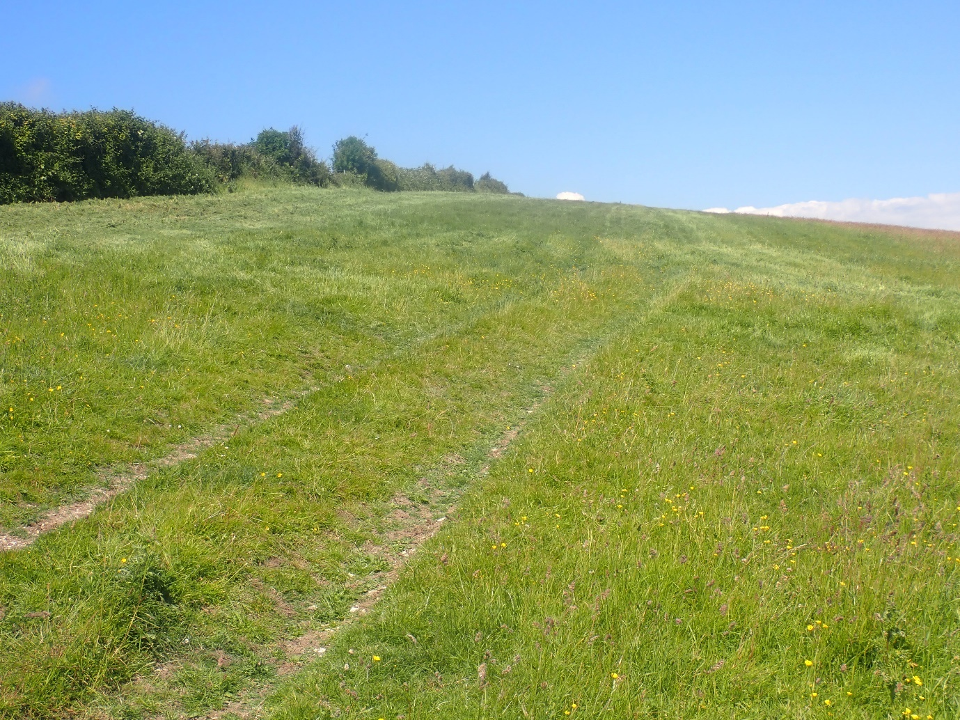
Fig. 44. Cutting of the gorse in Chalk B in June was too early.

Chalk C (Adders Corner, Frogshole Bank and Sutton & Black Shed)
Much of the recording in this block was concentrated on Adders Corner itself being the richest area in the block. A south-facing steep valley that catches the sunlight, this area is warm and scrubby in places, drifting towards more-base rich habitat mainly dominated with Tor-grass to the south east.
In 2021, grazing here was applied between the 2nd and 3rd visits, the key time for chalk-grassland and as such, was too hard a graze. There was very little structure and nectar left by September and a lighter graze and or a briefer graze are suggested for this time period in this area. By 2024, in early May many sheep were still on this site, making the spring visit extremely poor for many species (see figure 45), ideally these animals should have come off at least a month earlier. Species like Andrena gravida, Dotted Bee-fly and Dingy Skipper could not be found due to the over-grazing at this time. Animals were off by the June and August visits, however.
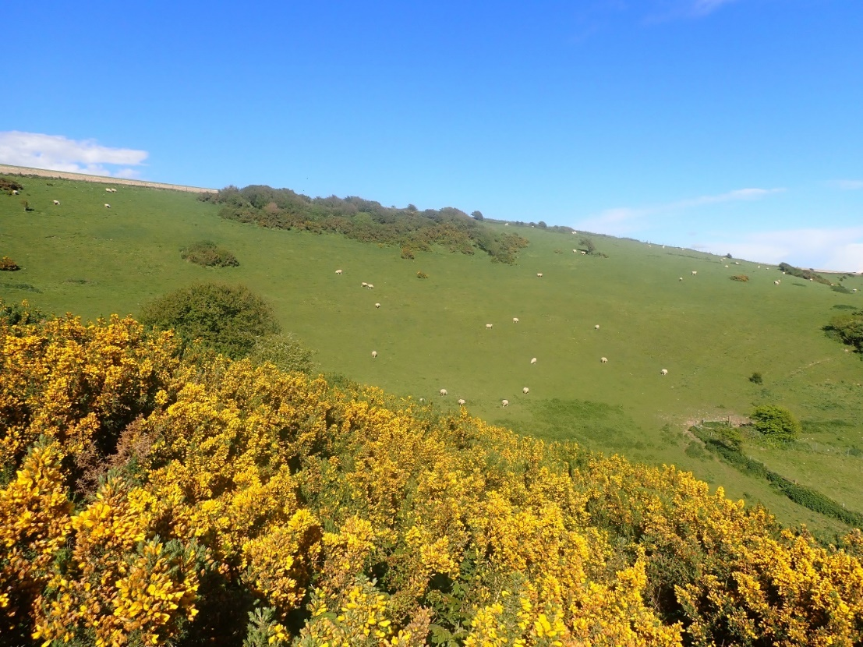
Fig. 45. Adders Corner (Chalk C) in April 2024.
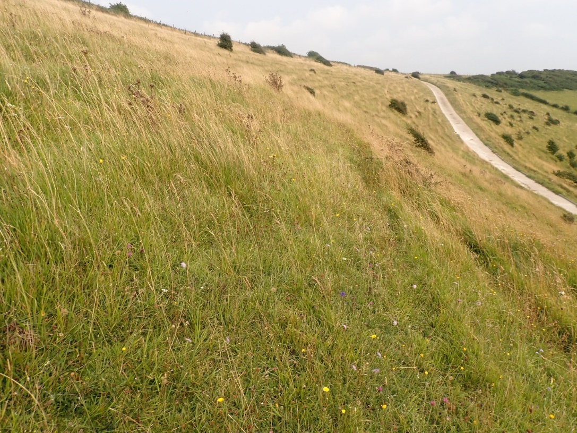
Fig. 46. The slightly ranker area to the south east of Adders Corner in August was looking very nice, the harder graze by sheep in spring will have hugely benefited this slope as that is when Tor-grass tends to be at its most palatable. This slope could have Wart-biter potential.

Chalk D (Home Bottom)
The main valley here is less base-rich, with a slightly more neutral element and thus fewer of the strict chalk-grassland species (although the rare bee, Halictus eurygnathus was recorded close to figure 47 in June 2024). As the valley curls back around towards Adder’s Corner to the south, there is another area of extremely nice chalk-grassland (see figures 48 & 49).
In 2021, this whole area and the nearby Long Bottom (part of Chalk-grassland E below) were very hard grazed throughout the whole survey period. By 2024, livestock were off these two compartments for most of the summer and the wildlife response reflected this in the data.
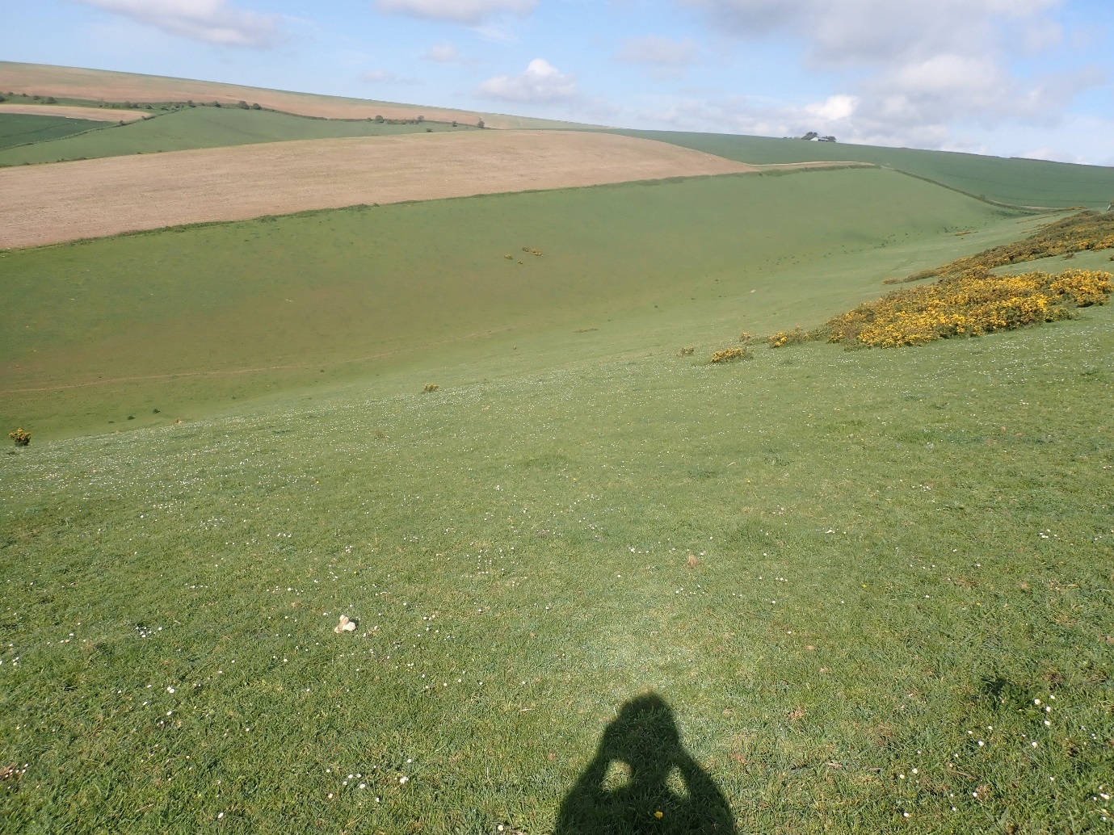
Fig. 47. The top part of Home Bottom in spring 2024.
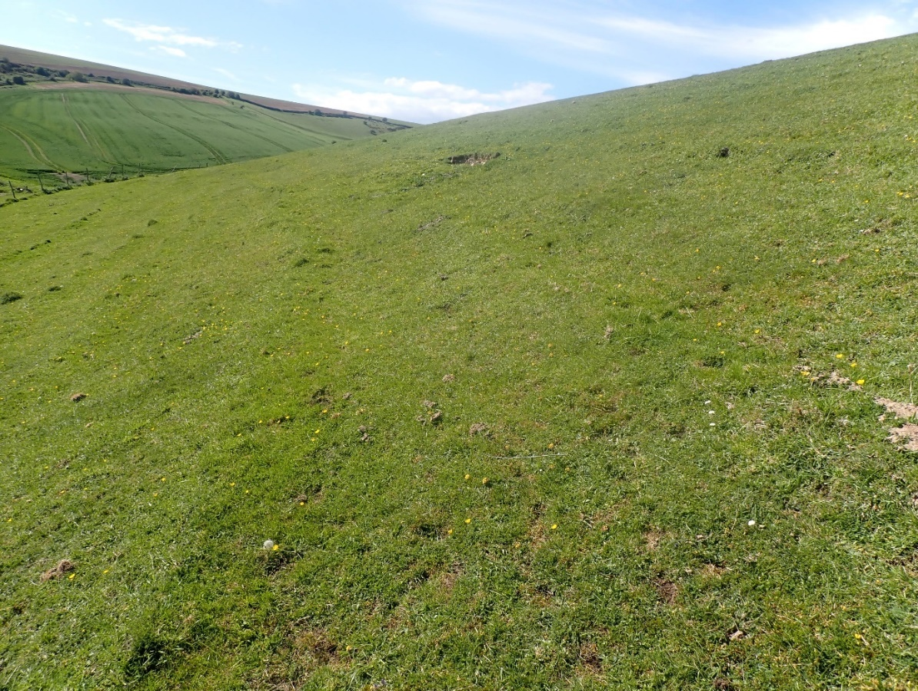
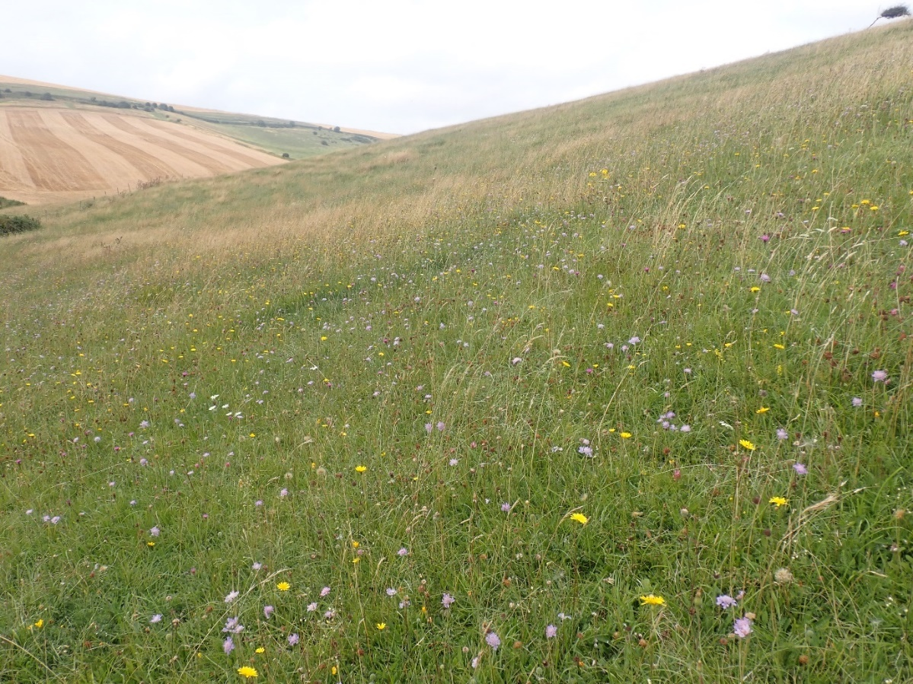
Figs. 48 & 49. The very nice area of CG2 to the south of Chalk D in early May (top) and August (bottom).

Chalk E (Long Bottom & The Triangle)
The Triangle is a ranker area that was not especially well grazed in 2021 (although livestock do have access to it at some times), by 2024 it was almost impossible to do a circular route around these two compartments and without some work here this slope could become lost to scrub. Long Bottom had clearly had a hard graze over the winter and cattle were still present on site in the spring. By June 2021, a small but significant number of sheep were still on this slope but after discussion with the Estate, these animals were moved onto the Triangle and fenced in there. No livestock were seen for the rest of the summer on Long Bottom and it responded very well to this release in grazing pressure. This is an example of a near perfect grazing regime for this kind of chalk-grassland.
The botanical and invertebrate diversity of the Triangle was not especially rich but having some of the chalk-grassland component longer is very welcome. There is a lot of scrub here which probably has a great benefit to breeding birds due to the limited resource in the surrounding landscape.
Long Bottom is a large block of extremely important CG2 chalk-grassland. It was suffering from over-grazing in 2021 but that was largely alleviated by 2024, however, the extremely high number of Red-legged Partridge here continuous to be a threat to biodiversity.
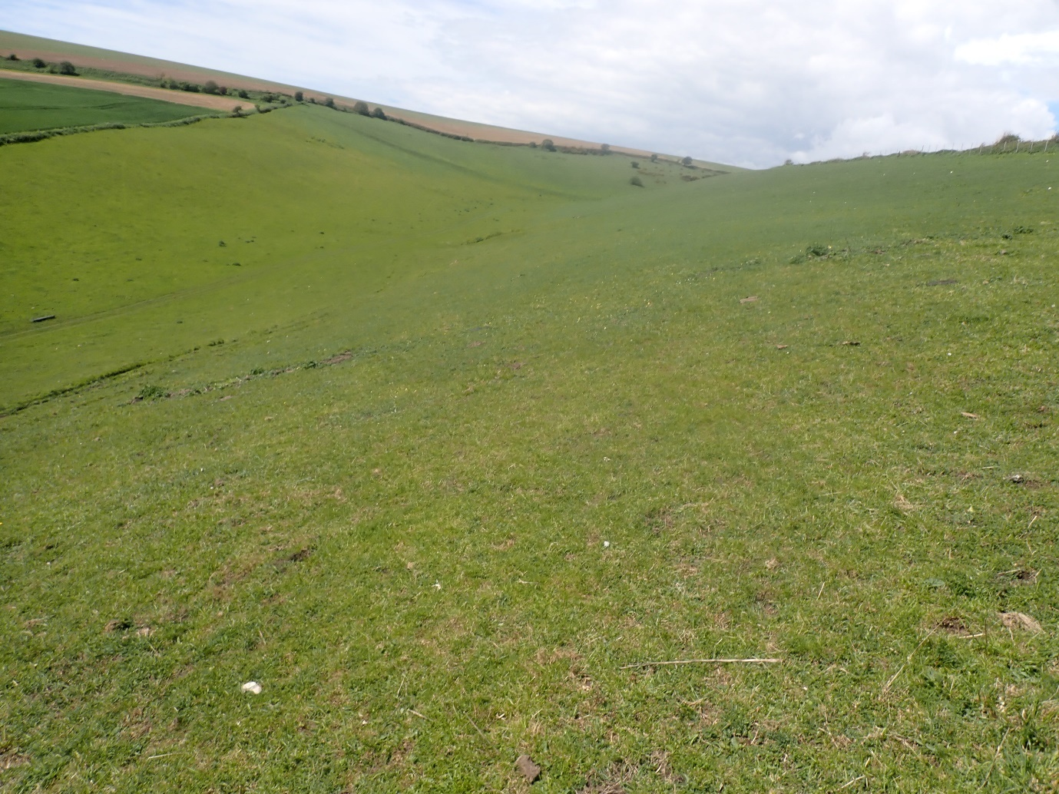
Fig. 50. Long Bottom in early May 2024.
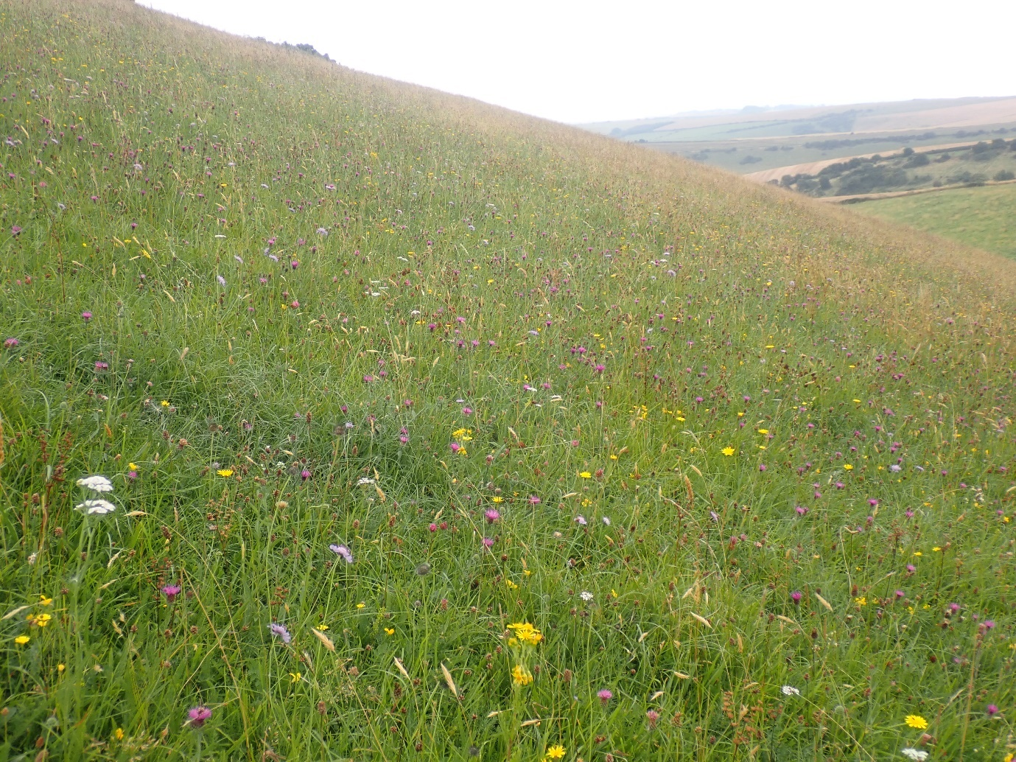
Fig. 51. Long Bottom in August 2024 was flowering very well – a perfect example.

Chalk F (High Down)
This is the isolated patch of scrub and ungrazed chalk-grassland at the extreme south west of the site, not far from Brighton. The grassland now makes up a very small component of the compartment and is threatened by scrub on all angles. In 2021, Rabbits were clearly the only thing keeping this area open. Despite this, it held some species not seen anywhere else. The discovery of a late flowering Frog Orchid (the first the author has seen in Sussex since 2008) in September. It was also the only place Grizzled Skipper was recorded (neither of these species were noted in 2024).
The following was written in 2021.
“Grazing is needed here but it must be sympathetic and applied at first with a light touch. It should be very much deployed hand in hand with the scrub management. The first thing that would be needed would be to make a very rough scrub map. Start with an aerial photo and then ground truth the area into the following habitats; established scrub, pristine chalk-grassland and chalk-grassland where low scrub is starting to dominate. This latter is the key to tackle first before tackling any established scrub. The reason for this is that this low scrub still has functioning chalk-grassland under it while established scrub does not. Established scrub takes years of aftercare to get it back into some form of grassland (and this will not be pristine chalk-grassland either). This is a draw on resources that will result in the low scrub dominated and destroying the existing chalk-grassland while the established scrub is being managed. It is simply a question of priorities that time after time the author sees tackled in the wrong way. Large scale funding is often the reason why these bigger jobs are tackled first. Low scrub can be done with brushcutters, hand saws, remote flails and tree poppers while the established scrub is very much a chainsaw job.
Arisings should be removed and ideally burnt on an area that is not pristine chalk-grassland. Any grazing should follow scrub management, as when the new growth begins to grow after management, this is when livestock will manage scrub. Only with the combination of grazing and cutting together over a number of years can scrub like this be managed without destroying the existing biodiversity through over-grazing.”
Grazing and scrub management has been applied here but it needs to be a little more nuanced in order to work well for biodiversity. The kind of scrub that has been cut (and dropped) has tended to be larger (albeit not very tall) patches around the centre and edges, not the spindly scrub growing in the grassland as stated in 2021. As such, the scrub in the sward has got much worse than it was in 2021. Meanwhile, the cut areas (without removal of arisings) are unlikely to return to grassland.
Grazing was applied in summer for perhaps the second year now, but sheep were applied in mid-summer to the entirety of the open grassland area. The eastern-most part of this site is dominated by very dense Tor-grass, the western area more dominated by Upright brome. Upright Brome is much easier to target with livestock than Tor-grass, so the author suggested splitting the grazing in two, so that animals were kept out of the richer Upright Brome area to the west. Without some management of the Tor-grass prior to applying the livestock however, it’s likely that they may just flatten it. Cutting and removing arisings first could well work (note, the time to put livestock on regenerating Tor-grass regrowth is Marh and April when it is palatable and soft). The Estate were quick to implement this and this allowed some of the grassland to recover by late summer. However, the general feel of this area is that it has declined since 2021 but it is early days, and this should not be seen as a reason to stop the direction of travel here. It just needs to be a little more sensitive.

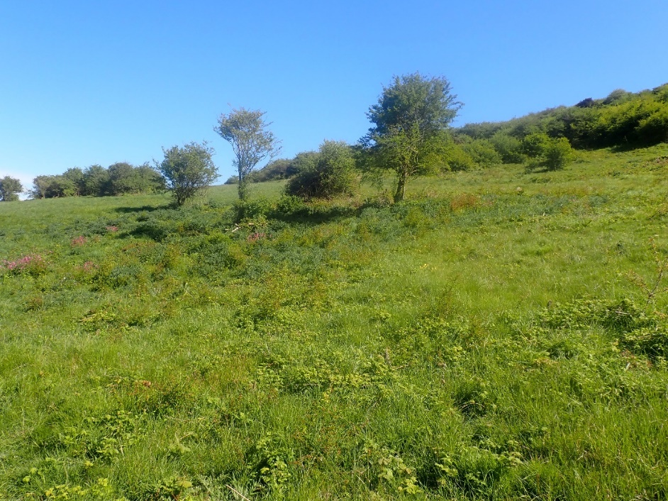
Fig. 52. Chalk F in spring. Large blocks of scrub (image centre) have been tackled, rather than the low scrub in the sward (the priority) in the foreground. Get the existing grassland right first, then move on to the larger blocks of scrub after.
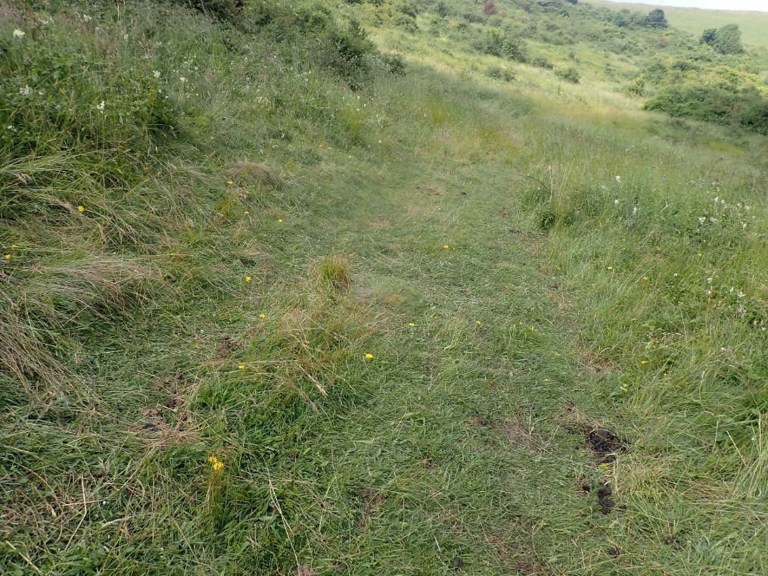
Fig. 53. As predicted, the richest area of Chalk F had already received a disproportionate amount of interest from the sheep in June.

5.3 – Brooks
In 2021, the author wrote “it is best to summarise the Brooks as being over-grazed (however, the author accepts that even with reduced grazing the grassland here is not especially interesting and is the more commercial side to the Estate), with little structure and nectar (but partly down to enrichments and seeding, it’s likely this would not be easy to rectify) and the ditches as being in fairly good condition, there could be more ditches in an early successional state at any one time and some areas are enriched for one reason or another. Finding the source of enrichment would be worth investigating, especially in Brooks A & D.”
However, by 2024 many areas in the Brooks looked if anything a little under-grazed. There certainly appeared to be more ditches in an early-successional state than there were in 2021, but the lack of accessibility across much of the Brooks in late April due to the floods will have had an impact on what was recorded there in some areas.

Brooks – A (including some SSSI)
The ditches here are more enriched than the rest of the Brooks, this may be due to the proximity to the farm yard. The ditches here have a distinct smell that is not present further out onto the Brooks.
The field to the south of the lake was quite floristic by late summer, with plenty of Common Fleabane and Water Mint. Leaving more areas like this in each field (especially the fields that are cut early right up to the hedge) would have a huge positive impact. Even just a metre or two.
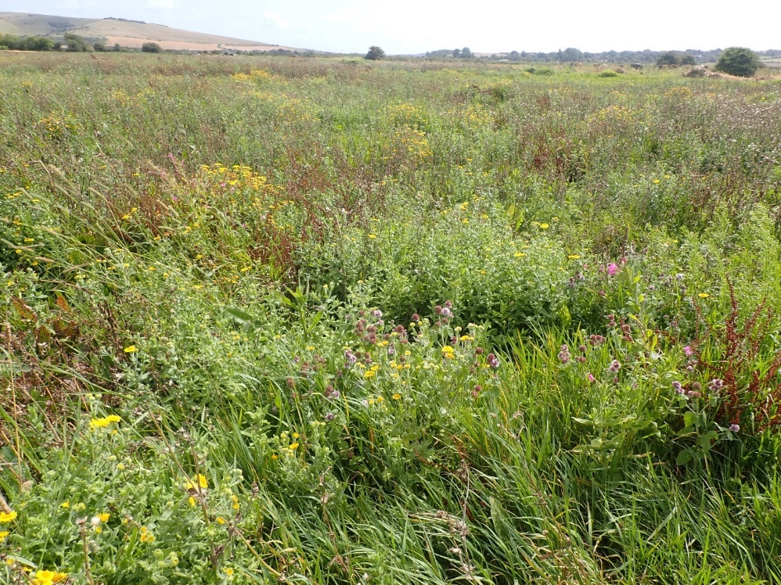
Fig. 54. It is remarkable to think that if this photo had been taken in April and not August, it may have featured a Common Carp.

Brooks – B
One of the richest areas of the Brooks, with the joint most species with status there. Although diversity was a little lower in 2024, this could well be due to the early cut, meaning only one visit aligned with this area not being cut.
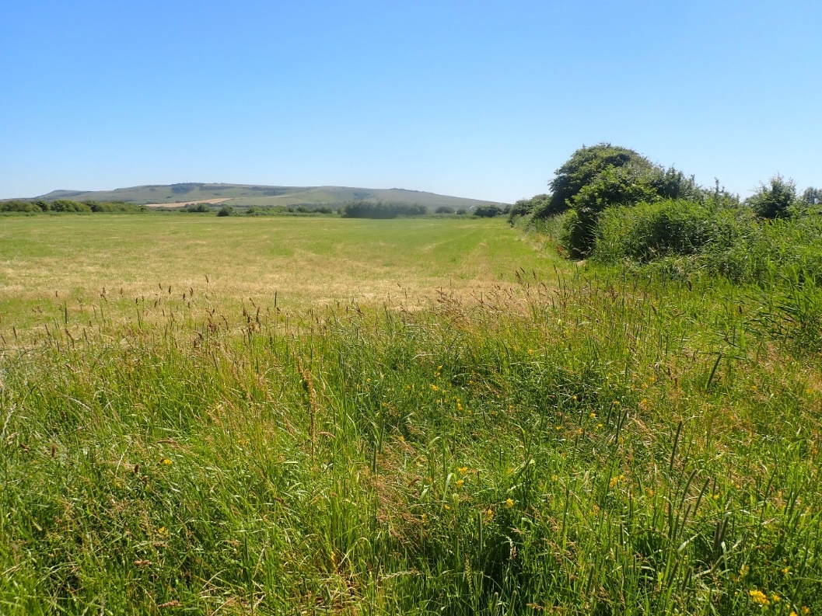
Fig. 55. More areas like the edge in the foreground should be left around the fields when they are cut as early as June. Most fields were cut tight to the hedges, removing all structure and nectar sources when most species are at their peak. Even a metre or two would have a very positive impact.
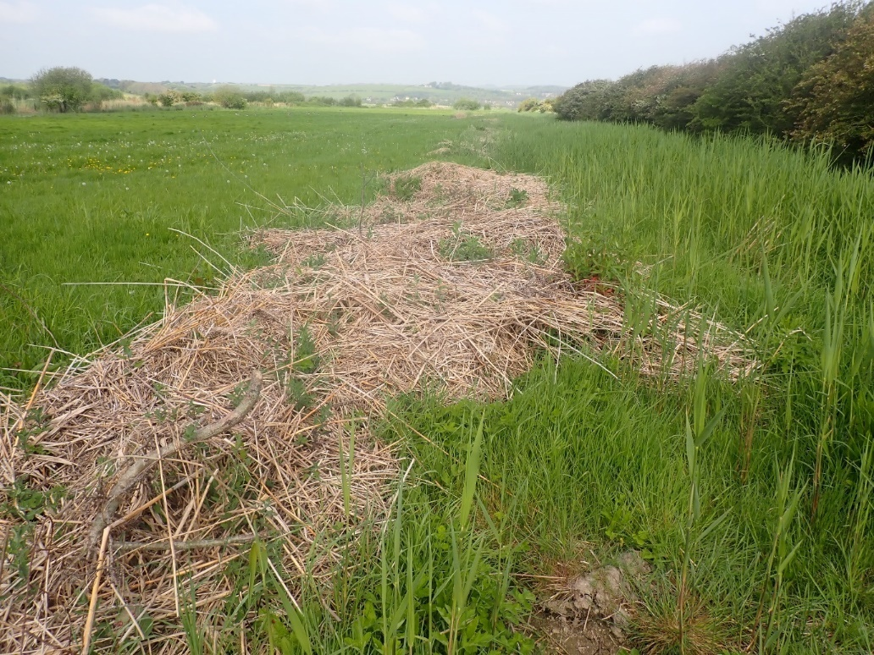
Fig. 56. Ideally, large patches of cut material like this should be piled up and/or burned.
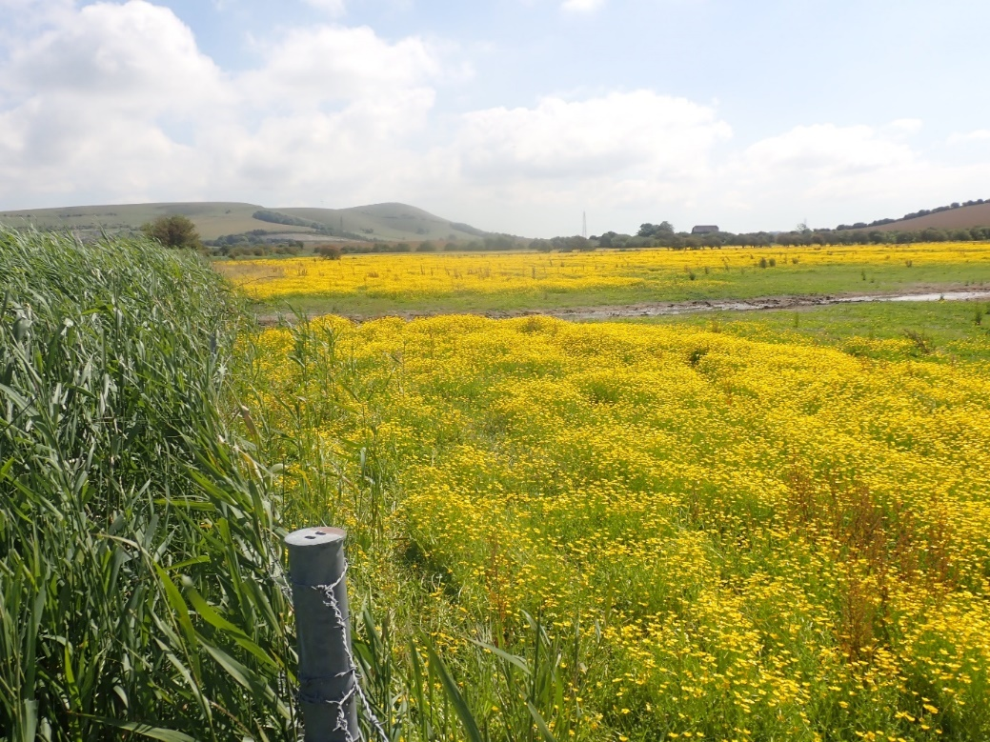
Fig. 57. By June, the fields that were flooded in April became awash with Hairy Buttercup that could be seen from miles away on the Downs.
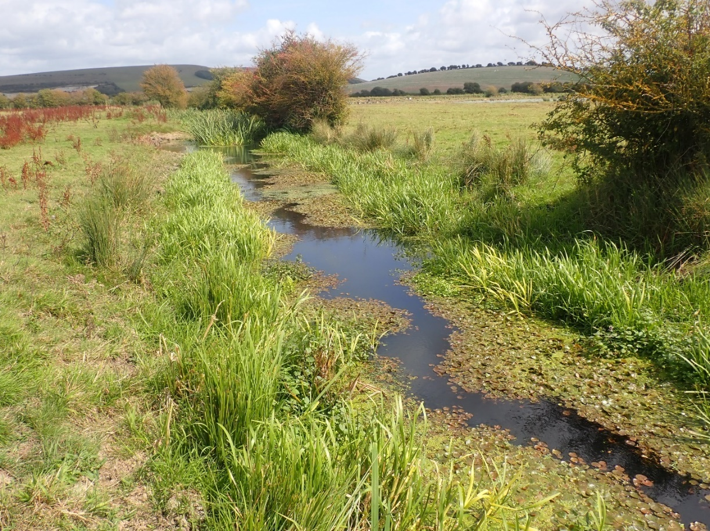
Fig. 58. To the north of the lake was one of the nice ditches on the Brooks. This is where the Round-fruited Rush was found.

Brooks – C – including some SSSI
This has some of the richest ditches on the site but as with much of the grassland here it is hard-grazed, enriched and not very interesting. Almost all the biodiversity is limited to the ditches and their edges. The grassland to the east is dominated by Tufted Hair-grass, giving the grassland a rougher feel.
A lot of ditch work had been done in this area.

Brooks – D – All SSSI
This area had quite enriched ditches in places, despite being part of the SSSI. It was well-grazed, with sheep and cattle and typically for the Brooks, the grassland was uninteresting lacking structure and nectar sources. Generally speaking, diversity was surprisingly low here and this area held the lowest number of invertebrates with status across the Brooks (along with Brooks C).

Brooks – E – including some SSSI
This included the fishing lakes, which were not especially rich for wildlife. It was also the area where Lapwing and Redshank were breeding, after much of the site was flooded in spring. A wide range of waders and herons were seen here in the spring, including Greenshank, Whimbrel and Cattle Egret.
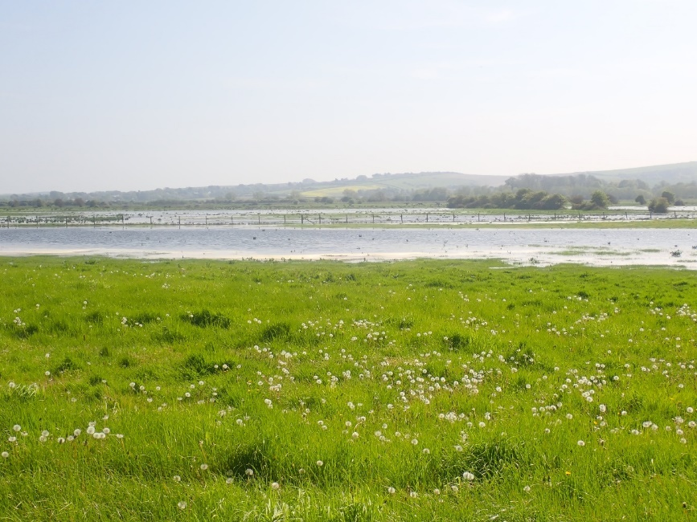
Fig. 59. Brooks E flooded in spring.

Brooks – F – including some SSSI
Some of the nicest ditches occurred in Brooks F.
Ditch management seemed to be good where it was observed across the Brooks but overall, more ditches in an early successional state at any one time would be more desirable. It was near impossible to access much of this site in spring due to the floods.
5.4 – Houndean
Houndean – A
This is the Biodiversity Net Gain area. The grassland mix is very new and dominated by a small number of species, many of which are not tailored for the chalk. It may therefore take some time for more native plants to become established within this mix. It was however, very floristic and combined with the arable margin below, resulted in this compartment having the highest number of bees of the whole survey (however, most of this is driven by the rich margin to this field, shown in figure 62 below).

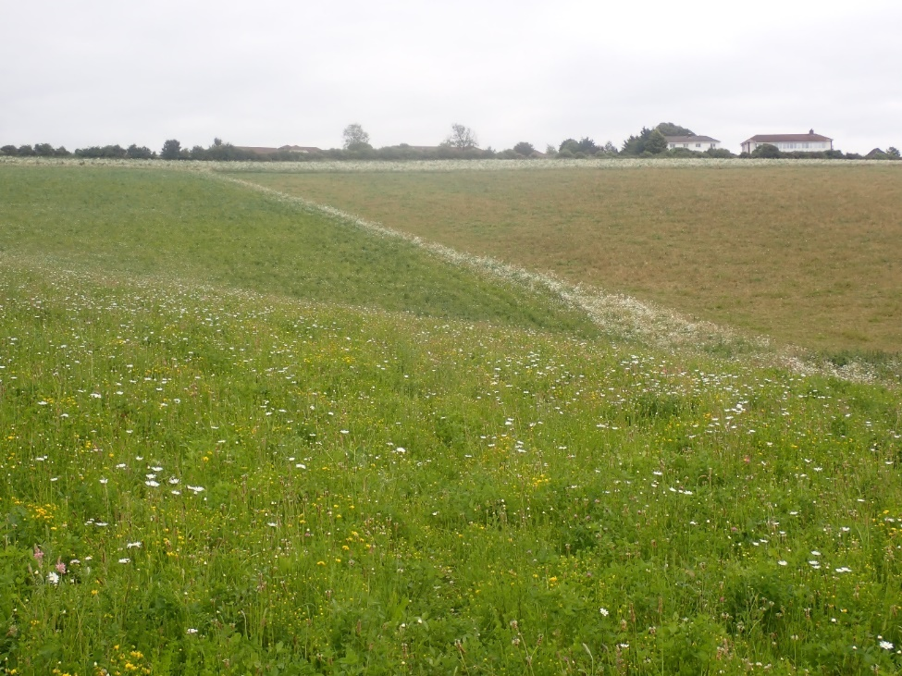
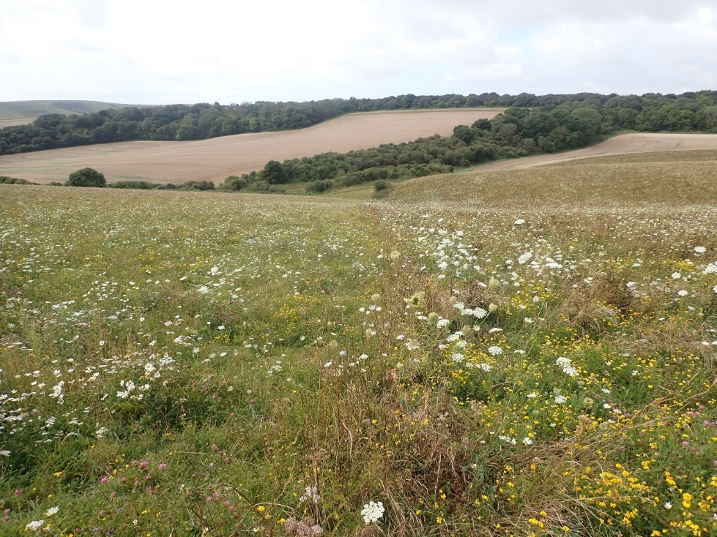
Fig. 60 & 61. The ex-arable grassland plot is dominated by Oxeye Daisy, Common Bird’s-foot-trefoil, Wild Carrot, Red Clover, Black Medick and a few other plants. The top photo shows the cattle-grazed area to the right showing as browner, the bottom photo after the cattle have been removed looking down the fence line (the cattle were grazing on the left here).
A mixture of cutting some of this area annually and removing the arisings, as well as gazing some of the area too (i.e., varying and overlapping treatments and not doing the same thing everywhere, all at once) is a really good approach.
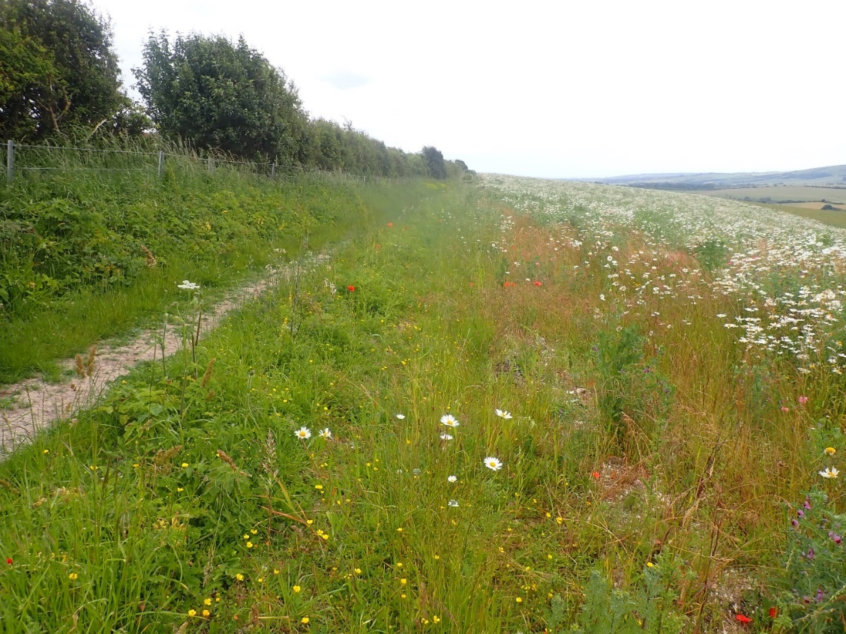
Fig. 62. Looking south down the eastern edge of Houndean A. This is an exceptionally warm and rich margin, with many rare bees seen here (including Halictus eurygnathus). Maintaining this margin like this is strongly suggested.
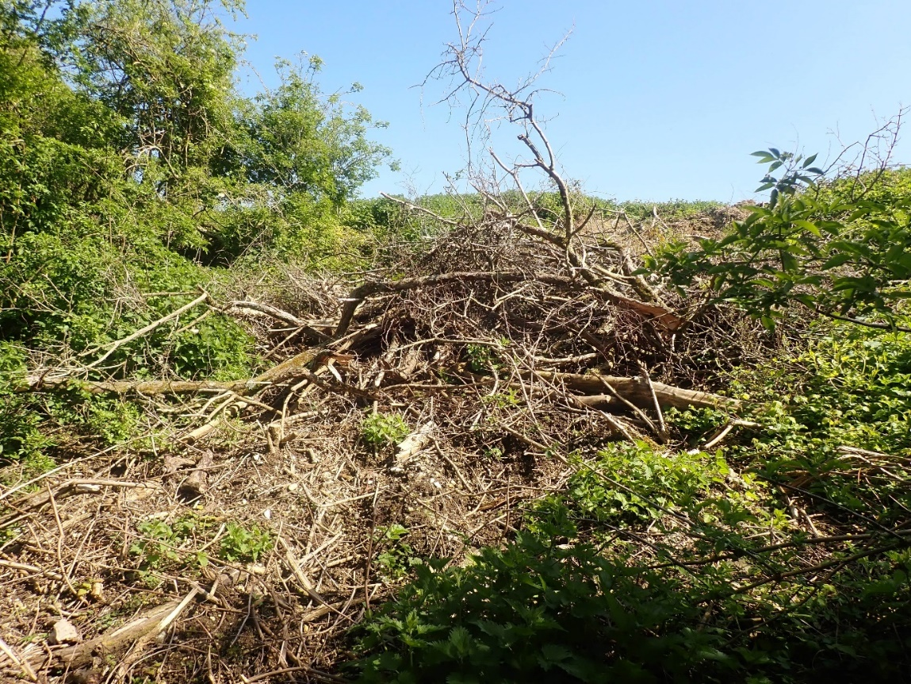
Fig. 63. The scalloping along the woodland will have had limited value as the cut material has been left in situ, rather than being removed and burnt/taken for firewood (live, healthy wood is of limited value for deadwood invertebrates). Leaving this brash will just mean these areas scrub over with bramble and revert to an even more tangled Hawthorn scrub.

Houndean – B (woodland)
The northern part of the woodland is not that far from the unusual oak woodland for the Downs; Ashcombe Bottom, with which it shares many features. It has some very large oak trees, that have many low lateral bows, showing they were once much more open-grown. Some are covered in Polypody. Beyond this though, much of the woodland is secondary Sycamore woodland, with a very poor ground flora and very few Ancient Woodland Indicators.
- Consider opening a wide ride up around the footpath (should be at least as wide as the trees that delineate it).
- Consider ‘haloing’ some of the veteran oaks (would need to be done carefully and over several years). To start, it would be worth mapping all of the veteran trees and measuring their girth to show priority trees.
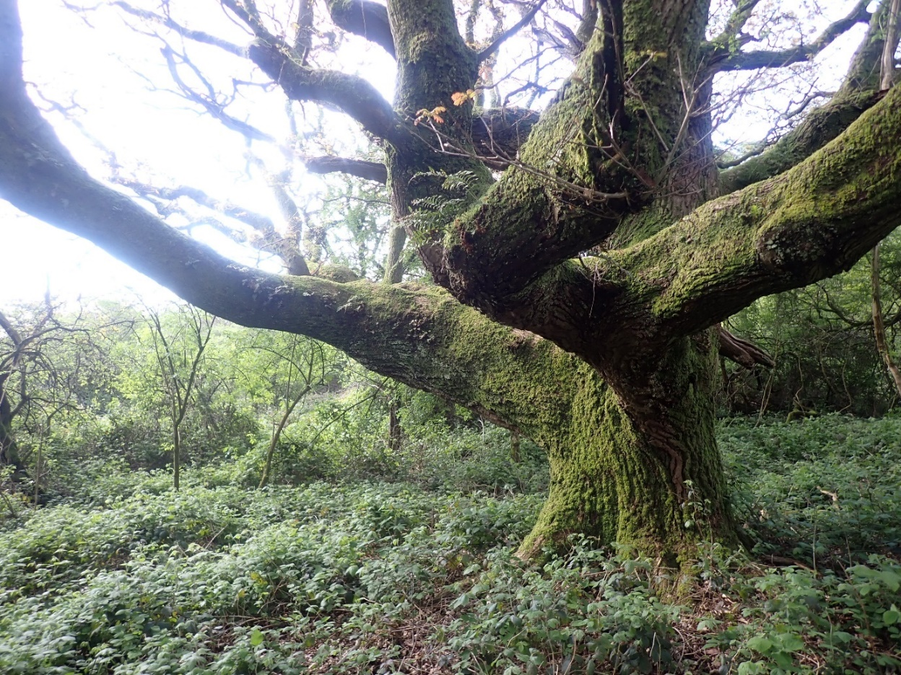
Fig. 64. A veteran oak to the north of the woodland.
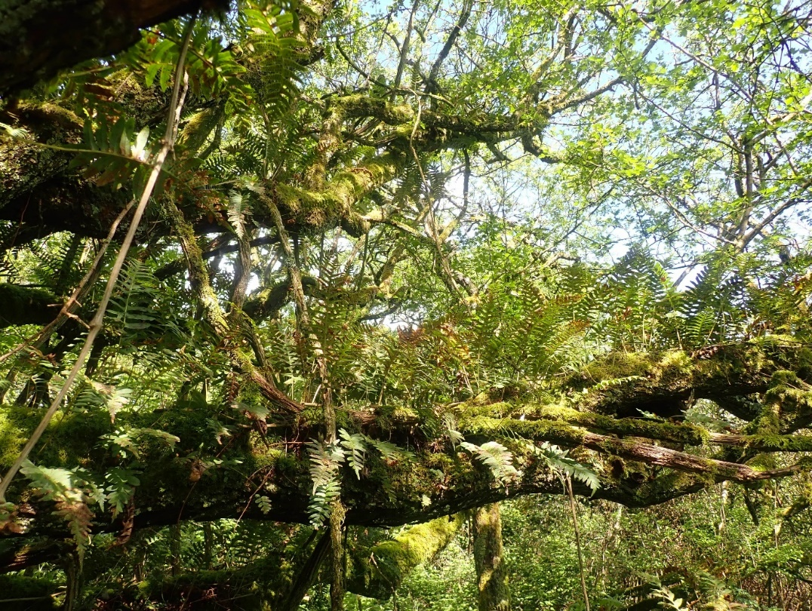
Fig. 65. A veteran oak limb covered in Polypody.
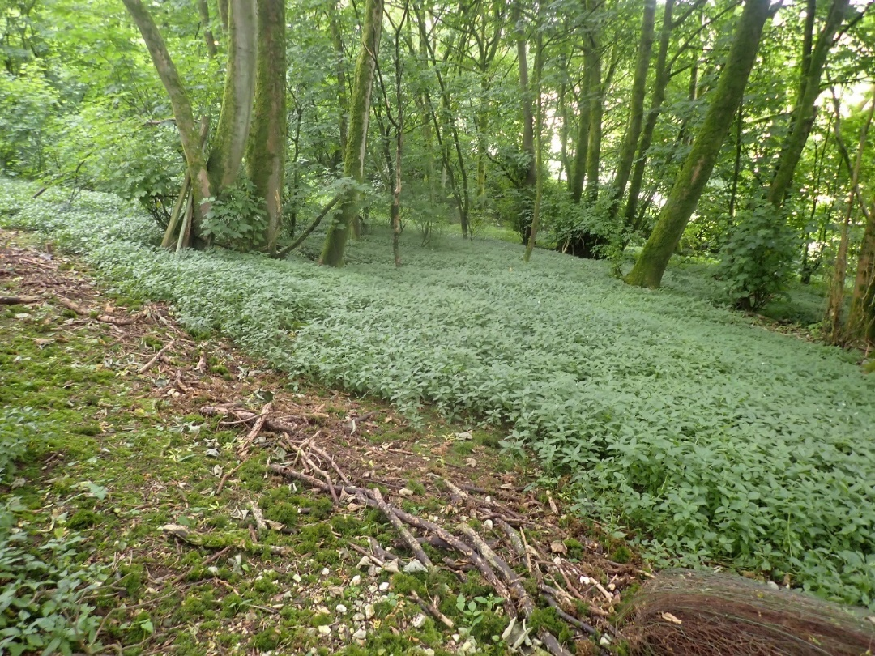
Fig.66. Typical area of Sycamore woodland with a dense ground flora of Dog’s Mercury is very typical for species-poor secondary woodland on the Downs. It is no surprise that this compartment was the worst performing for biodiversity out of all 24 compartments.

Houndean – C
The small, anomalous compartment on the edge of Lewes. A mixture of secondary woodland growing in False Oat-grass/MG1 grassland with a scattering of chalk-grassland plants that are barely present any more. The proximity to Lewes means there are many non-native plants here, especially woody ones. Grazing would be impractical due to the small size and number of dog walkers here. None intervention is reluctantly, probably the best bet here, as there are so many higher priorities on the Estate.

Houndean – D
The north-western edge of this compartment was extremely diverse in the spring. Especially along the sunny margin shown in figure 67 below.
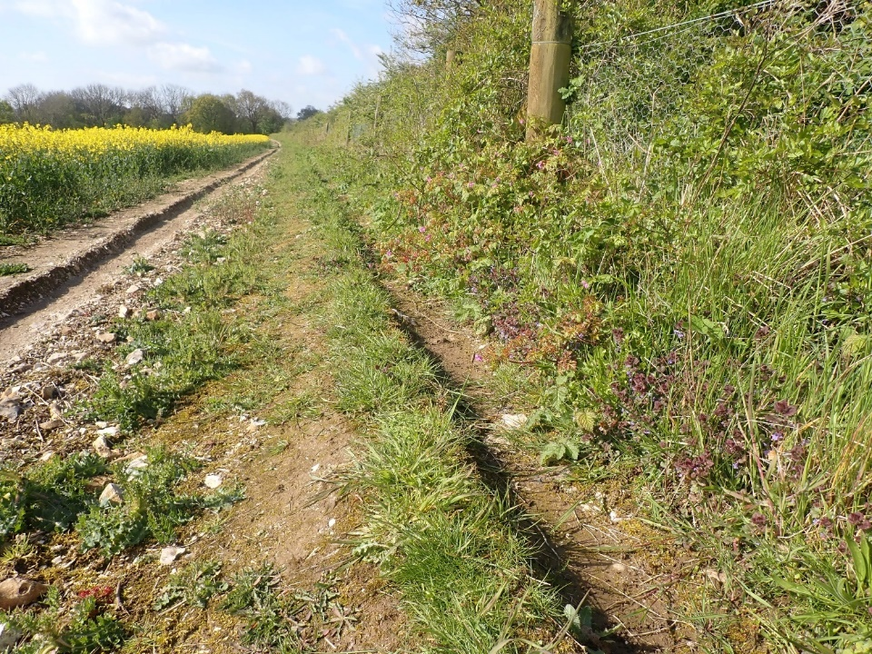
Fig. 67. Houndean D in spring.
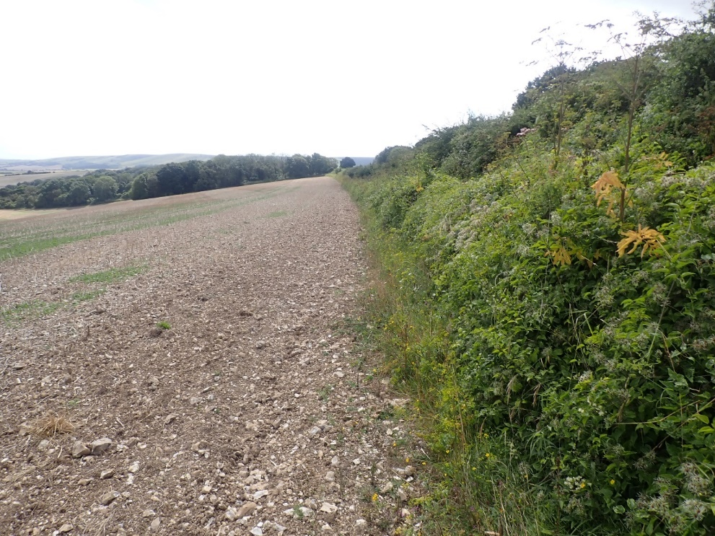
Fig.68. The same margin in August, the field had been ploughed much tighter to the edge and much of the interest had been lost.
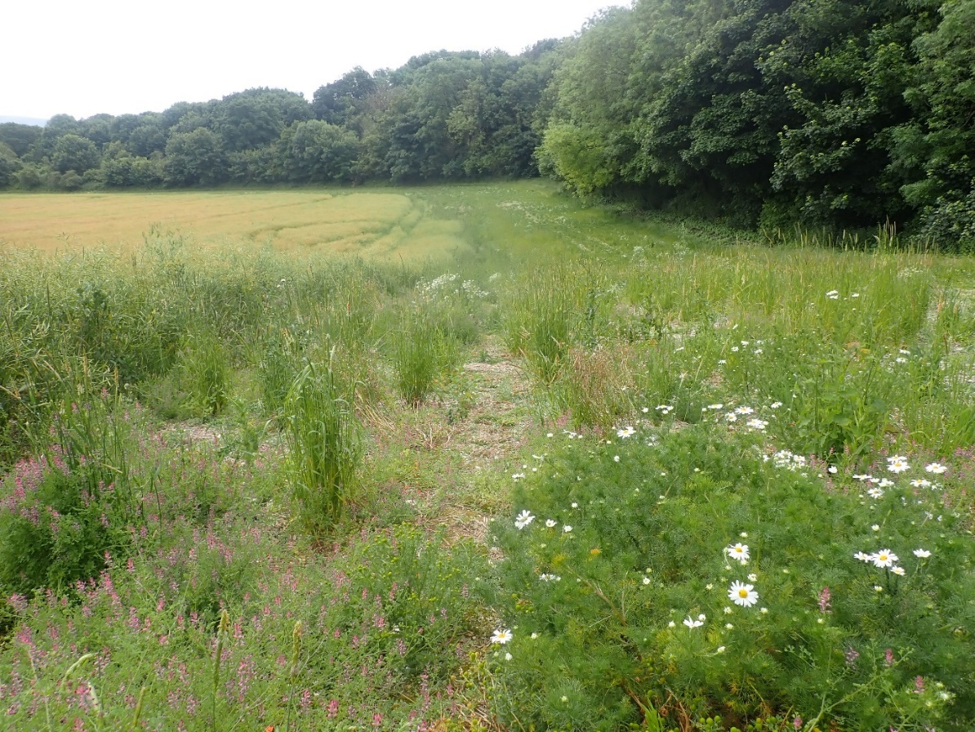
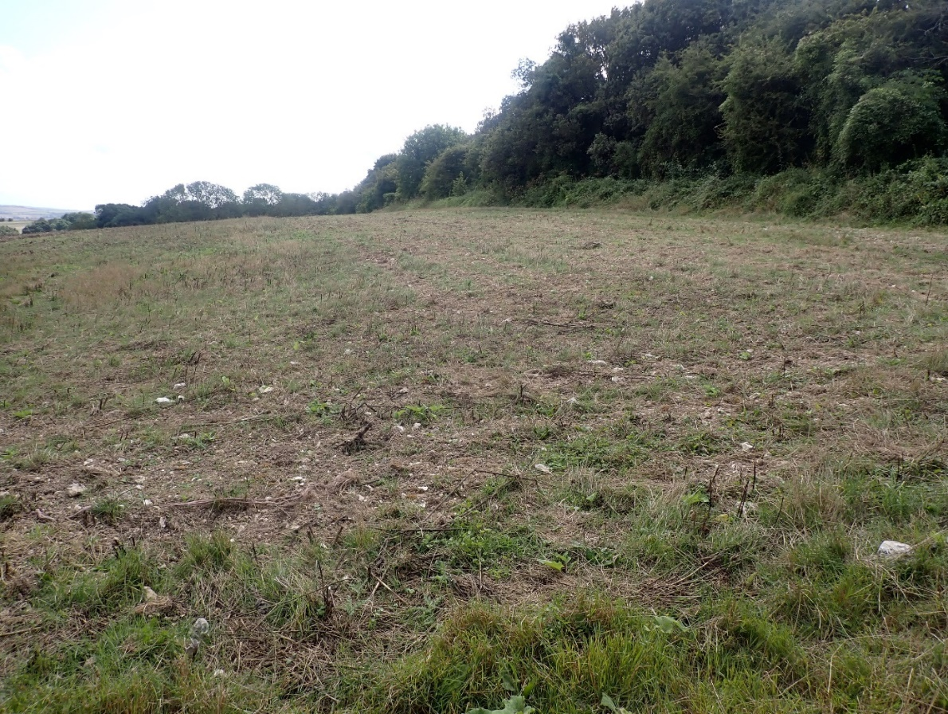
Fig. 69 & 70. A wide margin along the woodland in the southern section of Houndean D in spring June (above) and the area to the south of this in August (below). The former was really good for arable plants in June and the latter for general diversity but by August, there was a feeling of ‘over-tidiness’ at Houndean, with the entire margin cut and none of it left for overwintering invertebrates (even just 5% is considerably better than 0% - it’s good for biodiversity to be messy). This was directly at odds with observations on the main Estate, where margins were left uncut much later into the year.
Houndean – E
Remarkably, the most species-rich compartment of the entire survey. Along the field margin to the east of the site, the remnants of old chalk-grassland plants can be found like Common Rock-rose. Enhancing these margins and hedgerows by adding in some wide stewardship features in these arable areas is likely to have very good results and will most likely return wide biodiversity gains, such as those seen at Peppering Farm on the Norfolk Estate. They are also really good for ground nesting birds, like Grey Partridge. Extending the nice margin as seen in figure 62 to the south is suggested.
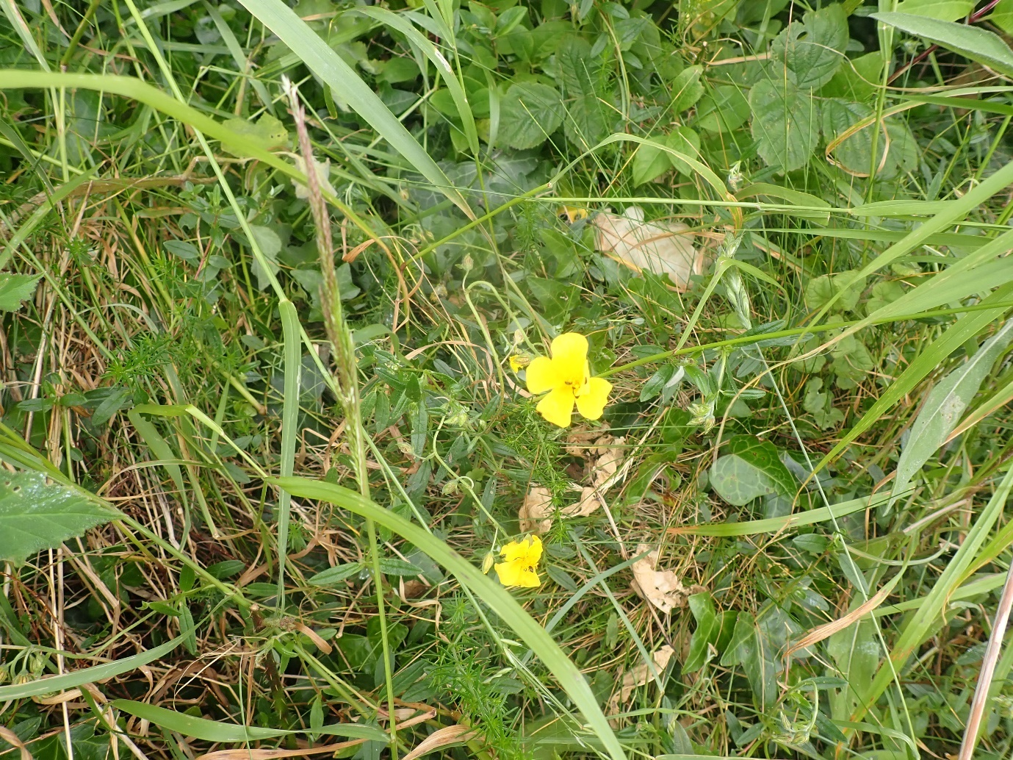
Fig. 71. Common Rock-rose in a hedge.

Houndean – F
See Houndean E.

5.5 – Red-legged Partridges
The huge number of non-native partridges put down in August really is diametrically at odds with the Estate’s desire to benefit biodiversity. The input of all of the grain that goes into these secluded chalk valleys and are then passed by the birds, or via their carcasses, will be increasing the nutrient content in this fragile landscape. Furthermore, the animals themselves will be taking many invertebrates themselves.
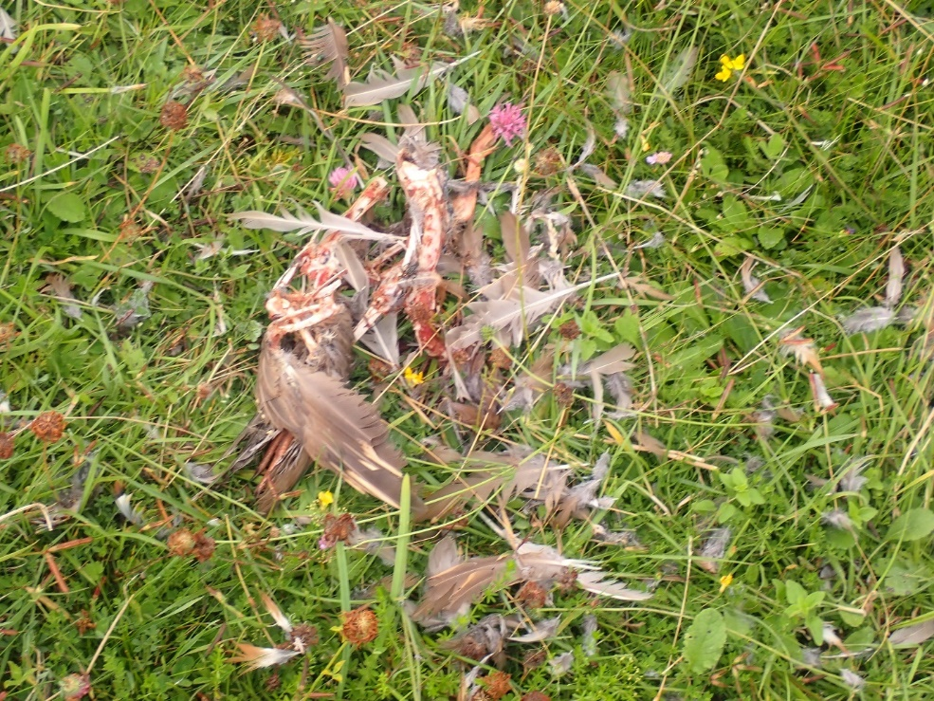
Fig. 72. In August, Chalk C, D & E were littered with partially eaten partridges and there were raptors and corvids everywhere. This annual event is likely having an impact on native ground-nesting birds, and could even impact species like Stone-curlew and Grey Partridge.
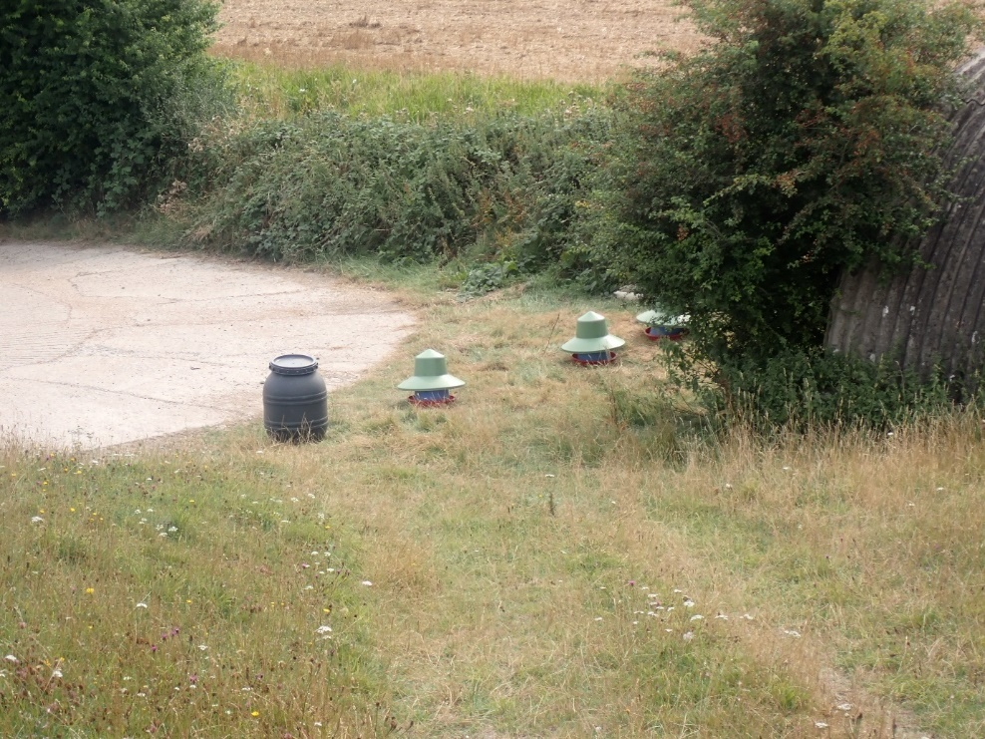
Fig. 73. The number of hoppers providing seed for the partridges will be pushing and unnatural quantity of nutrients into the chalk-grassland.

5.6 – Keeping a site list
Maintaining an accumulative site list (not just a snap shot in time like this survey) is suggested for all big estates like this one. A way of keeping track of all biodiversity on the site is a good way of seeing when something was last recorded, what the total number of species is over time, what the total number of species is that have status etc. The author has effectively done this for the Estate with the 2021 & 2024 data sets combined. The working spreadsheet is provided, rather than attach the species list in an appendix to this report as it has become too large and unwieldly.
The true number of species recorded on the site is far greater than 1980 species recorded by the author though. There will be a wide range of records made by the Estate, walkers, other naturalists, etc. Some will be held by the Estate and some by the Sussex Biodiversity Records Centre. It may be worth pulling all these together in one place, the author can help with this in the future if required.

5.7 – Repeating this survey in the future
The author would normally suggest a longer timescale for such a large survey but the sheer number of species recorded in 2024 that were not recorded in 2021 show just how much there is still to be found at Iford – these surveys are really just scratching the surface. A resurvey of the Estate in three years in 2027 has been booked in and will be rediscussed with the Estate in late 2026.

Acknowledgements
A big thanks to Ben Taylor for commissioning me to do the survey and for his support throughout it, as well as Wes Udall for his support. Many thanks to Mike Edwards for allowing me to use his text on the conservation statuses of invertebrates in the UK. Thanks to Richard Black for his help with some of the breeding birds on the site. Thanks to Frances Abraham and Nick Sturt for their help with the identity of Round-fruited Rush.

References and bibliography
Archer, M. E. (2014) The Vespoid Wasps (Tiphiidae, Mutillidae, Sapygidae, Scoliidae and Vespidae) of the British Isles. Royal Entomological Society.
Ball, S. & Morris, R. (2015) Britain’s Hoverflies – Second Edition. WILDGuides.
Barnard, P. & Ross, E. (2012) The adult Trichoptera (caddisflies) of Britain and Ireland. Royal Entomological Society.
Bee, L., Oxford, G. & Smith, H. (2017) Britain’s Spiders. WILDGuides.
Biedermann, R. & Niedringhaus, R. (2009) The Plant-and Leafhoppers of Germany. Frund.
Blower, J. G. (1985) Millipedes. The Linnean Society.
Booth, R. G. (2009) Draft Key to British species of Tachyporus Gravenhorst (Staphylinidae). Unpublished key.
Cox, M. L. (2007) Atlas of the Seed and Leaf Beetles of Britain and Ireland. Pisces Publications.
Duff, A. G. (2016) Beetles of Britain and Ireland Volume 2: Cerambycidae to Curculionidae. West Runton, Norfolk.
Duff, A. G. (2012) Beetles of Britain and Ireland Volume 1: Sphaeriusiade to Silphidae. West Runton, Norfolk.
Else, G. R. & Edwards, M. (2018) Handbook of the Bees of the British Isles. The Ray Society.
Falk, S. (2015) Field Guide to the Bees of Great Britain and Ireland. Bloomsbury.
Foster, G. N., Bilton, D. T. & Friday, L. E. (2014) Keys to the adults of the water beetles of Britain and Ireland (part 2). Royal Entomological Society.
Foster, G. N. & Friday, L. E. (2012) Keys to the adults of the water beetles of Britain and Ireland (part 1). Royal Entomological Society.
Jessop, L. (1986) Dung Beetles and Chafers Coleoptera: Scarabaeoidea. Royal Entomological Society.
Joy, N. H. (1932) A Practical Handbook of British Beetles. Pisces Conservation.
Kirby, P. (2015) British Heteroptera keys to terrestrial families other than Miridae. Unpublished key.
Kirk-Spriggs, A. H. (1996) Pollen Beetles Coleoptera: Kateretidae and Nitidulidae: Meligethinae. Royal Entomological Society.
Levey, B. (2010) British Scraptiidae. Royal Entomological Society.
Lott, D. A. (2009) The Staphylinidae (rover beetles) of Britain and Ireland Part 5: Scapidiinae, Piestinae, Oxytelinae. Royal Entomological Society.
Lott, D. A. & Anderson, R. (2011) The Staphylinidae (rove beetles) of Britain and Ireland Parts 7 & 8: Oxyporinae, Steninae, Euaesthetinae, Pseudopsinae, Paederinae, Staphylininae.
Luff, M. L. (2007) The Carabidae (ground beetles) of Britain and Ireland. Royal Entomological Society.
Lyons, G. (2021) Iford Estate Biodiversity Survey 2021. Unpublished report to Iford Estate.
Macadam, C. & Bennett, C. (2010) A Pictorial Guide to the British Ephemeroptera. Field Studies Council.
Morris, M. G. (1990) Orthocerous Weevils Coleoptera Curculionidae (Nemonychidae, Anthribidae, Urodeontidae, Attelabidae and Apionidae). Royal Entomological Society.
Morris, M. G. (2008) True Weevils (Part II) (Coleoptera: Curculionidae, Ceutorhynchinae). Royal Entomological Society.
Plant, C. W. (1997) A key to the adults of British lacewings and their allies. Field Studies Council.
Roberts, M. J. (1995) Field Guide to Spiders of Britain and Northern Europe. Collins.
Rowsan, B., Turner, J., Anderson, R. & Symnondson, B. (2014) Slugs of Britain and Ireland. Field Studies Council.
Roy, H., Brown, P. & Lewington, R. (2018) Field Guide to the Ladybirds of Great Britain and Ireland. Bloomsbury.
Savage, A. A. (1989) Adults of the British Aquatic Hemiptera Heteroptera. Freshwater Biological Association.
Sterling, P. & Parsons, M. (2012) Field Guide to the Micro Moths of Great Britain and Ireland. British Wildlife Publishing.
Stubbs, A. & Drake, M. (2001) British Soldierflies and their Allies. British Entomological and Natural History Society.
Stubbs, A. E. & Falk, S. J. (2000) British Hoverflies. British Entomological and Natural History Society.
Waring, P., Townsend, M. & Lewington, R. (2003) Field Guide to the Moths of Great Britain and Ireland. British Wildlife Publishing.
Yeo, P. F. & Corbet, S. A. (1983) Solitary Wasps. Pelagic Publishing.

Appendix 1
See the associated spreadsheet entitled “Iford biodiversity survey Master 2021 and 2024 combined.”

